CDX Distance Learning
Kahoot! Instructor Guide
Using Kahoot!

Visit the Kahoot! website at: https://kahoot.com/.

- If you do not have an account, you will need to sign up. Click the green Sign up button in the top right corner.

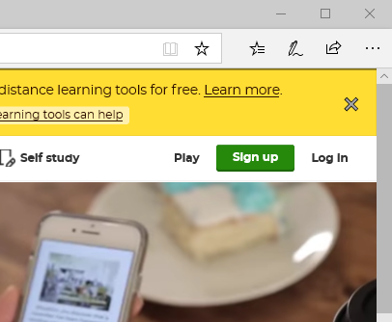

- Next you will need to select your account type. Most likely you will be selecting the Teacher account.

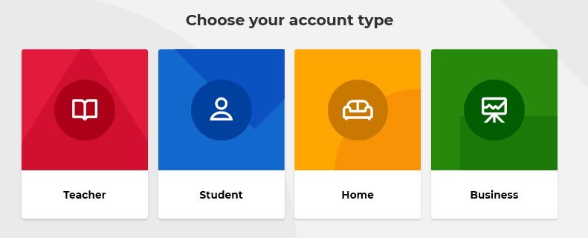

- Next you will describe your workplace. Most will be School, or Higher education.

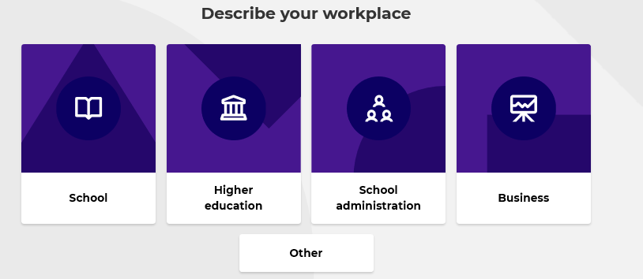

- Next you will need to enter your work email and password. We recommend that you select the box to receive information, offers, recommendations, and updates from Kahoot! since this will include score results and notifications when kahoots end.

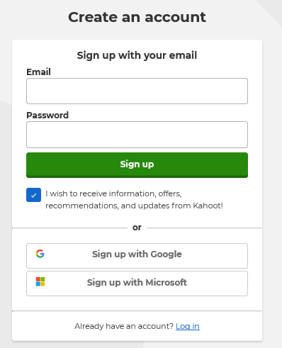

- Choose your account type, the Basic, free membership is enough for most. You will be able to access kahoots made by CDX Learning Systems with the Basic account.

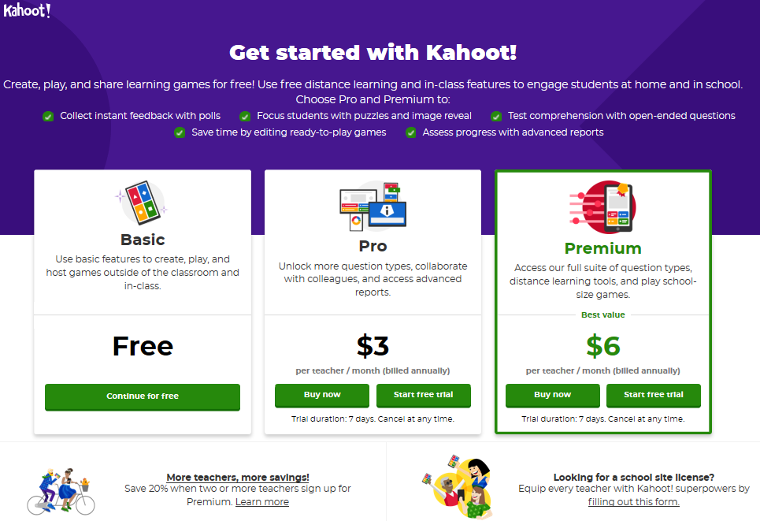

- Enter your Name, Username, and School (or business) name.

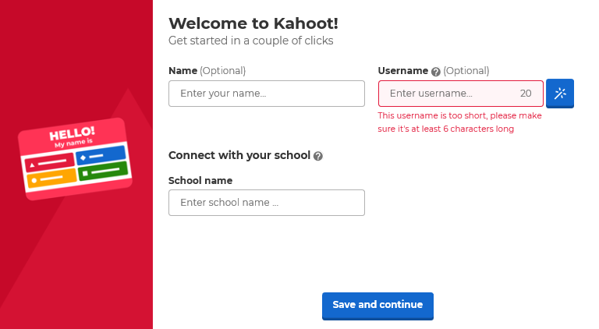

- Now you are at the home screen. You could play a demo game to familiarize yourself with Kahoot! The following steps will help you find kahoots from CDX Learning Systems.

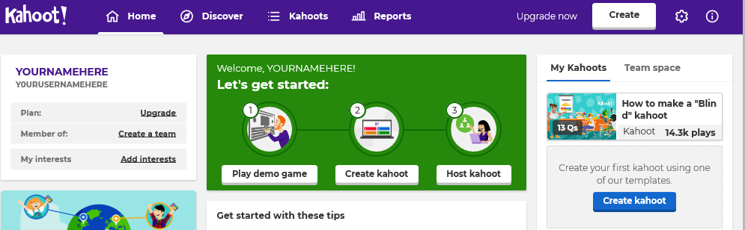

- Click the Discover tab in the upper purple bar. In the search bar, where it says, Find me a kahoot about…, type CDX_Learning_Systems.

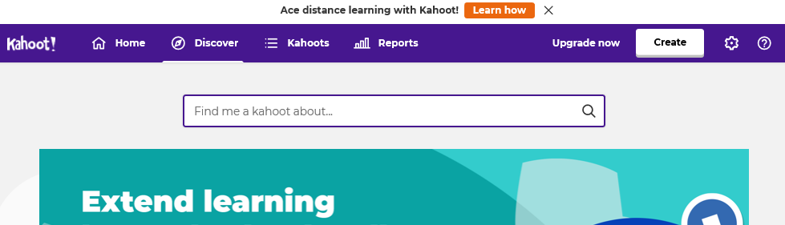

- There are many kahoots to choose from. They are organized by textbook title, ASE area, or concept. You can look for the image of the textbook you are using, or you can add to the search, for example A4.

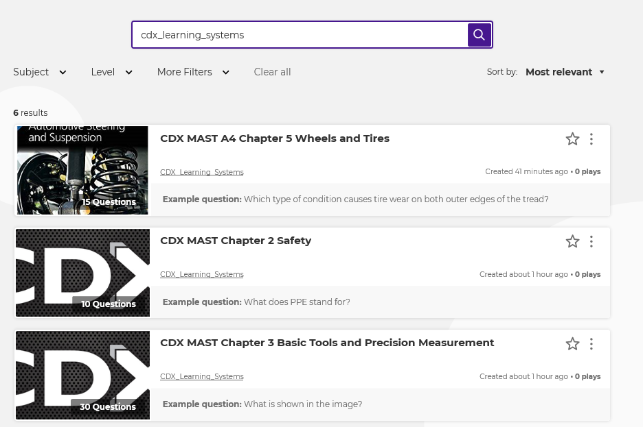
* Note: The MAST series textbooks often have common chapters 1–4. You will find those with the large CDX photo rather than your textbook photo.

- Once you have found a kahoot you wish to use, consider making it a favorite by clicking the star on the right side. Next click the title of the kahoot.

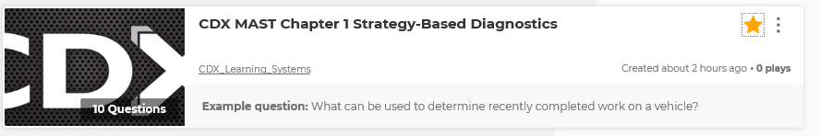

- Here you can preview the questions and answers. When you are ready for students to complete the kahoot, click the green Play button on the left side.

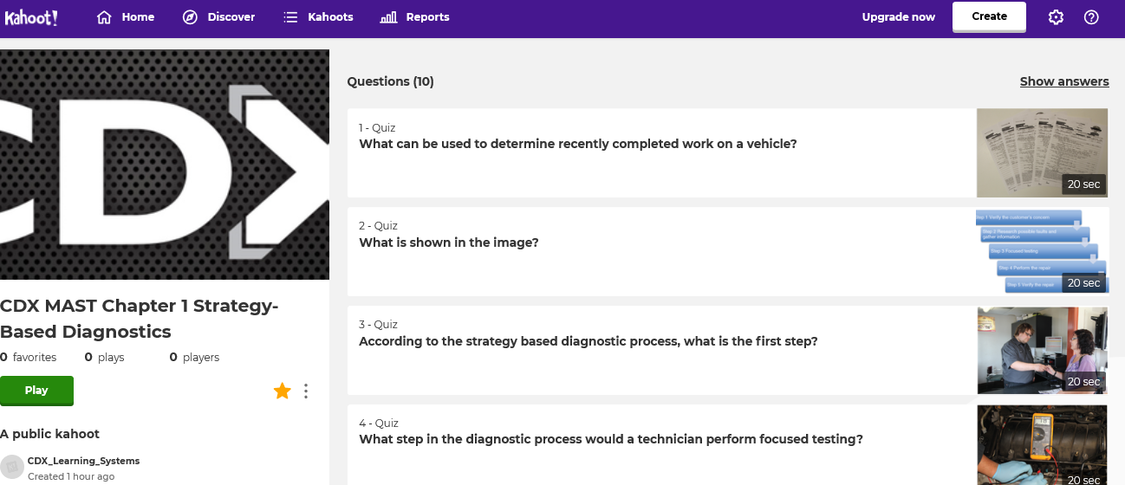

- At this point you are given options for play.

- You can choose Host Live if you are with your students in person. The questions will be displayed on your computer, which you would project onto a screen or similar for all to see. This will include student username and scores. Students can create unique usernames to remain anonymous if desired.
Or
- You can Create a Challenge. This will allow students to work on the kahoot if they are not with you in person. You can adjust due dates. Students’ scores will be shown to other students, and to you. They can make their own usernames to remain anonymous if desired.

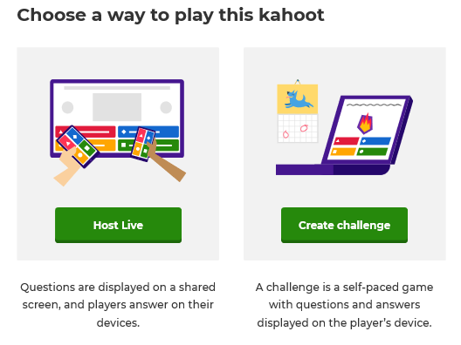

- If you are playing live, the next step is to set up game options.
- Classic is for individual play and requires students to have their own devices.
- Team mode allows grouped students to share a device.

Personalize the options as shown:

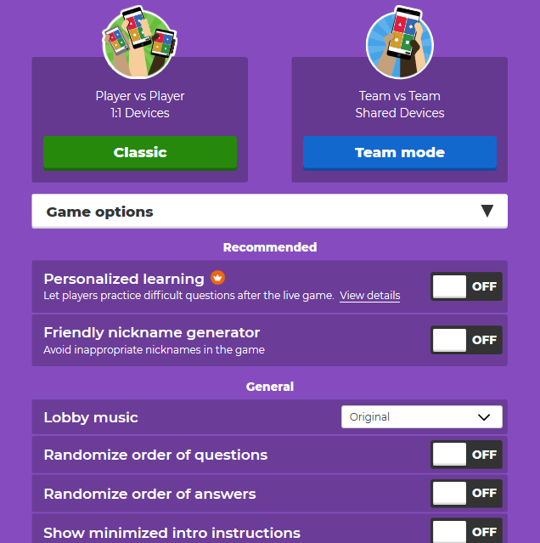

- If you are playing live, once you click Classic or Team mode the kahoot will begin. The start screen shows the Game PIN which is unique to your game. Students will need to log in using their devices. They can join at www.kahoot.it or with the Kahoot! app. They will enter the Game PIN and you will see their username pop up on screen.

Once you have all your players (late students can be added during the game as well), click the Start button in the top right.

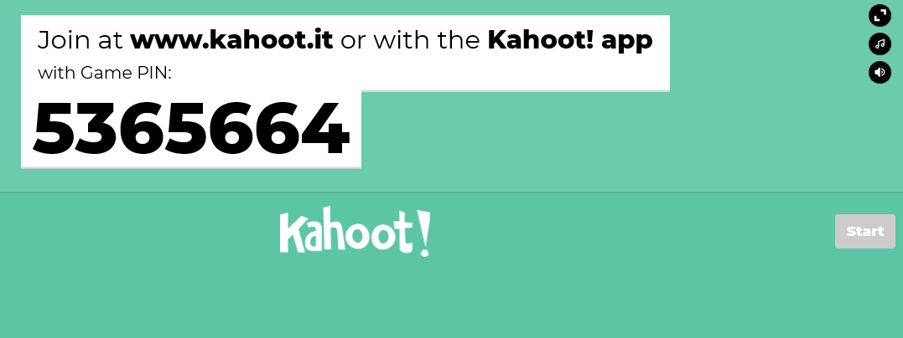

- If you are playing live, from this point it is very simple. The questions will show on screen, and students will have a limited time to answer. The time remaining is shown on the screen.

- If you are playing using a challenge:
- Set the due date.
- Customize the game options.
- Click Create challenge.

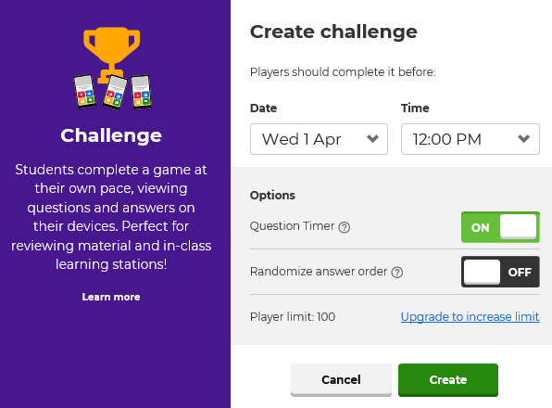

- If you are playing using a challenge, share the kahoot link using the Copy button for either the challenge link or the challenge pin.
- The challenge link will bring students straight to the game.
- The challenge pin will require students to go to kahoot.it.com, or to use the Kahoot! app on their device.

- Whether playing live or as a challenge, the scores will be displayed at the conclusion of the game.
Enjoy!

