CDX Distance Learning
Exercise #14

Alignment Angle Inspections

Student Name: Click or tap here to enter text.

Click or tap the check box next to the answer choice that best completes the statement or answers the question. Using the alignment results provided above each question will be required to answer each one correctly.

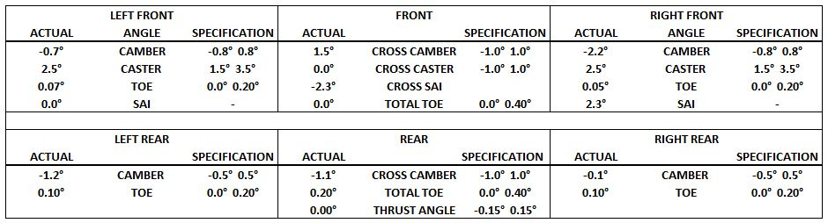
1. Where would tire wear occur?
☐ | a. | Right front
☐ | b. | Left front
☐ | c. | Right front and left rear
☐ | d. | Left front and right rear

2. What would the customer’s concern most likely be?
☐ | a. | Vehicle pulls to the right, steering wheel straight
☐ | b. | Vehicle pulls to the left, steering wheel straight
☐ | c. | Vehicle pulls to the right, steering wheel off center
☐ | d. | Vehicle pulls to the left, steering wheel off center

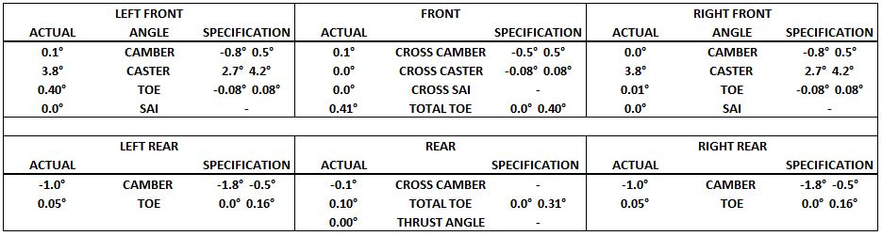

3. Where would there be tire wear, if any is present?
☐ | a. | There would be no tire wear
☐ | b. | Wear on the right front only
☐ | c. | Wear on the left front only
☐ | d. | Wear on both the left and right front

4. The alignment results provided above are being discussed. Technician A says that the vehicle will have a hard pull to the left. Technician B says that the vehicle will drive straight but have tire wear. Who is correct?
☐ | a. | Technician A
☐ | b. | Technician B
☐ | c. | Both technicians A and B
☐ | d. | Neither technician A nor B

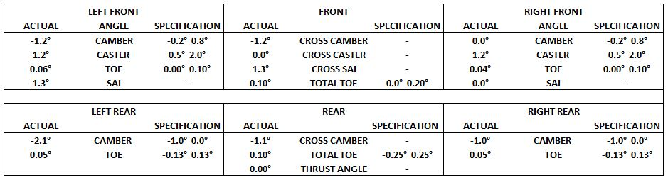

5. Two technicians are discussing the alignment results provided above. Technician A says that the vehicle will pull to the right. Technician B says that the vehicle will pull to the left. Who is correct?
☐ | a. | Technician A
☐ | b. | Technician B
☐ | c. | Both technicians A and B
☐ | d. | Neither technician A nor B

6. Where would a technician expect to see tire wear on this vehicle?
☐ | a. | On the right front
☐ | b. | On the left rear
☐ | c. | On the right rear
☐ | d. | All the choices listed

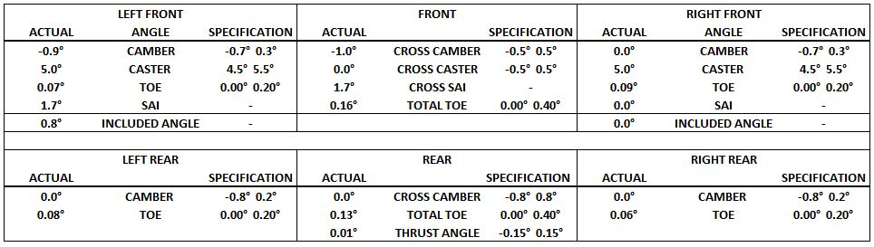

7. Two technicians are discussing the alignment results provided above. Technician A says that the vehicle will have tire wear on the right front of the vehicle. Technician B says that there will be tire wear on the left front. Who is correct?
☐ | a. | Technician A
☐ | b. | Technician B
☐ | c. | Both technicians A and B
☐ | d. | Neither technician A nor B

8. Two technicians are discussing the alignment results. Technician A says that the vehicle will pull to the left. Technician B says that vehicle will pull to the right. Who is correct?
☐ | a. | Technician A
☐ | b. | Technician B
☐ | c. | Both technicians A and B
☐ | d. | Neither technician A nor B

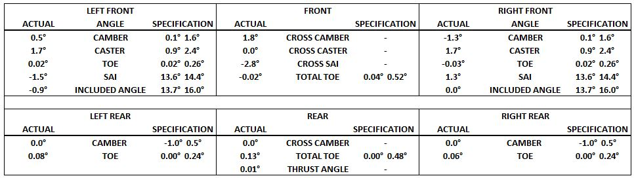

9. Where would the expected tire wear most likely occur?
☐ | a. | Left front
☐ | b. | Right front
☐ | c. | Left rear
☐ | d. | Right rear

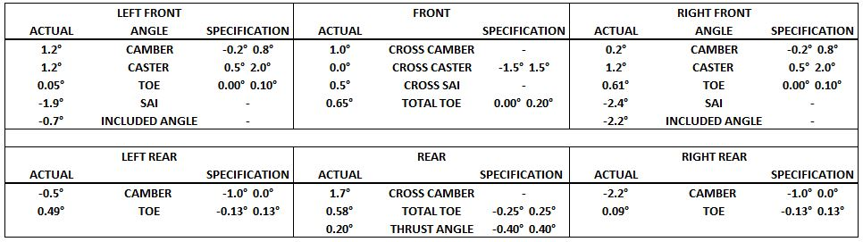

10. Two technicians are discussing the alignment results. Technician A says that there will be wear on the outside edge of the left, front tire. Technician B says that the right, rear tire will wear on the inside edge. Who is correct?
☐ | a. | Technician A
☐ | b. | Technician B
☐ | c. | Both technicians A and B
☐ | d. | Neither technician A nor B

