CDX Distance Learning
Exercise #19

DIN Wiring Diagram Diagnostics 1

Student Name: Click or tap here to enter text.
Understanding the wiring diagram is key to any electrical system diagnosis. Use the figure below to answer the following questions.

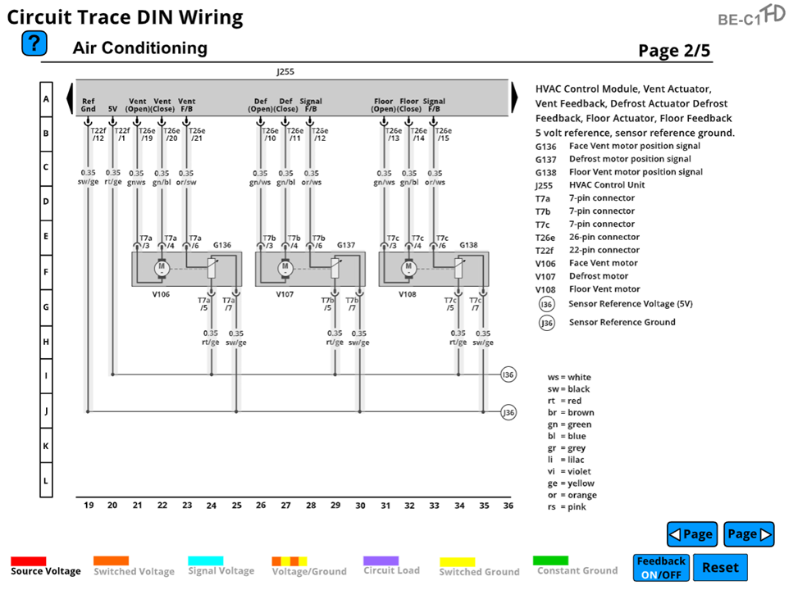

- When using wiring diagrams, the technician should be able to determine which pins they need to test to determine a system failure. In the wiring diagram, the face vent motor has a position error with a low voltage condition. Which pin is 5V reference for the sensing circuit on the face vent motor?
  - Pin T7a/4 ☐
  - Pin T7a/5 ☐
  - Pin T7a/6 ☐
  - Pin T7a/7 ☐

- If all the HVAC motors are indicating a feedback, low-side signal circuit failure, with which pin off of the J255 should the technician start their diagnosis?
  - Pin T22f/12 ☐
  - Pin T22f/1 ☐
  - Pin T26e/21 ☐
  - Pin T26e/15 ☐

- If the defrost motor is stuck in the open position and is indicating a DTC, how could the technician test to see if the ECM is trying to close the defrost vent?
  - The technician could look to see if there is a signal coming out of the ECM at pin T26e/11. ☐
  - The technician could do an ohm’s resistance check across the motor at pins T7b/3 and T7b/4. ☐
  - There is no check. The technician assumes the ECM is trying to correct the condition, so they just replace the motor. ☐
  - The technician could strike the motor to see if they can get it to work and then replace the motor. ☐

- If the plastic floor vent in the HVAC box becomes damaged and stuck, what will the floor vent motor indicate?
  - The floor motor will overcome any mechanical failure within the HVAC box. ☐
  - The HVAC module will indicate a mechanical failure of the HVAC box in a DTC. ☐
  - It will indicate a bad floor motor as everything electrical will be trying to work correctly. ☐
  - The HVAC module will adapt to a failed motor and adjust the others to compensate. ☐

- Using the wiring diagram legend to understand which components you are looking at is the first step in using wiring diagrams for diagnostics. Which component is indicated as V107?
  - HVAC module ☐
  - Defrost motor ☐
  - Face vent motor ☐
  - Floor vent motor ☐

- If one of the position sensors shorts the power feed to ground within the sensor, what can happen to the signal of the other sensors?
  - Since all the sensors use the same power feed, it could affect the output of the other sensors. ☐
  - Nothing, as each sensor is independent of every other sensor. ☐
  - The affected sensor will indicate the possibility of other issues within the sensor power-feed circuit. ☐
  - It will create an open within the power-feed circuit causing no feedback with no DTCs indicated. ☐

- Which of these labels indicate the ground circuit for all the signal feedback sensors?
  - I36 ☐
  - G136 ☐
  - V108 ☐
  - J36 ☐

- When using a DIN diagram, how does the technician know where the location of the component is on the wiring diagram?
  - The service information will indicate the position of the component based on a computer screen image of the system. ☐
  - Using the number scale on the bottom and the letter scale on the side, the technician can determine where the component is located on the schematic. ☐
  - The technician needs to just search for it throughout the whole set of wiring diagrams. ☐
  - The technician should just know which diagrams they should look at to find the required information. ☐

- When looking at a component, what does it indicate if the component has a solid line all the way around it without any indicators that other items are related?
  - It means that this image of the component includes all the wiring that this component has. ☐
  - It means the OEM has provided only part of the information for this component. ☐
  - It doesn’t mean anything; it is just a way to illustrate this component. ☐
  - That it is an integral component of the vehicle’s communication system. ☐

- What type of symbol is on the wiring diagram where the wires connect?
  - A dot that intersects both wires ☐
  - A space between two wires ☐
  - A pin at each module ☐
  - A u-shaped image ☐

