CDX Distance Learning
Exercise #19

DIN Wiring Diagram Diagnostics 2

Student Name: Click or tap here to enter text.

Understanding the wiring diagram is key to any electrical system diagnosis. Use the figure below to answer the following questions.
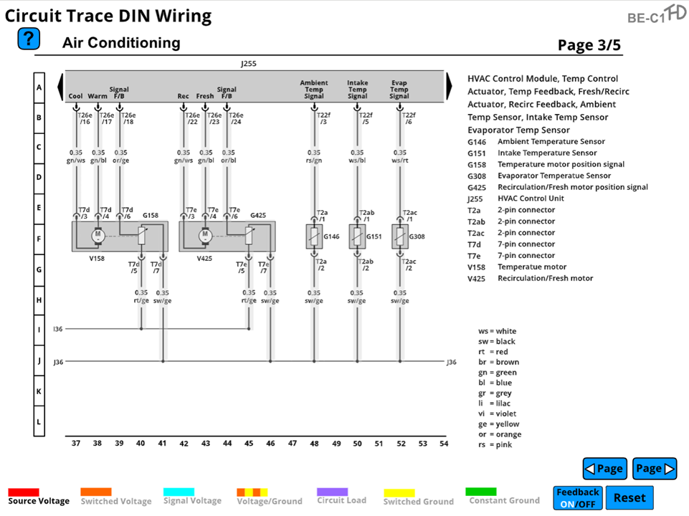

- What pin should the technician start with when diagnosing a signal failure DTC on an evaporator temperature sensor?
  - T22f/5 ☐
  - T22f/6 ☐
  - T22f/3 ☐
  - J36 ☐

- When the HVAC module calls for warm air in the cabin, which pin will it provide a signal to so that the temperature motor will provide the necessary movement?
  - T26e/17 ☐
  - T26e/16 ☐
  - T26e/18 ☐
  - T26e/22 ☐

- Which component on the wiring diagram is G151?
  - Ambient temperature sensor ☐
  - Intake temperature sensor ☐
  - Evaporator temperature sensor ☐
  - Temperature motor ☐

- What is the color of the fresh air control circuit on the V425 motor?
  - Gn/ws ☐
  - Ws/rt ☐
  - Rs/gn ☐
  - Gn/bl ☐

- Which pin on the V425 component is feedback for the HVAC module?
  - Pin T26e/24 ☐
  - Pin T26e/23 ☐
  - Pin T26e/22 ☐
  - Pin T26e/18 ☐

- When looking for issues with the ambient temperature connector, which pin should the technician be looking to evaluate?
  - T7e/6 ☐
  - G425 ☐
  - T2a ☐
  - T22f/3 ☐

- What connector is located at E-48 on the wiring diagram for this HVAC system?
  - T22f/3 ☐
  - T2ab/1 ☐
  - T2a/2 ☐
  - T2a/1 ☐

- When diagnosing a recirculation/fresh motor position signal fault, the technician should look at which wire of the recirculation/fresh air component?
  - Rt/ge ☐
  - Or/bl ☐
  - Gn/bl ☐
  - Gn/ws ☐

- What component is located at F-39 on the wiring diagram for this HVAC system?
  - Recirculation/Fresh Motor ☐
  - Evaporator Temperature Sensor ☐
  - Temperature Motor ☐
  - Ambient Temperature Sensor ☐

- When the HVAC module indicates a recirculation/fresh feedback signal fault, where should the technician start their diagnostic repair procedure?
  - T7e/4 ☐
  - T26e/24 ☐
  - T7e/6 ☐
  - T7e/3 ☐

