CDX Distance Learning
Exercise #21

Ohm’s Law/Electrical Testing

Student Name: Click or tap here to enter text.

Using the following image, complete the following exercises. Ohm’s law works for any electrical situation.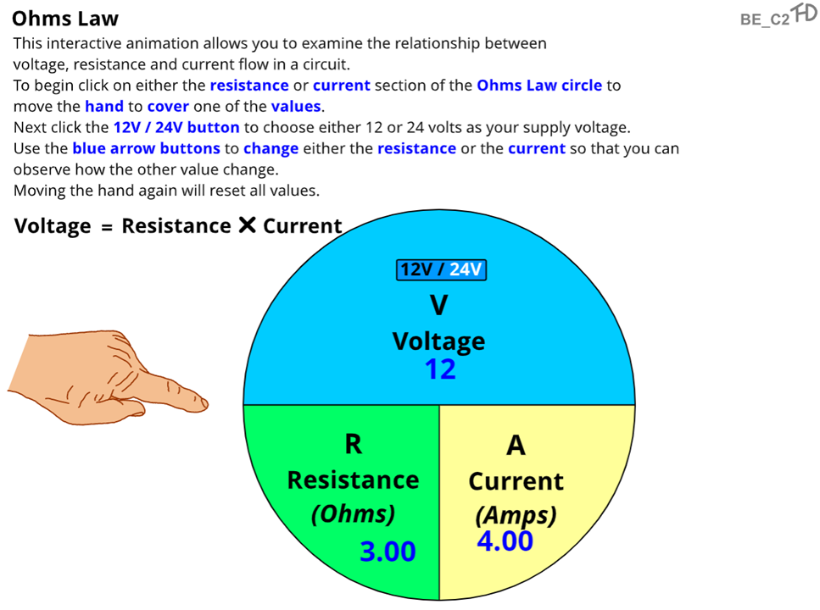

- A vehicle continuously blows the blower motor 20-amp fuse. The blower motor operates on the 12-volt system, and the resistance measurement of the blower motor is 0.4 ohms. Why is the vehicle blowing the fuse?

Click or tap here to enter text.

- A vehicle comes into your bay with an inoperative driver’s window motor. After you have removed the door panel and accessed the window motor, you determine that the motor’s resistance is 6 ohms and that the specification of the motor indicates that it will use 2 amps to operate. What voltage will the motor need to operate as designed?

Click or tap here to enter text.

- Using Ohm’s law, calculate the resistance of the circuit if the voltage is 24 volts and the amperage is 6 amps.

Click or tap here to enter text.

- Ohm’s law can help a technician determine the particulars of any circuit by using the formula to indicate the missing value. If you have a circuit that is powered with 18 volts and has three 2-ohms components in series, what is the actual amperage of the circuit?

Click or tap here to enter text.

- Not only can components cause a fuse to blow, but poor connections can also affect the circuit in a way that does not allow the components to operate properly. How can a poor connection cause poor component operation?

Click or tap here to enter text.

- Using Ohm’s law, calculate the voltage if the total circuit resistance is 6 ohms and the total circuit amperage is 6 amps.

Click or tap here to enter text.

- When determining the total resistance in a series circuit, what should the technician do? Explain how you would determine total resistance without using Ohm’s law.

Click or tap here to enter text.

- When using a voltmeter to measure the voltage drops of each load in the circuit, what should the total voltage be when you add all those voltage drops together?

Click or tap here to enter text.

- Calculate the voltage of the circuit if it has 6 amps and 10 ohms of resistance.

Click or tap here to enter text.

- Consider a dual head, low beam headlight circuit, where both low beam headlights are wired in series. When the right headlight power circuit fails, what happens to the left headlight?

Click or tap here to enter text.

- Calculate the resistance of the circuit if the voltage is 28 volts and amperage is 7 amps.

Click or tap here to enter text.

- When checking a relay coil for an open, what should the technician do to test the continuity of the circuit?

Click or tap here to enter text.

- When using a DMM to measure amperage within a circuit, what must the technician do with the DMM to get a reading?

Click or tap here to enter text.

- When doing a voltage drop on a ground circuit, what is the technician looking for if they find an excessive voltage drop of over 0.5 volts?

Click or tap here to enter text.

- What purpose does Ohm’s law provide for the technician in the field?

Click or tap here to enter text.

