CDX Distance Learning
Exercise #29

Drive Axle Service

Estimated Completion Time: 30–40 mins.
Student Name: Click or tap here to enter text.

Click the following link to access the service manual for a Spicer Drive Axle, model number S17-140. Use the manual and the images below to answer the following questions.

- Using the manual, explain the meaning of each of the letters and numbers in the model number.

Click or tap here to enter text.

- What is the pinion nut torque in foot-pounds (ft-lb) and newton meters (N·m)?

Click or tap here to enter text.

- What is the specified rotating torque reading in inch-pounds (in-lb) when pinion bearing preload is set?

Click or tap here to enter text.

- During the axle overhaul instructions, the names of the parts of the ring gear teeth are shown. What are the names of the numbered parts of the tooth pictured below?

Click or tap here to enter text.
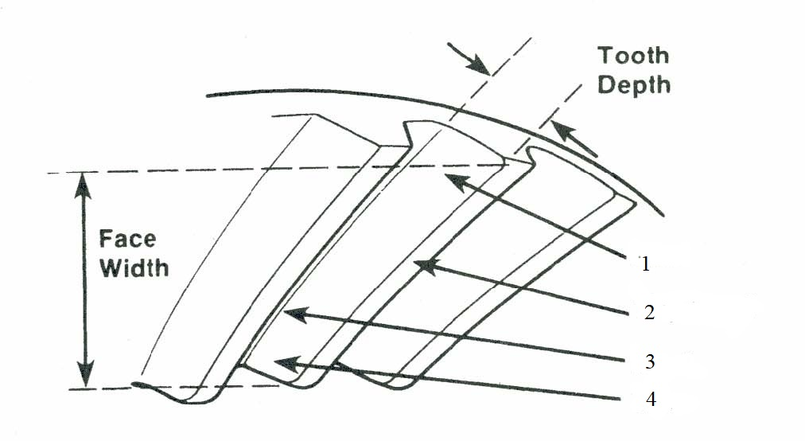
- What is the specification for ring gear total radial runout in inches (″) and millimeters (mm)?

Click or tap here to enter text.

- What is the specification for ring gear total backface runout in inches (″) and millimeters (mm)?

Click or tap here to enter text.

- If the contact pattern is incorrect, as shown below, what must be done to correct it?

Click or tap here to enter text.
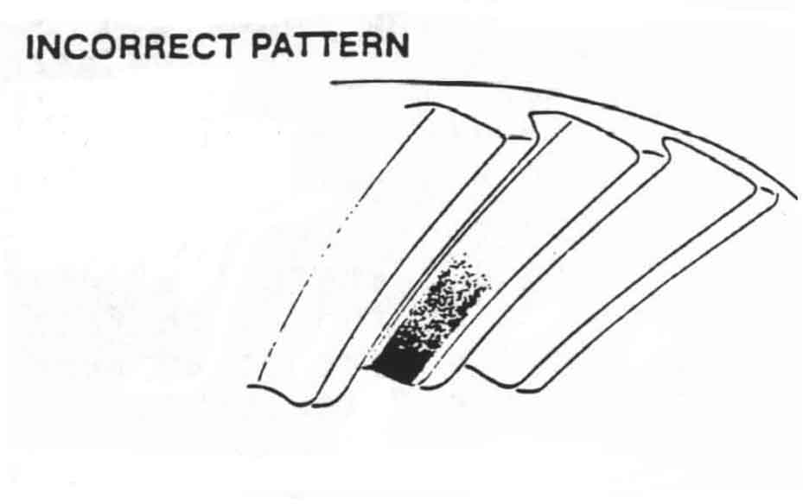
- If the contact pattern is incorrect, as shown below, what must be done to correct it?

Click or tap here to enter text.
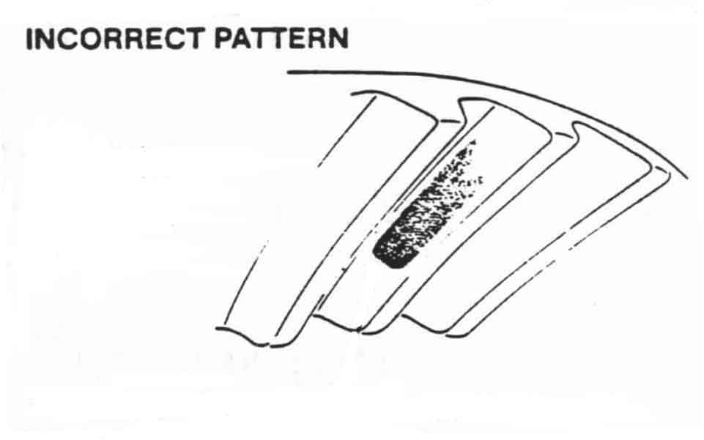
- What is the specified ring gear backlash setting in inches (″) and millimeters (mm)?

Click or tap here to enter text.

- What setting does the manual recommend you use for the ring gear backlash to allow for contact pattern adjustment in inches (″) and millimeters (mm)?

Click or tap here to enter text.

- What is the correct wheel end bearing endplay for this axle in inches (″) and millimeters (mm)?

Click or tap here to enter text.

- If the wheel ends do not have a fill plug, what is the recommended procedure to ensure that the lube levels in the wheel ends are sufficient?

Click or tap here to enter text.

