CDX Distance Learning
Exercise #30

Gear Ratio Calculations

Estimated Completion Time: 30 mins.
Student Name: Click or tap here to enter text.

Click or tap the check box next to the answer choice that best completes the statement or answers the question.

- When an input gear with 24 teeth is driving a countershaft driven gear with 48 teeth and a counter shaft second gear with 45 teeth is driving a mainshaft gear with 60 teeth, what gear ratio is produced? Round your calculations to two decimal places.
- 1.75:1 ☐
- 2.67:1 ☐
- 3.69:1 ☐
- 5.47:1 ☐

- How much torque will be present at the output shaft of the transmission in the above transmission scenario if the input torque is 1000 foot-pounds? Round your calculations to two decimal places.
- 1750.00 ft-lb ☐
- 2670.00 ft-lb ☐
- 666.00 ft-lb ☐
- 571.00 ft-lb ☐

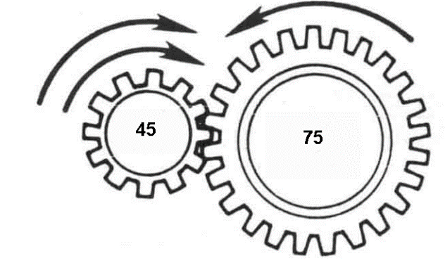
- A gear with 45 teeth rotating at 2700 rpm is driving a second gear with 75 teeth. Approximately how fast is the driven gear rotating? Round your calculations to two decimal places.
- 1616.77 rpm ☐
- 4509.00 rpm ☐
- 1620.00 rpm ☐
- 4500.00 rpm ☐

- The input gear in a transmission has 24 teeth, the countershaft driven gear has 40 teeth. The first gear countershaft has 12 teeth, and the mainshaft first has 36 teeth. What is the first gear ratio? Round your calculations to two decimals places.
- 1.00:5 ☐
- 0.55:1 ☐
- 1.80:1 ☐
- 5.00:1 ☐

- If input torque is 1000 foot-pounds, how much torque will be present at the output shaft when an input gear having 24 teeth is driving a countershaft driven gear with 36 teeth, and a counter shaft second gear with 45 teeth is driving a mainshaft gear with 72 teeth? Round up your answer to two decimal places.
- 270.00 ft-lb ☐
- 3750.00 ft-lb ☐
- 420.00 ft-lb ☐
- 2400.00 ft-lb ☐

- A gear with 48 teeth that is rotating at a speed of 400 rpm is driving another gear that has 78 teeth. How fast is the gear with 78 teeth rotating? Round your calculations to two decimal places.
- 245.40 rpm ☐
- 645.16 rpm ☐
- 652.00 rpm ☐
- 5.13 rpm ☐
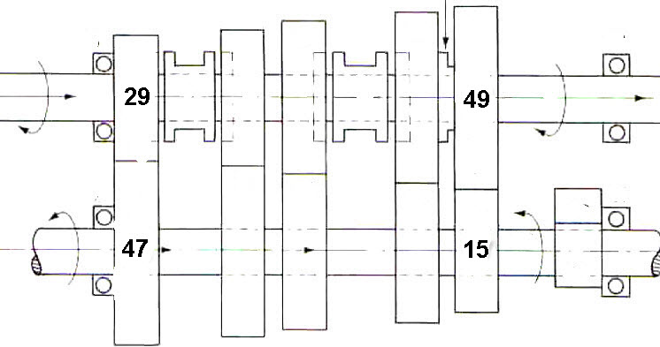

- The input gear in a transmission has 29 teeth, the countershaft driven gear has 47 teeth. The first gear countershaft has 15 teeth, and mainshaft first has 49 teeth. What is the first gear ratio? Round your calculations to two decimal places.
- 4.79:1 ☐
- 0.89:1 ☐
- 1.87:1 ☐
- 5.29:1 ☐

- The input gear in a transmission has 37 teeth, the countershaft driven gear has 43 teeth. The countershaft speed gear has 44 teeth, and the mainshaft speed gear has 36 teeth. What is the gear ratio? Round your calculations to two decimal places.
- 1.00:1 ☐
- 0.95:1 ☐
- 0.87:1 ☐
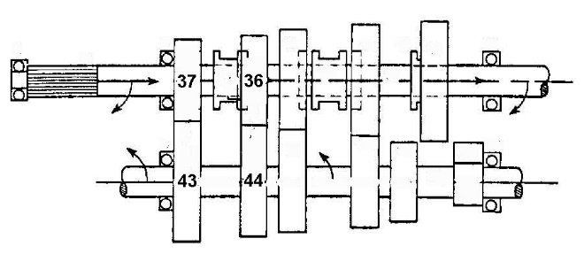
- 1.50:1 ☐
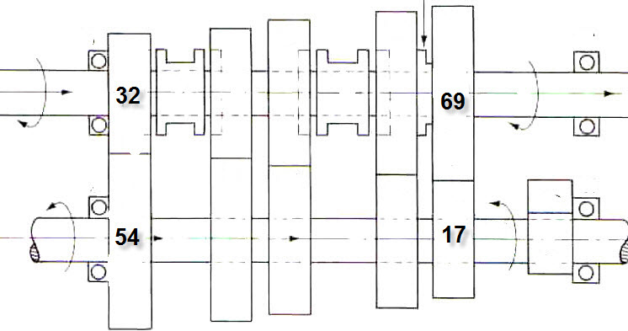

For the above drawing, the input speed is 1500 rpm and the input torque is 1300 foot-pounds. The number of teeth for the gears involved in the power flow are shown. Use the drawing to find the answers for the following three questions. Round your calculations to two decimal places.

- What is the ratio?
- 0.42:1 ☐
- 1.48:1 ☐
- 2.41:1 ☐
- 6.85:1 ☐

- What is the output speed?
- 218.98 rpm ☐
- 622.41 rpm ☐
- 1013.51 rpm ☐
- 3571.43 rpm ☐

- What is the output torque?
- 546.00 ft-lb ☐
- 8905.00 ft-lb ☐
- 3146.00 ft-lb ☐
- 1924.00 ft-lb ☐

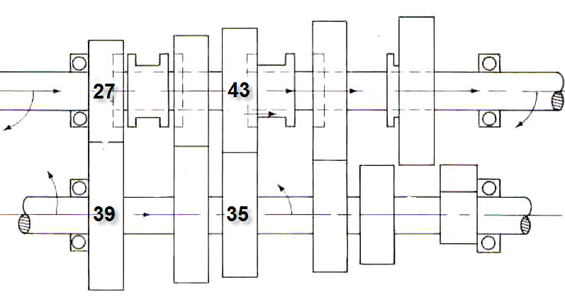

For the above drawing, the input speed is 2450 rpm and the input torque is 1250 foot-pounds. The number of teeth for the gears involved in the power flow are given. Use the drawing to find the answers to the following questions. Round your calculations to two decimal points

- What is the ratio?
- 0.70:1 ☐
- 0.85:1 ☐
- 1.43:1 ☐
- 1.78:1 ☐

13. What is the output speed?
- 1376.40 rpm ☐
- 1713.29 rpm ☐
- 2882.35 rpm ☐
- 3500.00 rpm ☐

14. What is the output torque?
- 875.00 ft-lb ☐
- 1062.50 ft-lb ☐
- 1787.50 ft-lb ☐
- 2225.00 ft-lb ☐

