CDX Distance Learning
Exercise #35

Power Steering Systems 1

Estimated Completion Time: 40–50 mins.
Student Name: Click or tap here to enter text.

Section 1:
Click this link to watch the Sheppard video, “Introduction to Power Steering.” Once you have watched the video, answer the following questions, or complete the following statements, by filling in the blank(s).

- When properly maintained, a power steering system should perform trouble free for the
truck.
Click or tap here to enter text.

2. When a power steering problem does occur, it can be the most Click or tap here to enter text. and Click or tap here to enter text. system.

3. Always refer to the Click or tap here to enter text. for complete repair procedures.

Section 2:
Click this link to watch the Sheppard video, “Steering Gear Identification.” Once you have watched the video, answer the following questions using the images provided.

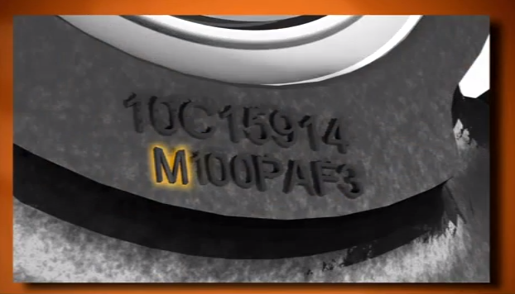
Figure 1
- What does the letter M indicate in Figure 1 above?

Click or tap here to enter text.

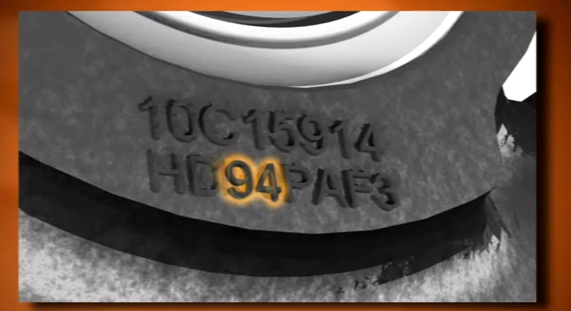
Figure 2
- What does the number 94 indicate in Figure 2 above?

Click or tap here to enter text.

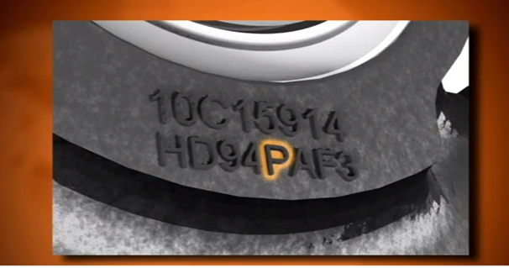
Figure 3
- What does the letter P indicate in Figure 3 above?

Click or tap here to enter text.

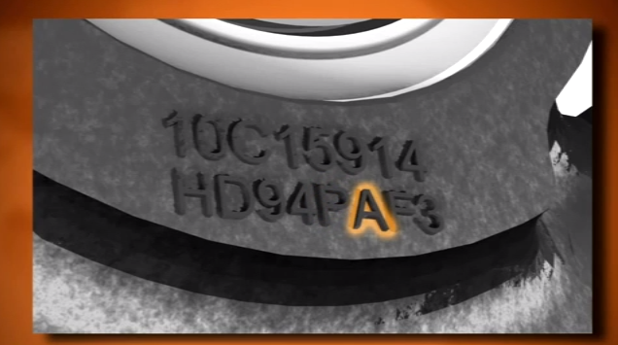
Figure 4
- What does the letter A indicate in Figure 4 above?

Click or tap here to enter text.

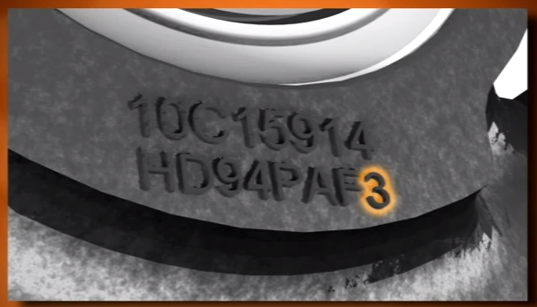
Figure 5
- What does the number 3 indicate in Figure 5 above?

Click or tap here to enter text.

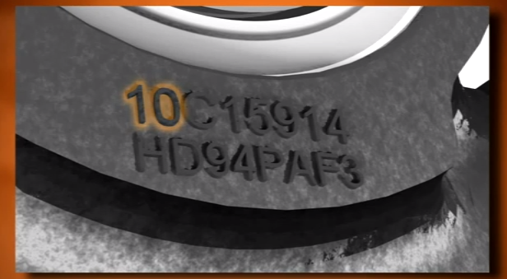
Figure 6
- What does the number 10 indicate in Figure 6 above?

Click or tap here to enter text.

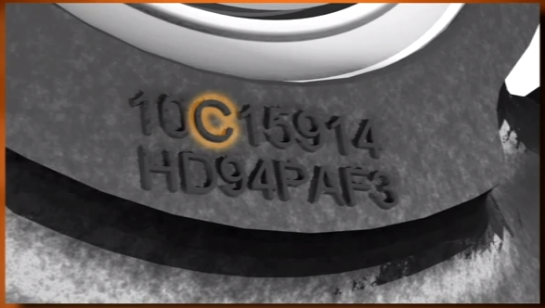
Figure 7
- What does the letter C indicate in Figure 7 above?

Click or tap here to enter text.

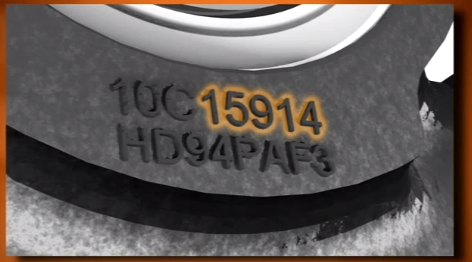
Figure 8
- What do the five number 15914 together indicate in figure 8 above?

Click or tap here to enter text.

Section 3:
Click this link to watch the Sheppard video, “Basic Steering Gear Operation.” Once you have watched the video, answer the following questions, or complete the following statements, by filling in the blank(s).

- The power steering gear input shaft is connected to the steering column ___________.

Click or tap here to enter text.

- The rotary valve is an _______ _______ valve that allows fluid to flow directly through the steering gear and back to reservoir in the neutral position.

Click or tap here to enter text.

- The rotary valve is supported both top and bottom by shims, washer, and ______ ________.

Click or tap here to enter text.

- The input shaft high pressure seal and the salt seal are located in the ______ ________ cover.

Click or tap here to enter text.

- The rotary shaft ball thread rotates within the _________ on 24 steel recirculating balls.

Click or tap here to enter text.

- The sector shaft rotates on two _____ ______, which are lubricated by the steering fluid.

Click or tap here to enter text.

- The sector pressure seals are located next to each _____.

Click or tap here to enter text.

- The sector shaft teeth engage with the _____ rack teeth.

Click or tap here to enter text.

- The pitman arm is mounted on the tapered splines of the _____ ______.

Click or tap here to enter text.

- The relief plungers are found in the bearing cap and _____ ______.

Click or tap here to enter text.

- The _____ ______ must be adjusted to obtain full turn angle or wheel cut of the steering.

Click or tap here to enter text.

- The _____ ______ prevent the axle stops from hitting the axle under full steering pump pressure.

Click or tap here to enter text.

- When the driver turns the steering wheel, the steering column rotates the steering box input shaft. This overcomes the resistance of the ___________, which opens the rotary valve.

Click or tap here to enter text.

- The more resistance encountered when turning the steering wheel, the more the rotary valve opens, and the more pressure from the pump is applied to the _____.

Click or tap here to enter text.

- Explain how fluid flows into and out of the steering gear when making a turn.

Click or tap here to enter text.

- Explain the purpose of the relief plunger and the relief ball.

Click or tap here to enter text.

- Explain what would happen if there is a loss of power steering pump pressure while driving.

Click or tap here to enter text.

Section 4:
Click this link to watch the TRW video, “ZF TRW ActivMode Energy Efficient Power Steering Pump.” Once you have watched the video, answer the following questions, or complete the following statements, by filling in the blank(s).

- The power steering pump operates in __________ stages.

Click or tap here to enter text.

- Describe how the pump operates in stage 1.

Click or tap here to enter text.

- Describe how the pump operates in stage 2.

Click or tap here to enter text.

- Describe how the pump operates in stage 3.

Click or tap here to enter text.

- Explain the over-pressurization safety feature that is built into the pump.

Click or tap here to enter text.

CDX Distance Learning
Exercise #35

Power Steering Systems 2

Estimated Completion Time: 20–30 mins.
Student Name: Click or tap here to enter text.

Click this link to watch the Sheppard video, “Maintenance Requirements & Checks.” Follow the instructions to develop a maintenance checklist using the table below.

- Develop a step-by-step checklist that includes inspection and maintenance steps covered in the video that you could use in the shop as a guide.

- Make sure to include all the safety steps as well.

3. Upload, copy and paste, or email it to your supervisor/instructor to receive your grade.

Power Steering Maintenance Checklist
Steps | Procedure

CDX Distance Learning
Exercise #35

Power Steering Systems 3

Estimated Completion Time: 15–20 mins.
Student Name: Click or tap here to enter text.

Click this link to watch the Sheppard video, “Bleeding Procedures.” Follow the instructions to develop a maintenance checklist using the table below.

- Develop a step-by-step checklist that includes the procedural steps covered in the video that you could use in the shop as a guide.

- Make sure to include all the safety steps as well.

- Upload, copy and paste, or email it to your supervisor/instructor to receive your grade.

Power Steering Bleeding Procedures
Steps | Procedure

CDX Distance Learning
Exercise #35

Power Steering Systems 4

Estimated Completion Time: 15–20 mins.
Student Name: Click or tap here to enter text.

Click this link to watch the Sheppard video, “Troubleshooting.” Follow the instructions to develop a maintenance checklist using the table below.

- Develop a step-by-step checklist that includes the procedural steps covered in the video that you could use in the shop as a guide.

- Make sure to include all the safety steps as well.

- Upload, copy and paste, or email it to your supervisor/instructor to receive your grade.

Power Steering Troubleshooting Procedure
Steps | Procedure

CDX Distance Learning
Exercise #35

Power Steering Systems 5

Estimated Completion Time: 15–20 mins.
Student Name: Click or tap here to enter text.

Click this link to watch the Sheppard video, “Troubleshooting Checklist.” Follow the instructions to develop a maintenance checklist using the form below. Once complete, answer the questions by clicking or tapping on the answer choice that best completes the statement or answers the question.

- Complete the checklist by entering results as they are measured using the analyzer in the video.

- Answer the questions pertaining to the test results.

- Upload, copy and paste, or email it to your supervisor/instructor to receive your grade.

Power Steering Troubleshooting Checklist

Engine Idle RPM Click or tap here to enter text. Engine Max RPM Click or tap here to enter text.
Oil Temperature Click or tap here to enter text. °F (Tests should be run at about 180° F)
System Backpressure @ Idle Click or tap here to enter text. PSI Backpressure @ Max RPM Click or tap here to enter text. PSI
Maximum System Pressure (Pump Relief Setting) at Idle Click or tap here to enter text. PSI at Max RPM Click or tap here to enter text.
PSI Flow@ Idle with Backpressure Only Click or tap here to enter text. GPM
Flow@ Max RPM Backpressure Only Click or tap here to enter text. GPM
Flow@ Idle With 1500 PSI Load Applied Click or tap here to enter text. GPM
Flow @ Max RPM With 1500 PSI Load Applied Click or tap here to enter text. GPM
Does Steering Gear Stay in Pressure when the Steering Wheel is Released? YES ☐ NO ☐
Static Steer Turning Pressure RIGHT Turn Click or tap here to enter text. PSI LEFT Turn Click or tap here to enter text. PSI
Relief Plunger Trip Pressure RIGHT Turn Click or tap here to enter text. PSI Pressure Drops Down to Click or tap here to enter text. PSI
Relief Plunger Trip Pressure LEFT Turn Click or tap here to enter text. PSI Pressure Drops Down to Click or tap here to enter text. PSI
Steering Gear Internal Leakage RIGHT Turn Click or tap here to enter text. PSI Click or tap here to enter text. GPM
Steering Gear Internal Leakage LEFT Turn Click or tap here to enter text. PSI Click or tap here to enter text. GPM
Static Steer Turning Input Effort RIGHT Turn Click or tap here to enter text. In-Lb LEFT Turn Click or tap here to enter text. In-Lb

Answer the questions below.

- What type of an effect will too low of engine idle have on the steering system?
  - Fast steering ☐
  - Hard steering ☐
  - Wandering ☐
  - No effect ☐

- When checking the steering fluid temperature, never exceed ______ °F.
  - 195 ☐
  - 275 ☐
  - 250 ☐
  - 150 ☐

- The system backpressure test will reveal if the system is ______.
  - Restricted ☐
  - Aerated ☐
  - Over heated ☐
  - Overloaded ☐

- The system backpressure should be less than ______ psi for a single steering gear.
  - 150 ☐
  - 75 ☐
  - 50 ☐
  - 1500 ☐

- When checking the maximum system pressure, you should close the valve on the analyzer until the gauge shows what?
  - 1500 psi ☐
  - 3100 psi ☐
  - Maximum flow ☐
  - Zero flow ☐

- When checking the maximum system pressure, you should close the valve on the analyzer for no longer than _____ seconds.
  - Three ☐
  - Six ☐
  - Thirty ☐
  - Fifteen ☐

- While checking the maximum system pressure, you find the pressure is well below specification. What does this indicate?
  - Restriction ☐
  - Failed pump ☐
  - Failed gear box ☐
  - Low fluid ☐

- When performing the flow at idle and flow at maximum rpm with 1500 psi load, you find that the flow is well below specification. What does this indicate?
  - Restriction ☐
  - Failed pump ☐
  - Failed gear box ☐
  - Low fluid ☐

- If the steering gear stays under pressure when the steering wheel is released, what does this indicate?
  - Steering column side loading ☐
  - High pump flow ☐
  - Failed gear box ☐
  - Restriction ☐

- When performing the static steer turning pressure test you find that the pressure exceeds pump relief pressure when turning to the right. What does this indicate?
  - Restriction ☐
  - Failed pump ☐
  - Failed gear box ☐
  - Binding steering linkage ☐

- While performing the steering gear internal leakage test, you find that the flow is greater than 1 GPM. What does this indicate?
  - Plugged filter ☐
  - Failed pump ☐
  - Failed gear box ☐
  - Binding steering linkage ☐

- When performing the static steer input effort, you find the rotating torque lumpy (40–150 in-lb). What does this indicate?
  - Phasing incorrect ☐
  - Failed pump ☐
  - Failed gear box ☐
  - Binding kingpins ☐
CDX Distance Learning
Exercise #35

Power Steering Systems 6

Estimated Completion Time: 30–60 mins.
Student Name: Click or tap here to enter text.

Click this link to watch the Sheppard video, “Relief Plunger Adjustment.” Follow the instructions to develop a maintenance checklist using the form below. Once complete, answer the questions by clicking or tapping on the answer choice that best completes the statement or answers the question.

- Develop a step-by-step checklist that includes the procedural steps covered in the video that you could use in the shop as a guide.

- Make sure to include all the safety steps as well.

- Answer the multiple choice questions.

- Upload, copy and paste, or email it to your supervisor/instructor to receive your grade.

Power Steering Relief Plunger Adjustment Checklist

Steps | Procedure
 | Setting Auto Plungers
6.

 | Setting Manual Plungers

Answer the questions below.

- When discussing steering gears, Technician A says that all steering gears, including slave gears, use relief plungers. Technician B says relief plungers unload steering system pressure prior to the axle stops contacting the axle. Who is correct?
  - Technician A ☐
  - Technician B ☐
  - Both Technician A and Technician B ☐
  - Neither Technician A nor Technician B ☐

- Technician A says relief plungers prevent the power steering pump from operating at maximum relief pressure at the end of steering travel. Technician B says the relief plungers prevent the power steering pump from operating at maximum relief pressure throughout entire steering gear travel. Who is correct?
  - Technician A ☐
  - Technician B ☐
  - Both Technician A and Technician B ☐
  - Neither Technician A nor Technician B ☐

- Technician A says relief plungers are adjusted at the factory and do not require adjustment. Technician B says that only manual relief plungers require adjustment. Who is correct?
  - Technician A ☐
  - Technician B ☐
  - Both Technician A and Technician B ☐
  - Neither Technician A nor Technician B ☐

- When discussing the auto plunger reset procedure, Technician A says keep the punch straight to prevent scoring of plunger bore. Technician B says that if the plunger bore is scored, it cannot be repaired. Who is correct?
  - Technician A ☐
  - Technician B ☐
  - Both Technician A and Technician B ☐
  - Neither Technician A nor Technician B ☐

CDX Distance Learning
Exercise #35

Power Steering Systems 7

Estimated Completion Time: 20–30 mins.
Student Name: Click or tap here to enter text.

Complete the case study below.

- Review the technician’s notes.

- Make a recommendation of what you think is wrong with the system.

- Make sure to include a detailed explanation on how you came about your recommendation.

- Upload, copy and paste, or email it to your supervisor/instructor to receive your grade.

A technician in your shop has finished his shift and left you this note on a truck with a steering problem he is working on.

Customer complaint: Truck steers hard to the right but good to the left, loaded or unloaded.

Verify: I test drove the truck with the customer and verified that the truck does in fact steer hard to the right.

Visual inspection: I performed a visual inspection of the truck and everything appears to be in good operating condition.

Troubleshooting checks: I performed all troubleshooting steps and the steering column, steering shaft, steering linkage, steering gear, pitman arm, drag link, steering knuckles, king pins, tie rods, suspension components, and fifth wheel all are in good shape.

Troubleshooting checklist: I hooked up the power steering analyzer and performed the following checks:

Engine Idle RPM 750 Engine Max RPM 1850
Oil Temperature 180 °F (Tests should be run at about 180° F)
System Backpressure @ Idle 0 PSI Backpressure @ Max RPM 15 PSI
Maximum System Pressure (Pump Relief Setting) at Idle _2650_ PSI at Max RPM _2650_ PSI
Flow@ Idle with Backpressure Only _4__ GPM
Flow@ Max RPM Backpressure Only _5__ GPM
Flow@ Idle With 1500 PSI Load Applied _4_ GPM
Flow @ Max RPM With 1500 PSI Load Applied _4_ GPM
Does Steering Gear Stay in Pressure when the Steering Wheel is Released? YES __ NO __X_
Static Steer Turning Pressure RIGHT Turn _750__ PSI LEFT Turn _1000__ PSI
Relief Plunger Trip Pressure RIGHT Turn _750 PSI Pressure Drops Down to _600 PSI
Relief Plunger Trip Pressure LEFT Turn __1200___ PSI Pressure Drops Down to 600 PSI
Steering Gear Internal Leakage RIGHT Turn __750__ PSI __2__ GPM
Steering Gear Internal Leakage LEFT Turn __2650___ PSI __0___ GPM
Static Steer Turning Input Effort RIGHT Turn __45___ In-Lb LEFT Turn ___45__ In-Lb

Recommendation:

Click or tap here to enter text.

