CDX Distance Learning
Exercise #42

Air Conditioning Kahoot!

Student Name: Click or tap here to enter text.

Visit the Kahoot! website at: https://kahoot.com/.

- If you do not have an account, you will need to sign up for one. Instructions are included in a previous release titled “Using Kahoot!”

- Begin at the home screen by clicking the top left Home button, as pictured below.

- Go to the search bar, where it says: “Find me a kahoot about…”
Type CDX_Learning_Systems into the search bar.

- You will see many Kahoot! choices from which to select. They are organized by textbook title, ASE area, or concept. You should look for “CDX MAST A7.”

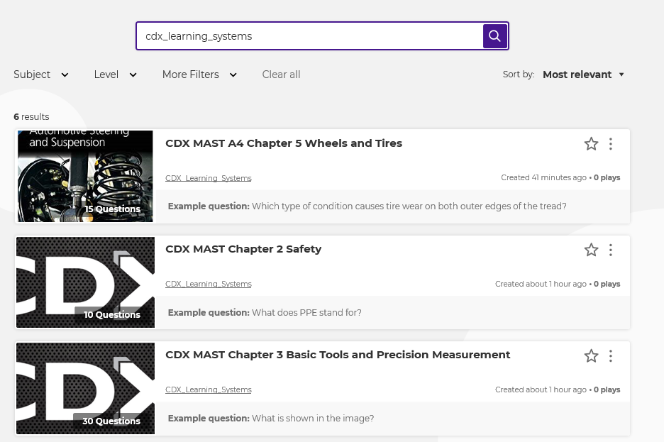

- The updated Kahoot! list is included below. All of the listed subjects are ready for play!

ASE A7 Automotive Heating, Ventilation, and Air Conditioning Subjects:

- CDX MAST A7 Chapter 2: History and Safety Procedures of Mobile HVAC Systems
- CDX MAST A7 Chapter 3: Operating Principles, Heat Transfer and Temperature/Pressure Relationship
- CDX MAST A7 Chapter 4: Refrigeration Cycle and Basic Component Operation
- CDX MAST A7 Chapter 5: Environmental and Legal Concerns and Responsibilities
- CDX MAST A7 Chapter 6: HVAC System Tools for System Repairs
- CDX MAST A7 Chapter 7: AC Refrigerant and Refrigerant Oil
- CDX MAST A7 Chapter 8: AC Compressor Design, Operation, and Controls
- CDX MAST A7 Chapter 9: Restrictions, Accumulators, and Driers
- CDX MAST A7 Chapter 10: Heat Exchangers, Hoses, Lines, Fittings, and Seals
- CDX MAST A7 Chapter 11: AC System Inspection, Diagnosis, and Repair Controls
- CDX MAST A7 Chapter 12: AC System Recovery, Recycling, Evacuation, and Recharge
- CDX MAST A7 Chapter 13: Thermal Management Systems and Components
- CDX MAST A7 Chapter 14: Thermal Management System Inspection, Diagnosis, and Repair
- CDX MAST A7 Chapter 15: Air Distribution and Control System Operation
- CDX MAST A7 Chapter 16: Air Management and Control System Inspection, Diagnosis, and Repair
- CDX MAST A7 Chapter 17: Emerging Mobile HVAC and Thermal Management Technology

