CDX Distance Learning
Exercise #48

Automatic Transmission and Transaxle Kahoot!

Student Name: Click or tap here to enter text.

Visit the Kahoot! website at: https://kahoot.com/.
- If you do not have an account, you will need to sign up for one. Instructions are included in a previous release titled “Using Kahoot!”

- Begin at the home screen by clicking the top left Home button, as pictured below.

- Go to the search bar, where it says “Find me a kahoot about…”
Type CDX_Learning_Systems into the search bar.

- You will see many Kahoot! from which to select. They are organized by textbook title, ASE area, or concept. You should look for the image of the textbook cover you are using. You can add terms (such as A4) to the search to narrow the results.

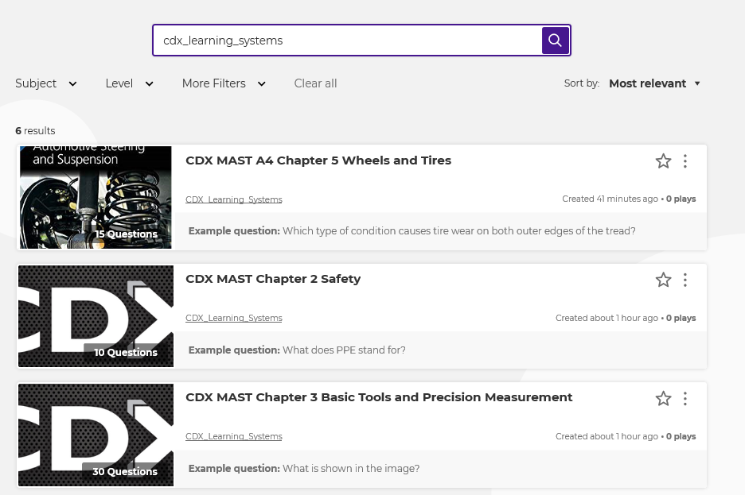

- The updated Kahoot list is attached. All of the listed subjects are ready for play!

Multiple subject content:

- CDX MAST Chapter 1: Strategy-Based Diagnosis
- CDX MAST Chapter 2: Safety
- CDX MAST Chapter 3: Basic Tools and Precision Measurement
- CDX MAST Chapter 4: Fastener and Thread Repair

ASE A1 Automotive Engine Repair:

- CDX MAST A1 Chapter 5: Engine Design Fundamentals
- CDX MAST A1 Chapter 6: Engine Mechanical Testing
- CDX MAST A1 Chapter 7: Lubrication Systems
- CDX MAST A1 Chapter 8: Engine Cooling systems
- CDX MAST A1 Chapter 9: Engine Systems Maintenance and Repair
- CDX MAST A1 Chapter 10: Engine Removal and Installation
- CDX MAST A1 Chapter 11: Engine Disassembly
- CDX MAST A1 Chapter 12: Engine Block Design and Usage
- CDX MAST A1 Chapter 13: Crankshaft and Bearings
- CDX MAST A1 Chapter 14: Pistons, Rings, and Connecting Rods
- CDX MAST A1 Chapter 15: Camshafts, Valvetrains, and Balance Shafts
- CDX MAST A1 Chapter 16: Timing Chains, VVT, Timing Belt, and Cylinder Deactivation
- CDX MAST A1 Chapter 17: Cylinder Head Design and Service
- CDX MAST A1 Chapter 18: Intake and Exhaust Systems Design
- CDX MAST A1 Chapter 19: Supercharging and Turbocharging Theory
- CDX MAST A1 Chapter 20: Engine Machining
- CDX MAST A1 Chapter 21: Engine Cleaning and Crack Detection
- CDX MAST A1 Chapter 21: Gaskets, Seals, and Sealants
- CDX MAST A1 Chapter 23: Balancing and Blueprinting
- CDX MAST A1 Chapter 24: Engine Assembly
- CDX MAST A1 Chapter 25: Engine Installation and Break In
- CDX MAST A1 Chapter 26: Engine Failure Diagnosis and Service
- CDX MAST A1 Chapter 27: Diesel Engine Theory

ASE A2 Automatic Transmission and Transaxle:

- CDX MAST A2 Chapter 5: Vehicle, Customer, and Service Information
- CDX MAST A2 Chapter 6: Automatic Transmission Fundamentals
- CDX MAST A2 Chapter 7: Transmission Components
- CDX MAST A2 Chapter 8: Hydraulic Fundamentals
- CDX MAST A2 Chapter 9: Torque Converter Principles
- CDX MAST A2 Chapter 10: Hydraulically Controlled Transmission
- CDX MAST A2 Chapter 11: Electronically Controlled Transmission
- CDX MAST A2 Chapter 12: In-Vehicle Transmission Repairs
- CDX MAST A2 Chapter 13: Transmission Removal
- CDX MAST A2 Chapter 14: Transmission Disassembly
- CDX MAST A2 Chapter 15: Hydraulic System Rebuilding
- CDX MAST A2 Chapter 16: Gear Train Rebuild
- CDX MAST A2 Chapter 17: Valve Body and Electric Service
- CDX MAST A2 Chapter 18: Transmission Reassembly
- CDX MAST A2 Chapter 19: Transmission Reinstallation
- CDX MAST A2 Chapter 20: Dual Clutch Transmissions
- CDX MAST A2 Chapter 21: CVT Transmissions
- CDX MAST A2 Chapter 22: Hybrid Transmissions
- CDX MAST A2 Chapter 23: Honda Transmissions
- CDX MAST A2 Chapter 24: Chrysler 6 Speed 62TE Transmission
- CDX MAST A2 Chapter 25: 6T40 6F35 Transmission
- CDX MAST A2 Chapter 26: ZF 9HP Chrysler 948TE Transmission
- CDX MAST A2 Chapter 27: Ford 6R60/ZF6HP26
- CDX MAST A2 Chapter 28: Allison 1000 and 2000 Series Transmissions

ASE A4 Suspension and Steering Systems Subjects:

- CDX MAST A4 Chapter 5: Wheels and Tires
- CDX MAST A4 Chapter 6: Tire Pressure Monitoring Systems (TPMS)
- CDX MAST A4 Chapter 7: Tire and Wheel Diagnosis and Service
- CDX MAST A4 Chapter 8: Wheel Bearing and Seal Service
- CDX MAST A4 Chapter 9: Suspension Systems
- CDX MAST A4 Chapter 10: Front and Rear Suspension Diagnosis and Service
- CDX MAST A4 Chapter 11: Steering Systems
- CDX MAST A4 Chapter 12: Steering Diagnosis and Service
- CDX MAST A4 Chapter 13: Wheel Alignment Principles and Adjustments
- CDX MAST A4 Chapter 14: Wheel Alignment Adjustments
- CDX MAST A4 Chapter 15: Drive Axle Shafts and CV Joints

ASE A5 Brake Systems Subjects:

- CDX MAST A5 Chapter 2: Principles of Braking
- CDX MAST A5 Chapter 3: Hydraulic Brake Systems
- CDX MAST A5 Chapter 4: Disc Brake Systems
- CDX MAST A5 Chapter 5: Drum Brake Systems
- CDX MAST A5 Chapter 6: Refinishing Brake Rotors and Drums
- CDX MAST A5 Chapter 7: Parking Brakes
- CDX MAST A5 Chapter 8: Power-Assist Systems
- CDX MAST A5 Chapter 9: Wheel Bearing and Seal Service
- CDX MAST A5 Chapter 10: Hybrid Vehicle Braking Systems
- CDX MAST A5 Chapter 11: Advanced Braking Systems: Electronic Brake Controls
- CDX MAST A5 Chapter 12: Electronic Stability Control Systems

ASE A7 Automotive Heating Ventilation, and Air Conditioning Subjects:

- CDX MAST A7 Chapter 2: History and Safety Procedures of Mobile HVAC Systems
- CDX MAST A7 Chapter 3: Operating Principles, Heat Transfer, and Temperature/Pressure Relationship
- CDX MAST A7 Chapter 4: Refrigeration Cycle and Basic Component Operation
- CDX MAST A7 Chapter 5: Environmental and Legal Concerns and Responsibilities
- CDX MAST A7 Chapter 6: HVAC System Tools for System Repairs
- CDX MAST A7 Chapter 7: AC Refrigerant and Refrigerant Oil
- CDX MAST A7 Chapter 8: AC Compressor Design, Operation, and Controls
- CDX MAST A7 Chapter 9: Restrictions, Accumulators, and Driers
- CDX MAST A7 Chapter 10: Heat Exchangers, Hoses, Lines, Fittings, and Seals
- CDX MAST A7 Chapter 11: AC System Inspection, Diagnosis, and Repair Controls
- CDX MAST A7 Chapter 12: AC System Recovery, Recycling, Evacuation, and Recharge
- CDX MAST A7 Chapter 13: Thermal Management Systems and Components
- CDX MAST A7 Chapter 14: Thermal Management System Inspection, Diagnosis, and Repair
- CDX MAST A7 Chapter 15: Air Distribution and Control System Operation
- CDX MAST A7 Chapter 16: Air Management and Control System Inspection, Diagnosis, and Repair
- CDX MAST A7 Chapter 17: Emerging Mobile HVAC and Thermal Management Technology

