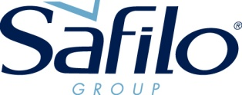

SAFILO ANNOUNCES PPE PROTECTIVE EYEWEAR SOLUTIONS PROGRAM
FOR EYECARE PROFESSIONALS AND RETAIL PARTNERS
IN THE U.S. AND CANADA

#UNITED4EYECARE

SECAUCUS (NJ) – May 07, 2020 – Safilo announces a PPE Protective Eyewear Solutions program developed for eyecare professionals and retail partners in the United States and Canada who are in need of protection for their office and store personnel, as they re-enter the workplace, as well as options to sell to their customers.

Born out of critical necessity for PPE eyewear as ECP offices and retailers reopen across North America, Safilo has quickly industrialized a quality range of affordable, durable and even stylish protective eyewear solutions, in its own manufacturing facilities in the U.S. and Italy, leveraging on Safilo’s expertise as a leader in premium and performance sport eyewear segments.

Safilo’s PPE Protective Eyewear Solutions program will consist of a select range of four items with a focus on speed to market. One will be offered under the Safilo corporate logo which will be widely available for ECPs. Additional options for Safilo’s Smith and Polaroid brands will also be offered. The collection will include three full face shields, one with a wrap-around goggle with an optional Rx compatible ocular docking station, and one safety shield option.

All can be pre-ordered through the company starting May 15 with shipping starting from June.

THE RANGE

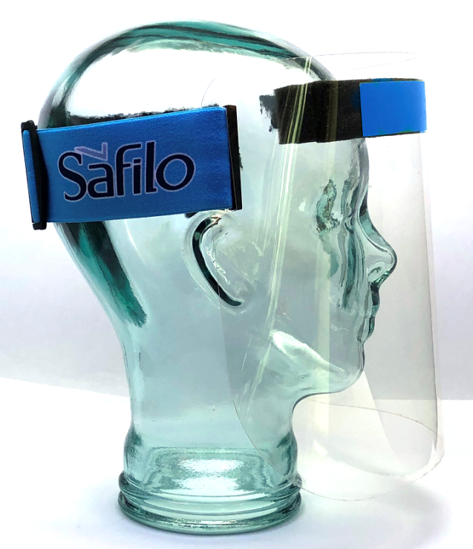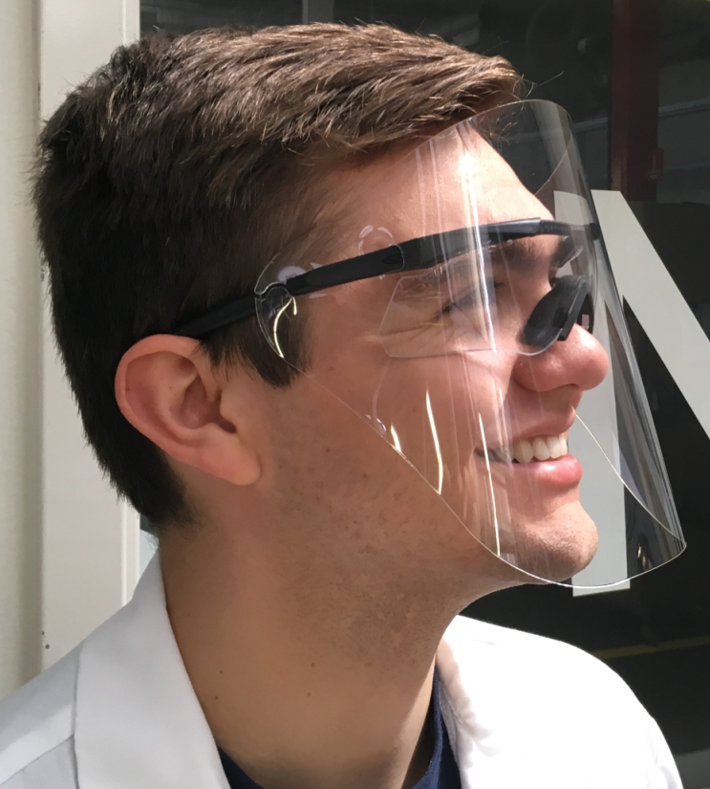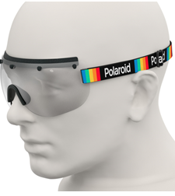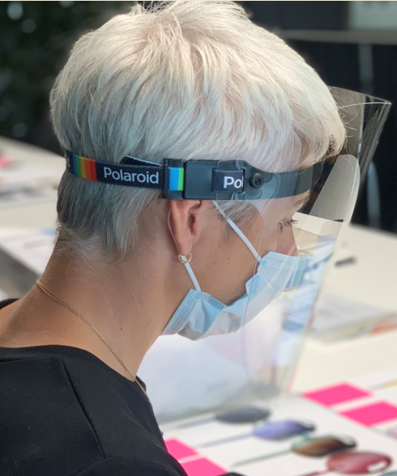
Shield by Safilo Aegis Face Shield by Smith Polaroid STAYSAFE1 Polaroid STAYSAFE2

SHIELD BY SAFILO – A full-coverage, high-clarity and anti-fog face shield that is compatible with N95 face masks and branded with the Safilo corporate logo at the top and on the adjustable head strap. The shield is medical-approved, meeting ANSI z87.1 “splash certification requirements” and EN166 shield requirements.
Price: US: $19.80 (MSRP)/$9.90 (WHSL) CAN: $30.00 (MSRP)/$14.00 (WHSL)

AEGIS FACE SHIELD BY SMITH – A combination offer that includes a full-coverage face shield with a high-clarity anti-fog lens that is compatible with N95 face masks. The detachable face shield can be mounted onto Smith’s Aegis wraparound frame outfitted with clear lenses and is Rx-compatible with Smith’s Ocular Docking Station. Medical-approved, the shield meets ANSI z87.1 “splash certification requirements,” and EN166 shield requirements.
Price: US: $90.00 (MSRP)/$45.00 (WHSL) CAN: $110.00 (MSRP)/$55.00 (WHSL)

The Shield by Safilo and the Aegis Face Shield by Smith are both being domestically assembled in Safilo’s own Smith manufacturing facility in Clearfield, UT, which received confirmation from the Defense Industrial Base Essential Critical Infrastructure Workforce to remain open to support existing military contracts:

POLAROID STAY SAFE COLLECTION
Two options from Safilo Group’s Polaroid STAY SAFE collection, available globally, will be offered in North America as part of the overall program. These are the first two PPE devices developed by Polaroid to offer protection and safety in healthcare and professional settings but also to meet the daily protection needs for patients/end consumers and will be part of a complete range of Polaroid Eyewear personal protection products.

STAYSAFE1 is the first professional safety eyewear by Polaroid designed to effectively protect the eyes of the wearer. These transparent wraparound shield glasses cover the eye area and offer a comfortable adjustable rubber band personalized with the Polaroid logo and the distinctive rainbow symbol. PPE certified, the visor is made from polycarbonate with Polyamide nose pads.
Price: US: $35.00 (MSRP)/$16.00 (WHSL) CAN: $50.00 (MSRP)/$22.00 (WHSL)

STAYSAFE2 is the first professional face shield by Polaroid designed to protect the face, eyes nose and mouth, from external factors. Particularly suited for professional use, STAYSAFE2 is PPE certified. The visor is made from polycarbonate while the rubber band is adjustable.
Price: US: $35.00 (MSRP)/$16.00 (WHSL) CAN: $50.00 (MSRP)/$22.00 (WHSL)

Made in Italy as well as Made by Safilo, both Polaroid options are produced in Safilo Group’s Italian manufacturing facilities in Santa Maria di Sala (Veneto) and Brembate di Sopra (Bergamo), which were converted to make PPE. The new devices comply with the UNI EN 166 standards, and 10,000 glasses and shields have already been donated to hospitals in the hardest hit areas of Italy and Spain, in order to support health care workers at the forefront of the pandemic.

HOW TO ORDER:
The four items will be available mid-May to pre-order in the following ways: by contacting their local Safilo sales representative, ordering online via Safilo’s b2b websites in the U.S. and Canada on mysafilo.com or mysafilocanada.com, respectively or by calling Safilo’s customer care centers 1-800-631-1188 (USA) and 1-800-387-7234 (Canada).

“Our dedication and commitment to offering quality eyewear, and now quality protective eyewear, to our customers has never been stronger,” said Steve Wright, President and Chief Commercial Officer of Safilo North America. “We are honored to be in a position to help and to make a difference – leveraging on the capabilities of our own factories – to present a range of affordable and durable protective eyewear for the safety of our customers and the eyewear community at large,” added Wright.

#wearehereforyou #wearebackforyou

About Safilo Group
Safilo Group is a worldwide leader in the design, manufacturing and distribution of sunglasses, optical frames, sports eyewear and related products. Thanks to strong craftsmanship expertise dating back to 1878, Safilo translates its designs into high-quality products according to the Italian tradition. Through an extensive wholly owned network of subsidiaries in 40 countries and more than 50 distribution partners in key markets throughout North and Latin America, Europe, Africa, the Middle East, Asia Pacific and China, Safilo is committed to quality distribution of its products in nearly 100,000 selected points of sale worldwide. Safilo’s portfolio encompasses its own core brands Carrera, Polaroid, Smith, Safilo, Privé Revaux, and licensed brands Dior, Dior Homme, Fendi, Banana Republic, BOSS, David Beckham, Elie Saab, Fossil, Givenchy, havaianas, HUGO, Jimmy Choo, Juicy Couture, kate spade new york, Levi’s, Liz Claiborne, Love Moschino, Marc Jacobs, Max Mara., Missoni, M Missoni, Moschino, Pierre Cardin, rag&bone, Rebecca Minkoff, Saks Fifth Avenue, Swatch, and Tommy Hilfiger.

Listed on the Italian Stock Exchange (ISIN code IT0004604762, Bloomberg SFL.IM, Reuters SFLG.MI), in 2019 Safilo recorded net revenues for Euro 939 million.

Contacts:

Safilo Group Press Office Safilo North America
Antonella Leoni Eden Wexler
Milan – Ph. +39 02 77807607 Eden.Wexler@safilo.com
Padua – Ph. +39 049 6986021



