This is your BOLD and BIG headline for this!
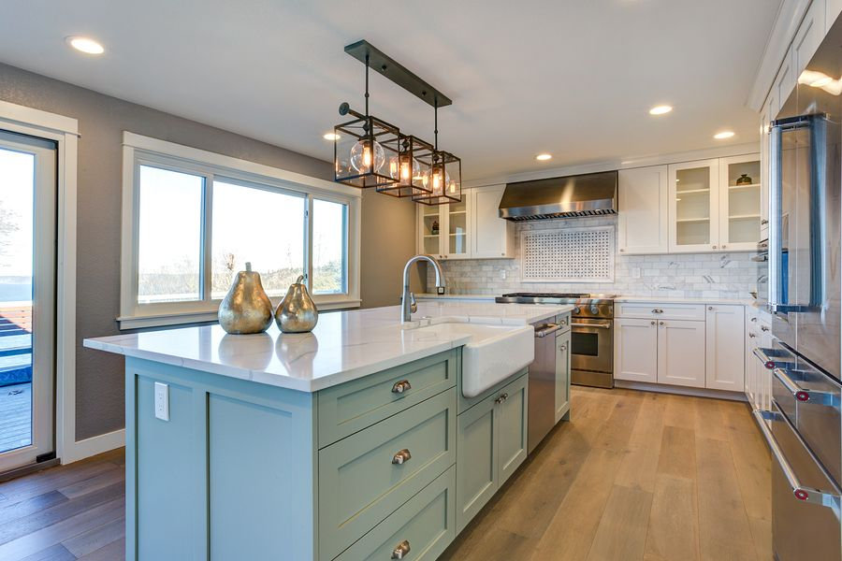
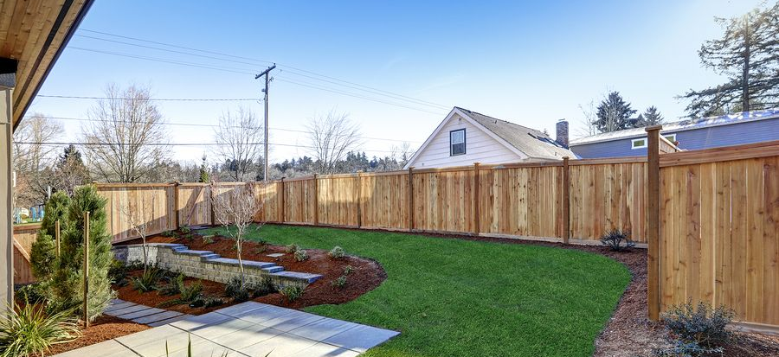
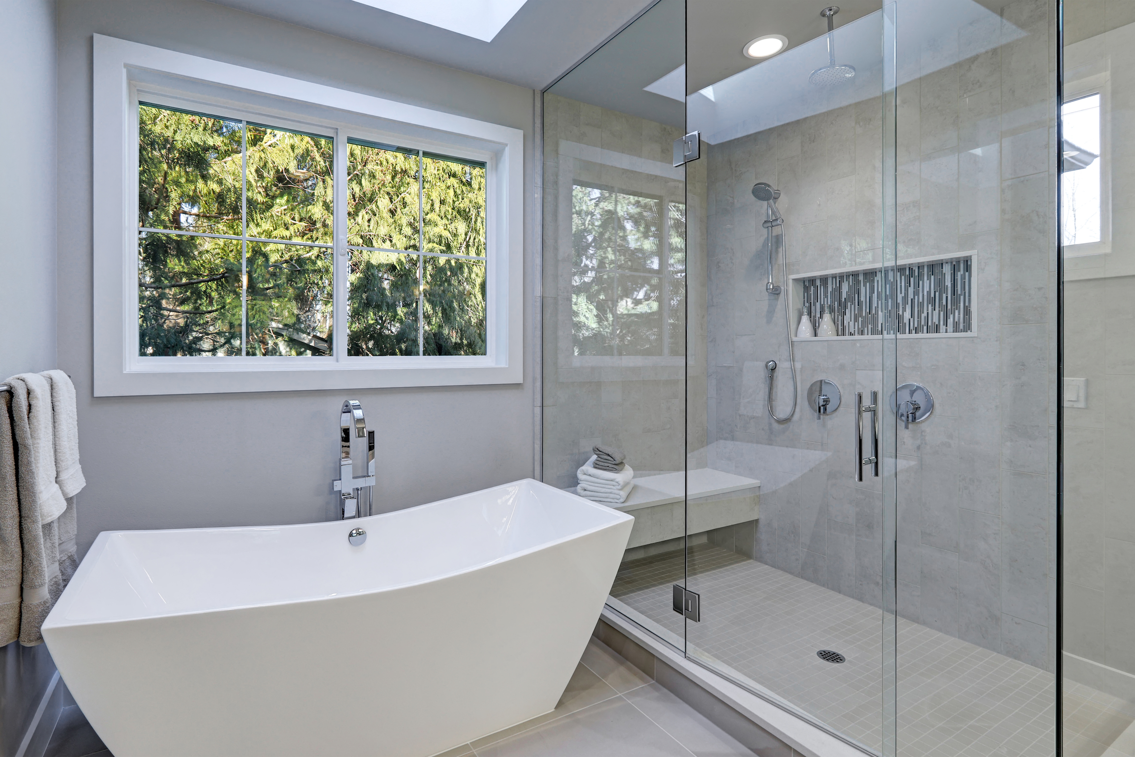
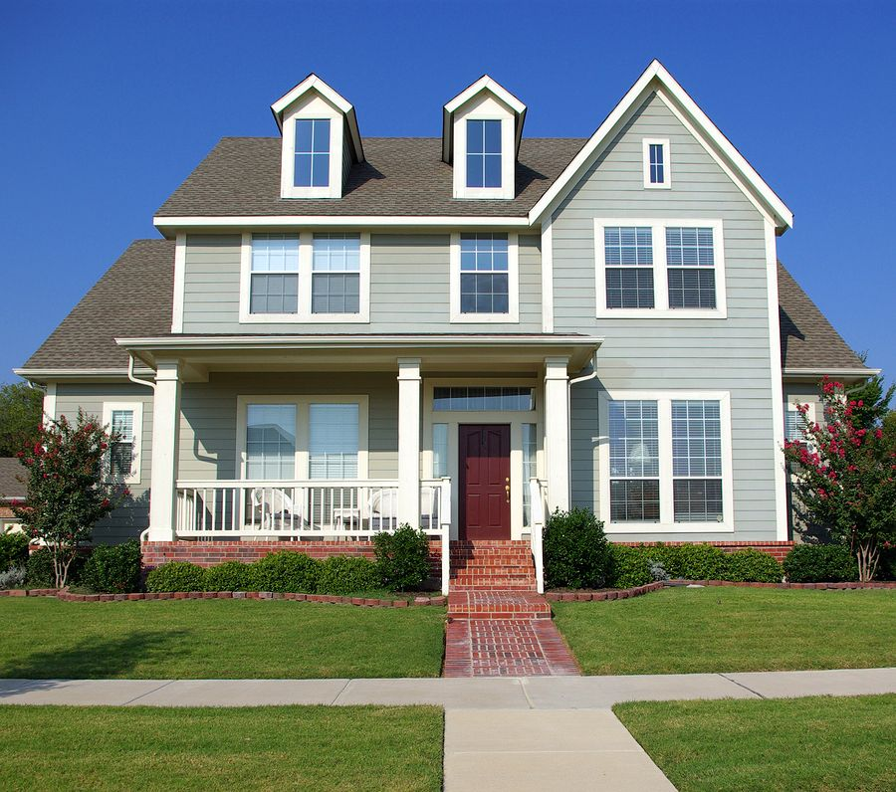
Fall in love with this (# of stories) story fully remodeled (property type) within walking distance of the (Local Attraction). Situated in the (pick an adjective: friendly/peaceful/bustling/popular/hot) (Neighborhood/Street) of (city), this (#of beds) bedroom, (# of bathrooms) bathroom home is move-in ready. With (square footage) and plenty of modern amenities like (amenity 1), (amenity 2), and (amenity 3), you’ll have everything you need to enjoy time with your family and friends.
The Details:
- 3 Bedroom | - 2,234 Square Feet | - Fireplace
- 2.5 Bathroom | - 1/2 acre lot | - Finished Basement
- Modern Victorian | - Central Air Conditioning | - 2 Car Garage
- Built in 1987 | - Forced Air Heat | - Hot tub

Text 1234 to
1 (333) 222-1111
For more information & to schedule
a time to see it before anyone else!

