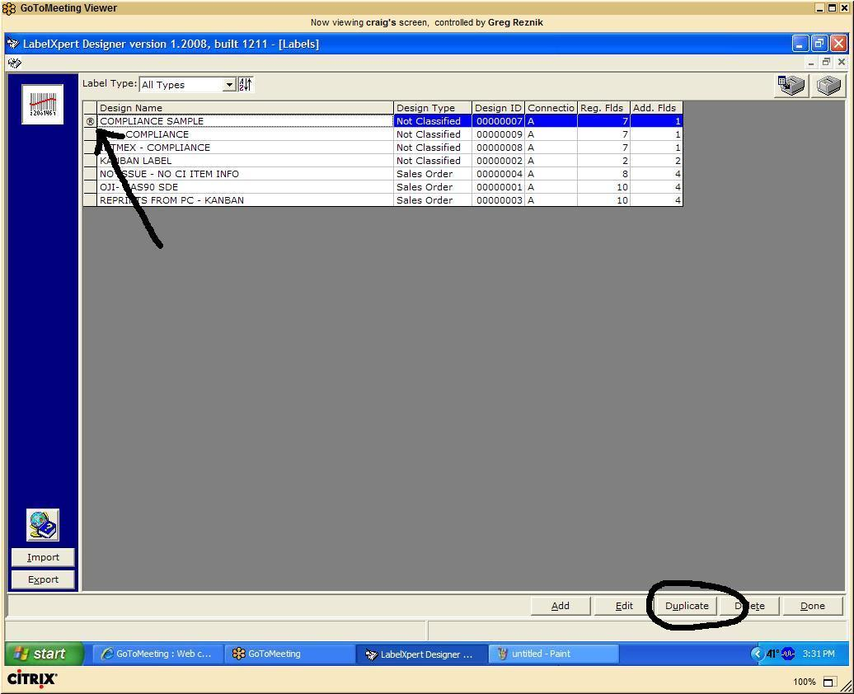

To Create a new Label Design…

1. Make sure Label Matrix is CLOSED. Within LabelXpert, please open “Maintain Labels”.
2. “Duplicate” the existing “COMPLIANCE ‐ SAMPLE” design:
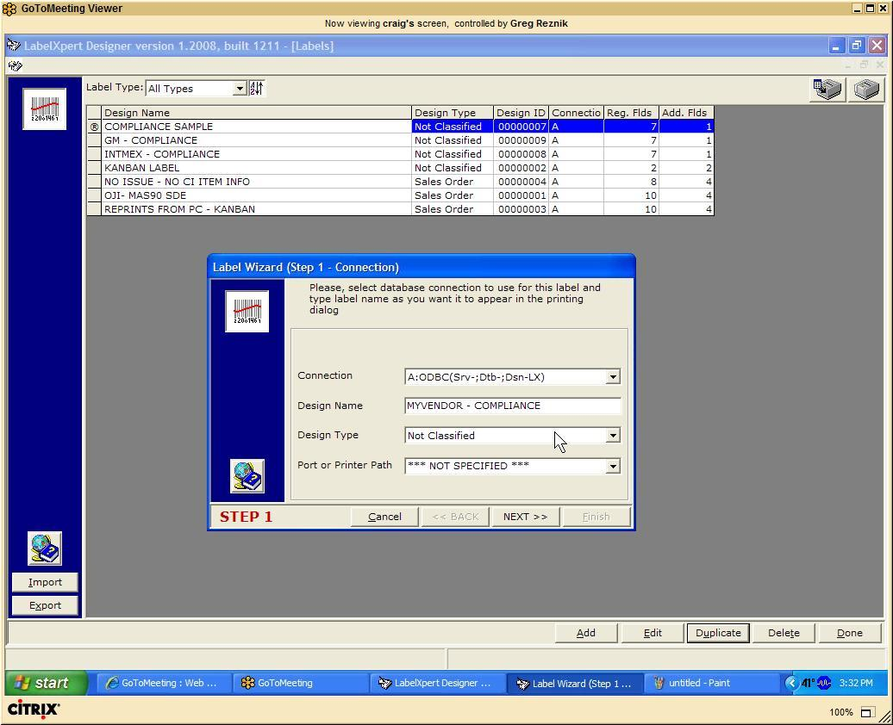

3. Specify a new design name (Wizard: Step 1)…
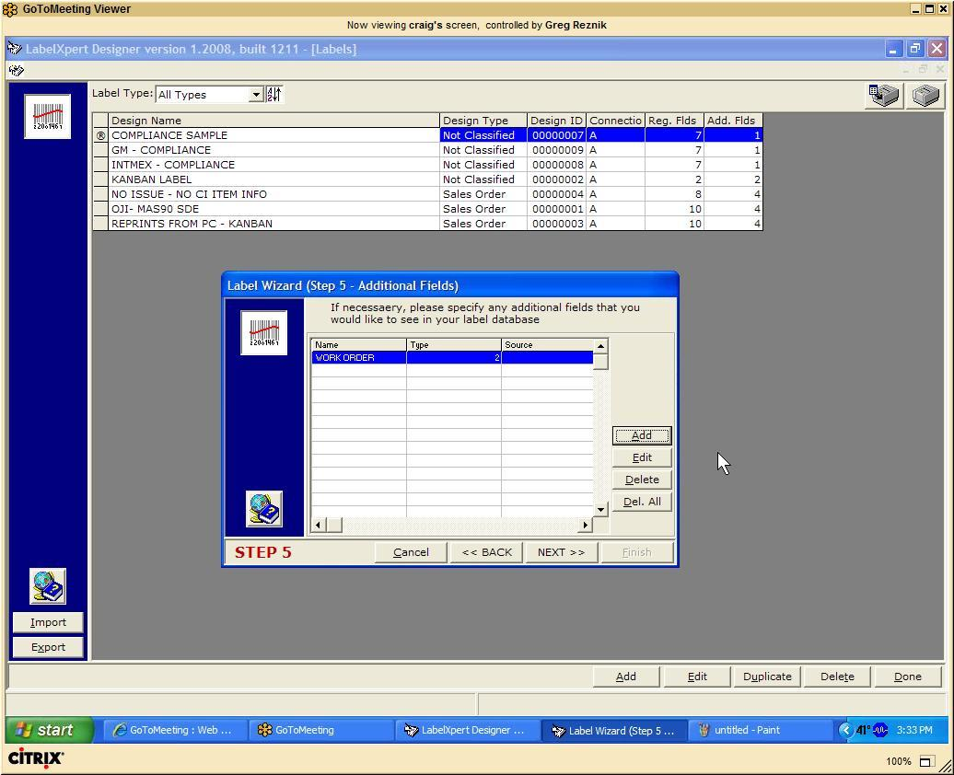
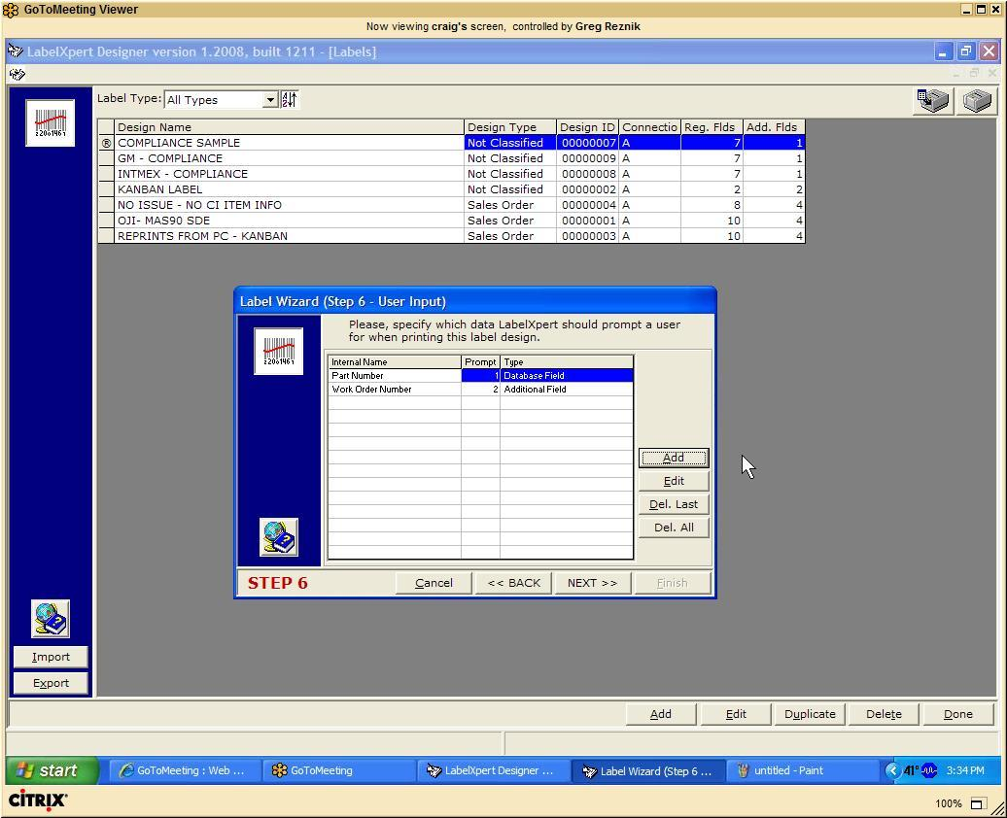

4. Click “Next” button a few times until you reach Wizard step # 5. If you need to add additional
data to be prompted to a user, Wizard: Step 5 and Wizard: Step 6 are the places to do it. On the
example screens below you can see how additional field Work Order was added (Step5) and
then made into an Input (Step 6):
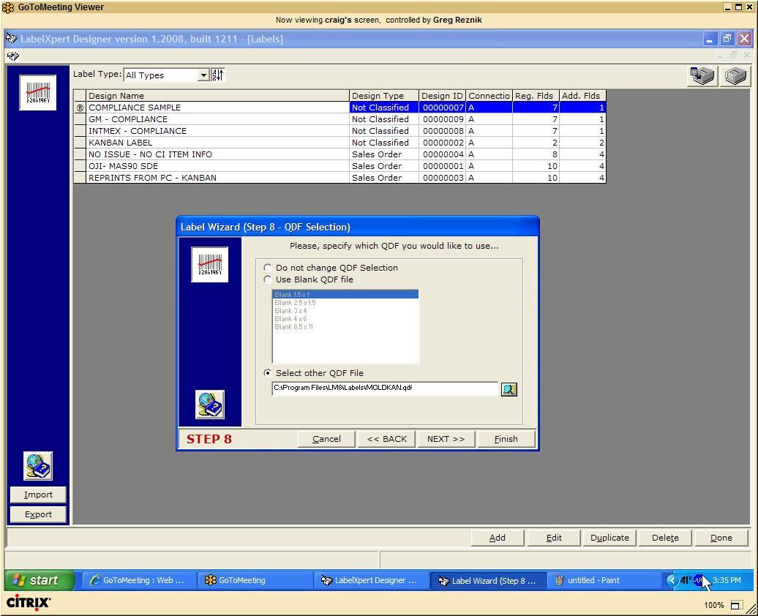

5. Click “Next” until you reach Wizard: Step8. This is the place to select your template “qdf” file
that you might’ve previously created for this trading partner:

After specifying your QDF, click “Next” then click “Finish”. Please note, that sometimes, clicking
“Finish” directly on this screen does not properly attach the QDF. We know about this little
issue, and working on adjusting the program in the next versions of LabelXpert.
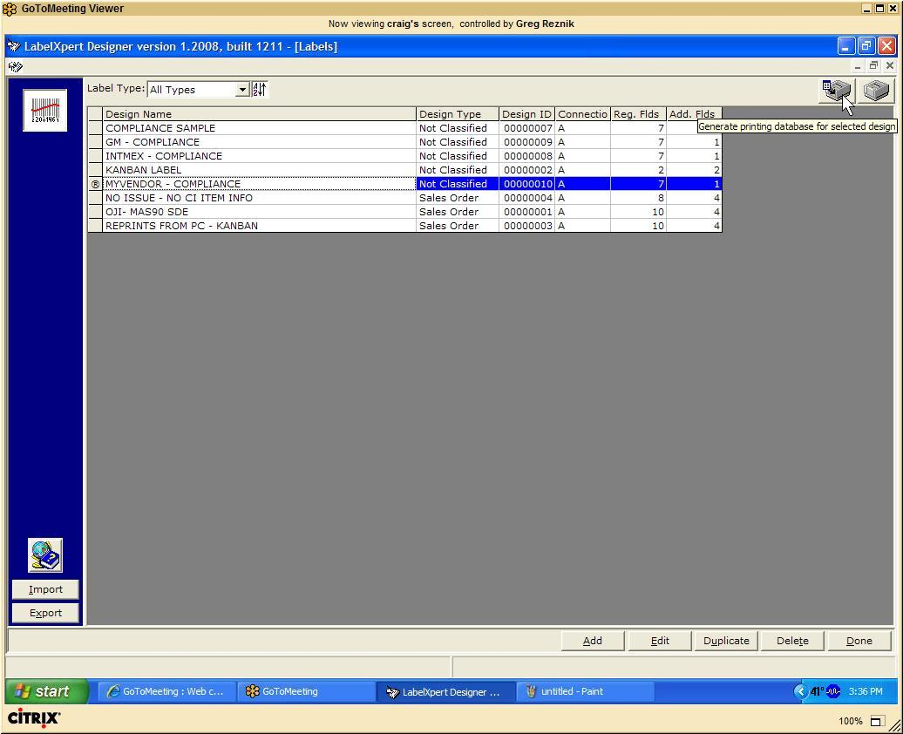

6. Now, it is time to link up to a real data from the database. In order to do that, we need to select
our design, and click “Generate Printing Database” button (as shown here)

In this example, our newly created “My Vendor – Compliance” label is selected, and then user
clicks “Generate Printing database” button in the upper right hand side corner. (When doing
“Generate Printing Database”, please make sure that the LabelMatrix window is not open somewhere –
for this operation Label Matrix needs to be completely closed!!! )
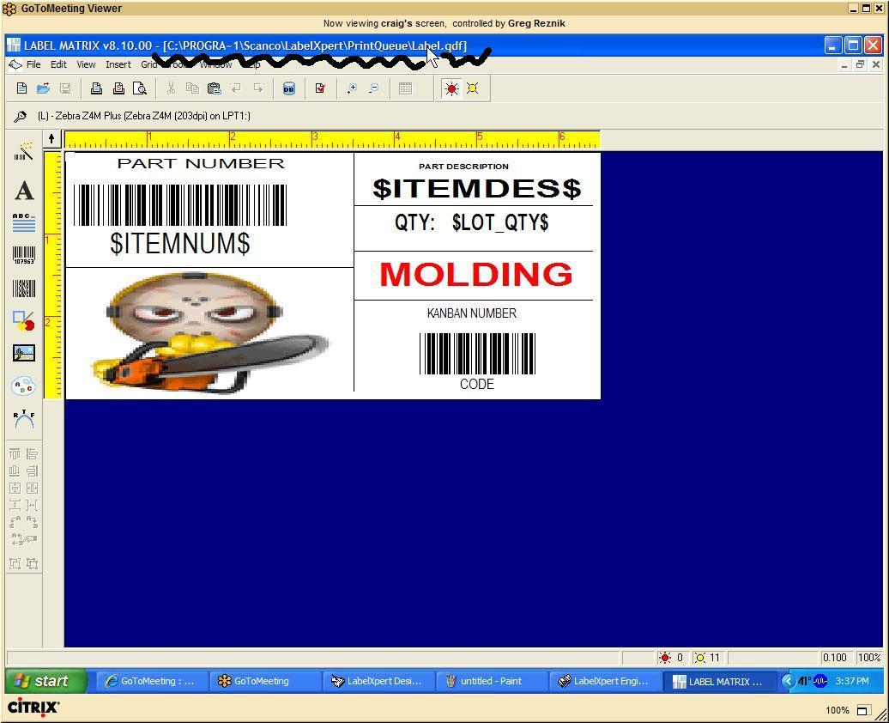

7. When generating database, LabelXpert will prompt you the part number and all other input
fields, just like it would do when it actually prints the label. At the end, though, instead of
sending data right to the printer, it’ll bring up Label Matrix instead. Notice, that Label Matrix
should automatically open “C:\Program Files\Scanco\LabelXpert\PrintQueue\Label.qdf”
file. (if the file is not opened automatically, you’ll need to open it manually)
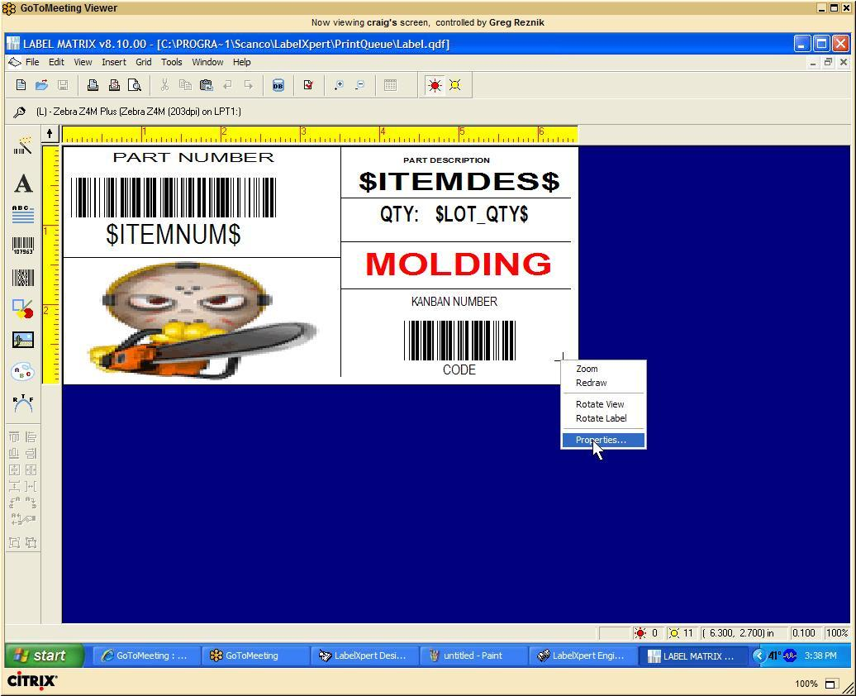

8. To link up to the database file, do the following:

a. right click anywhere on the white body of the label and go to “Properties” popup menu
item…
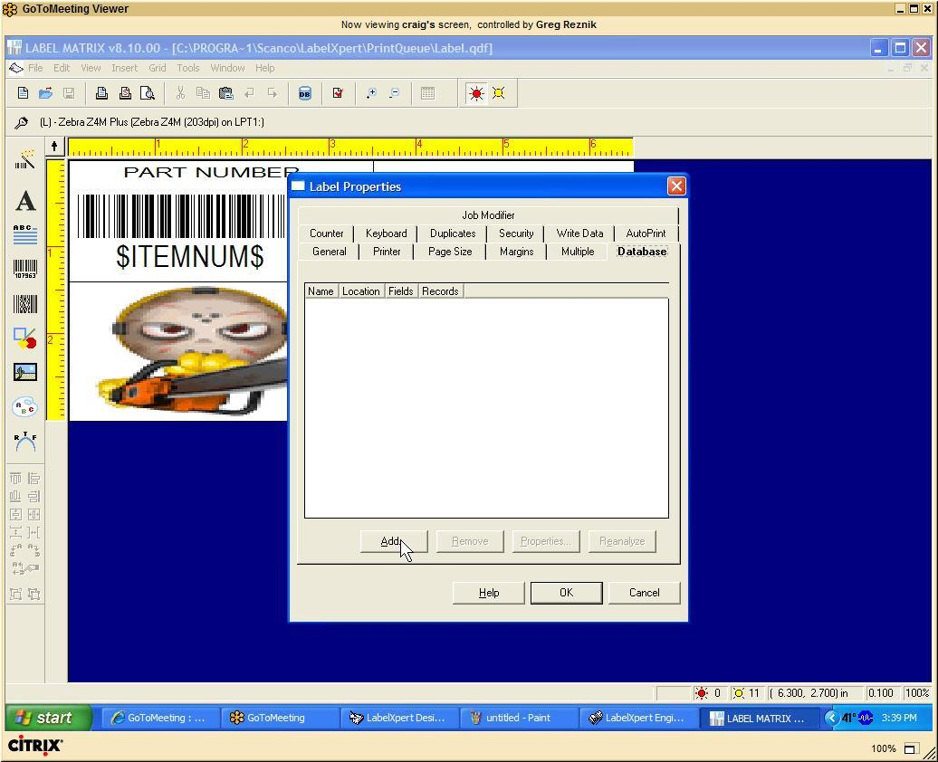

b. go to the “Database” tab and click “Add” button
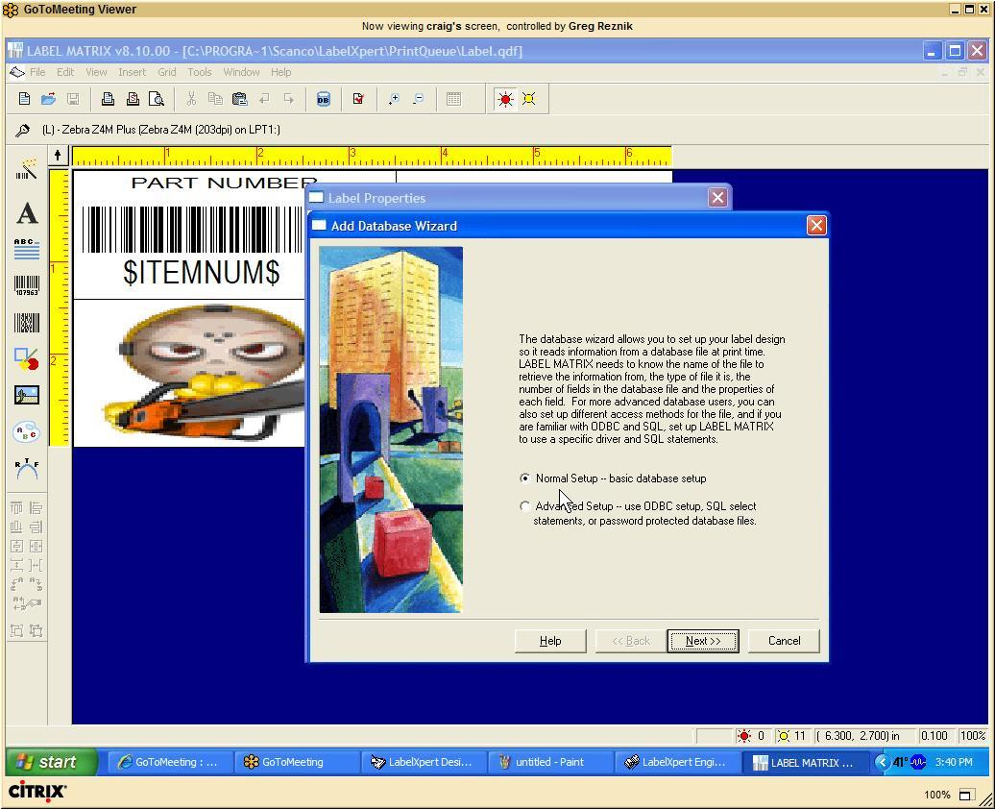

c. In the “Database Wizard” select “Normal Setup”
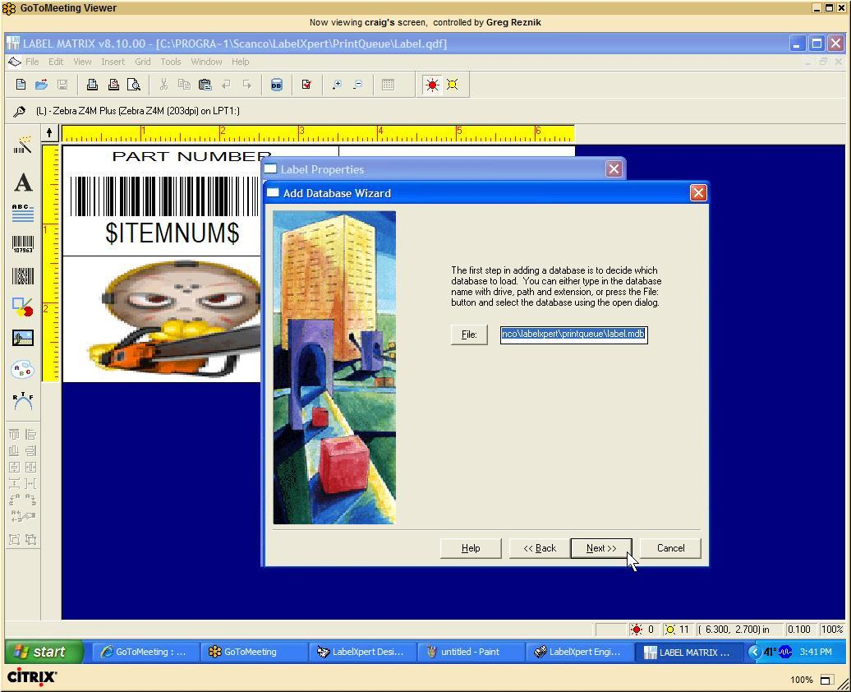

d. Keep clicking “Next” until prompted for a file. When you are, specify “C:\Program
Files\Scanco\LabelXpert\PrintQueue\Label.mdb” as a database file that you’re trying
to link up to.

Keep ckicking “Next” all the way until you get a “Finish” button. Ckick “Finish” button to
complete and close “Database Wizard”

9. In Order to add a counter, do the following:
a. right click anywhere on the white body of the label and go to “Properties” popup menu
item…
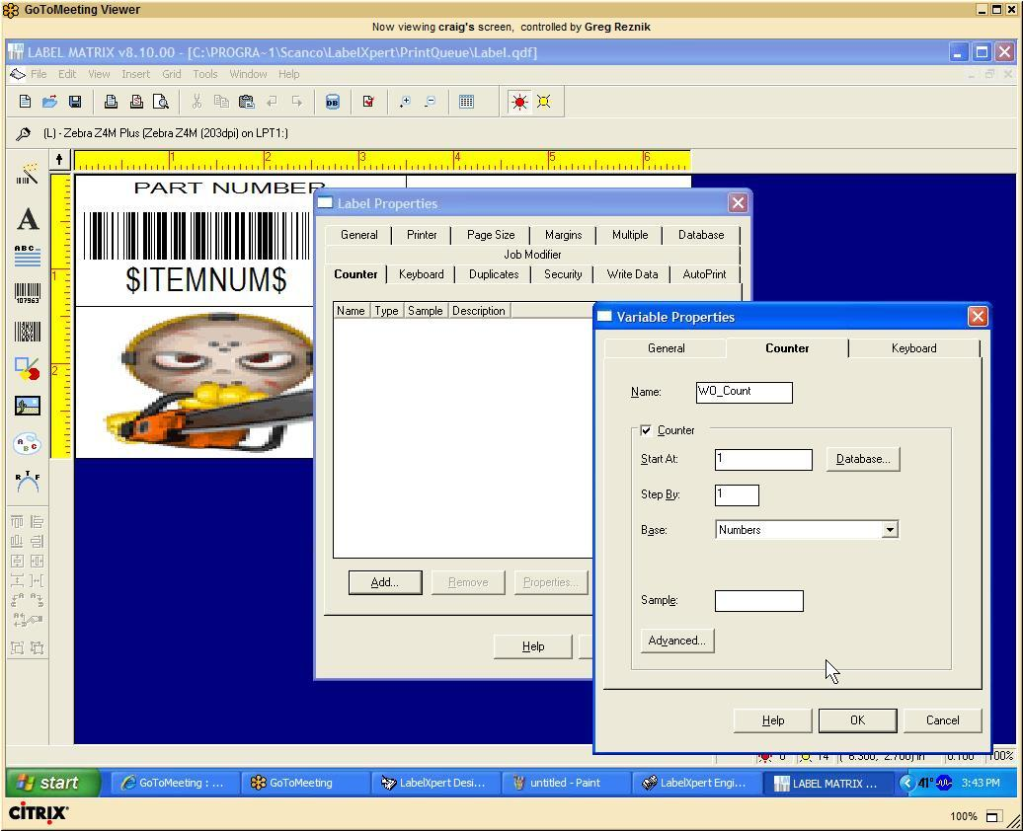

b. Go to the “Counter” tab and click “Add”
c. Create new Counter that starts with “1”. On the example here, the counter
“WO_Count” is being created:

d. Click “OK” to create a counter, then “OK” to close label properties dialog.
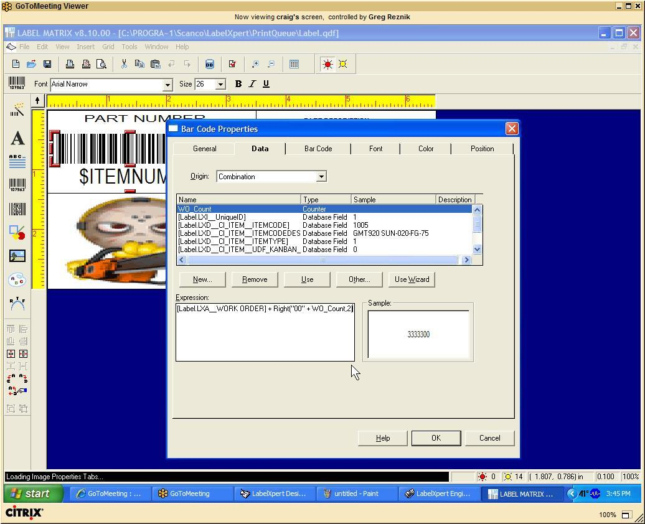

10. In Order to add a Serial Number that consists of a Work Order number and 2 digit incremental
counter, make sure that bullet number 9 of this document has been complete, and do the
following:
a. right click on the barcode or a text field that will output the serial number. Go to
“Properties” popup menu item…
b. Select “Combination” from the “Origin” drop down list.
c. Specify the following formula into the combination field:
AAAAAAA + Right(“00” + BBBBBBB, 2)
where AAAAAAA is WorkOrder field from the database, and BBBBBBB is a counter

In the example above, AAAAAAA is represented by a field [Label.LXA_WORKORDER], and
the label counter BBBBBBB is represented by WO_Count field.
d. Click “OK” to close the properties dialog.

11.

