Paper Kite instructions:
Materials (per kite): 1 piece of 8.5x11” paper, shish kabob skewer, masking tape, string, tongue depressor or cardboard string holder, plastic bag (cut into strips), markers or colored pencils
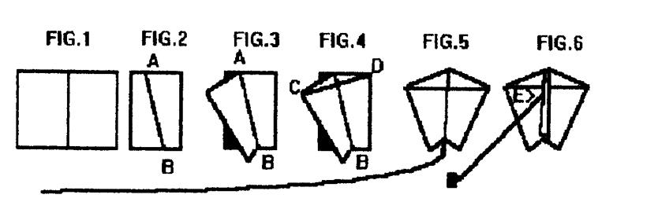
1. Fold a sheet of 8 1/2" x 11" paper in half to 8 1/2" x 5 1/2"
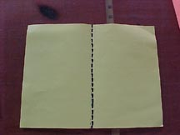
2. Fold again along the diagonal line A in Fig.2. This diagonal line can be determined by making a mark at the top 1 inch from the fold and a mark at the bottom 3 in. from the fold and drawing a line between these marks.
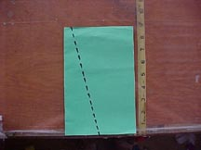
3. Fold back one side forming kite shape in Fig.3 and place tape firmly along fold line AB.(No stick is needed here because the fold stiffens the paper and acts like a spine.)
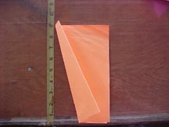
4. Place bar-b-que stick from point C to D and tape it down firmly.
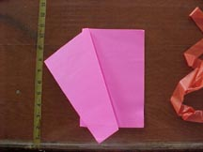
5. Cut off 6 to 10 feet of plastic ribbon and tape it to the bottom of the kite at B.
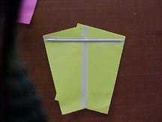
6. Flip kite over onto its back and fold the front flap back and forth until it stands straight up.(Otherwise it acts like a rudder and the kite spins around in circles.)
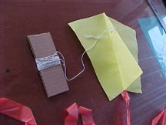
7.Punch a hole in the flap at E, about 1/3 down from the top point A. This hole can be reinforced with an additional piece of tape.
Tie one end of the string to the hole and wind the other end onto the cardboard string winder.

