Parent Friendly Lesson Plans

Weekly Coding Plans for Student Success.
These provide weekly goals for students and parents to make sure they are progressing forward, having fun and learning new skills. Optional but made to help parents.

Level 0 - Newbie - Introduction to Coding

- Weekly Goals to progress :

Project Points : Complete 1 - 3 projects and earn 100 - 300 project points
Challenge Points : Complete 1 - 3 challenges and earn 100 - 300 challenge points

- Types of Components :

You should break down your programs all the way to TWYS which means “Type What You See”.

- Levels of Challenges :

You should complete challenges that are Level 1 or 2. Higher challenges may be difficult.

- Don’t Know What to Choose? Sample Projects to Complete for this Level.

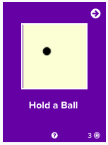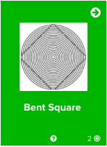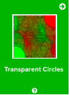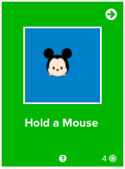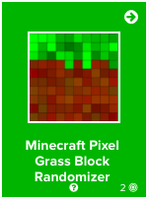

Coding Skills Learned : Focus on Variables, functions, and learning basic syntax for a variety of different coding skills

Progression/Motivation Stars - Set Easy to Assess Goals.

Students (8 - 12) normally work around level 2-4. What star level can you reach?
These increase while you level up! CC = Challenge points and PP = Project points.

