Parent Friendly Lesson Plans

Weekly Coding Plans for Student Success.
These provide weekly goals for students and parents to make sure they are progressing forward, having fun and learning new skills. Optional but made to help parents.

Level 14 - Practice Master

- Weekly Goals to progress :

Project Points : Complete 3 - 10 projects and earn 4000 - 20000 project points
Challenge Points : Complete 8 - 12 challenges and earn 4000 - 20000 challenge points

- Types of Components :

Continue to work from English Description, you can use lower levels to help.

- Levels of Challenges :

You should complete challenges that are Level 6, or 7. Higher challenges may be difficult.

4. Don’t Know What to Choose? Sample easy projects to work at English Description.

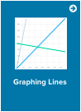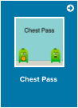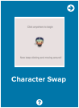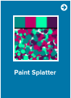
Coding Skills Learned : Practice slightly longer projects and finish all components at English Description. Focus on using math skills in coding and higher component projects. Go back to your completed projects and try to do challenges you could not do before.

Progression/Motivation Stars - Set Easy to Assess Goals.

Students (8 - 12) normally work around level 2-4. What star level can you reach?
CC = Challenge points and PP = Project points.

