Parent Friendly Lesson Plans

Weekly Coding Plans for Student Success.
These provide weekly goals for students and parents to make sure they are progressing forward, having fun and learning new skills. Optional but made to help parents.

Level 3 - Challenge Rookie

- Weekly Goals to progress :

Project Points : Complete 2 - 5 projects and earn 400 - 2000 project points
Challenge Points : Complete 3 - 6 challenges and earn 500 - 2500 challenge points

- Types of Components :

You should break down your programs all the way to TWYS which means “Type What You See”.

- Levels of Challenges :

You should complete challenges that are Level 2, 3 or 4. Higher challenges may be difficult.

- Don’t Know What to Choose? Sample Projects to Complete for this Level.

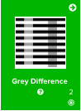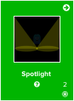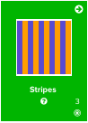
Coding Skills Learned : Practice coding concepts learned from previous projects. Introduction and practice of key concepts like if/else, for loops, increments, and mouseClicked.

Progression/Motivation Stars - Set Easy to Assess Goals.

Students (8 - 12) normally work around level 2-4. What star level can you reach?
These increase while you level up! CC = Challenge points and PP = Project points.

