Parent Friendly Lesson Plans

Weekly Coding Plans for Student Success.
These provide weekly goals for students and parents to make sure they are progressing forward, having fun and learning new skills. Optional but made to help parents.

Level 4 - Pseudocode Rookie

- Weekly Goals to progress :

Project Points : Complete 2 - 5 projects and earn 600 - 2000 project points
Challenge Points : Complete 3 - 6 challenges and earn 500 - 3000 challenge points

- Types of Components :

You should finish some projects at pseudocode, you should still use the TWYS to learn ideas.

- Levels of Challenges :

You should complete challenges that are Level 3 or 4. Higher challenges may be difficult.

- Don’t Know What to Choose? Sample Projects to Complete for this Level.

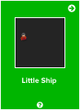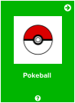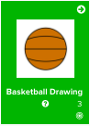

Coding Skills Learned : Practiced writing from pseudocode. Use previous projects and the Reference Manual to complete projects and incorporate new concepts.

Progression/Motivation Stars - Set Easy to Assess Goals.

Students (8 - 12) normally work around level 2 - 4. What star level can you reach?
These increase while you level up! CC = Challenge points and PP = Project points.

