Parent Friendly Lesson Plans

Weekly Coding Plans for Student Success.
These provide weekly goals for students and parents to make sure they are progressing forward, having fun and learning new skills. Optional but made to help parents.

Level 6 - Junior Hacker

- Weekly Goals to progress :

Project Points : Complete 2 - 6 projects and earn 1200 - 4000 project points
Challenge Points : Complete 5 - 10 challenges and earn 1400 - 4000 challenge points

- Types of Components :

You should finish most projects at pseudocode, you should start moving away from TWYS.

- Levels of Challenges :

You should complete challenges that are Level 3 or 4. Higher challenges may be difficult.

- Don’t Know What to Choose? Sample Projects to Complete for this Level.

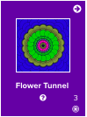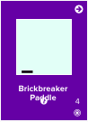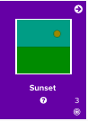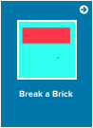

Coding Skills Learned : Practice coding from the pseudocode level. Introduction to objects and object-oriented programming.

Progression/Motivation Stars - Set Easy to Assess Goals.

Students (8 - 12) normally work around level 2-4. What star level can you reach?
These increase while you level up! CC = Challenge points and PP = Project points.

