Parent Friendly Lesson Plans

Weekly Coding Plans for Student Success.
These provide weekly goals for students and parents to make sure they are progressing forward, having fun and learning new skills. Optional but made to help parents.

Level 9 - Requirement Finisher

- Weekly Goals to progress :

Project Points : Complete 1 - 6 projects and earn 1000 - 6000 project points
Challenge Points : Complete 4 - 10 challenges and earn 1400 - 6000 challenge points

- Types of Components :

You complete some challenges at English Description, you can use lower levels to help.

- Levels of Challenges :

You should complete challenges that are Level 5 or 6. Higher challenges may be difficult.

- Don’t Know What to Choose? Sample easy projects to work at English Description.

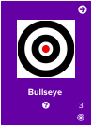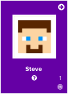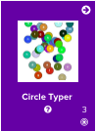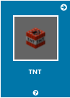
Coding Skills Learned : Learn how to work from English Description. You may want to try easier projects at this level that you did not previously complete.

Progression/Motivation Stars - Set Easy to Assess Goals.

Students (8 - 12) normally work around level 2-4. What star level can you reach?
These increase while you level up! CC = Challenge points and PP = Project points.

