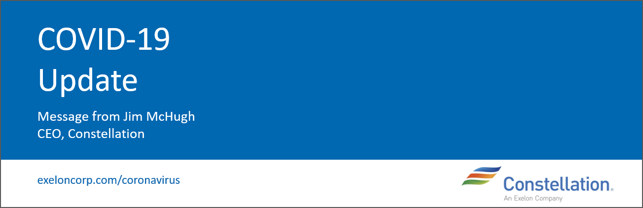

*This message is being sent for internal distribution only to all Constellation and embedded employees on behalf of Jim McHugh.*

May 13, 2020

Colleagues,

It was a pleasure having Exelon Generation President and CEO Ken Cornew join our All-Hands today to help break down last week’s Exelon 2020 Q1 earnings call with a focus on the Nuclear, Power, and Constellation businesses. If you weren’t able to dial in, a full recording [is available here](https://web.microsoftstream.com/video/80cac102-d093-420b-b80e-02c28c2919c6). (Instructions on how to access Microsoft Stream are below.)

Ken also provided insights regarding the communication you received Monday [from Amy Best](http://myexelon.exeloncorp.com/Exelon/news/Pages/Extending-Remote-Work;-Planning-for-Responsible-Re-entry;-and-Vacation-Time.aspx), which covered the extension of remote work, our planning for a responsible reentry, and the use of vacation time.

One portion of Ken’s remarks today that I really hope resonated with you is how, even amid COVID-19, Exelon continues to see value in Constellation and views us an integral part of the business. There’s a level of awareness within Exelon leadership and the Board that yes, we’re missing on some numbers right now, but those results are understandable. It was encouraging to hear Ken reinforce that leadership is committed to our strategy from a long-term perspective.

Now that we’ve had both Ken and Chris Crane join us over the last couple of weeks, I hope you’ve gotten a sense for how highly engaged our leadership team has been in responding to this situation. While we might not have all the answers, there’s a clear openness and willingness from leadership to recognize that things won’t be the same, commit to doing our best to learn from our experience, and implement longstanding changes based on those learnings. There is continuous dialogue in that regard taking place every day.

I want to thank you all again for your work to serve our customers and move our business forward while placing safety at the forefront of all that we do. (I’ll also note that there were several Q&A submissions that we didn’t have time to answer during the call. We’re compiling answers to your questions and will share those in the coming days.)

I shared this on the call today, but this statement from Chris during the earnings call is definitely worth repeating here: “**Constellation is the premier integrated competitive platform. It is the most effective way to bring our generation to market while providing customizable solutions to fit the needs of our customers**.”

He’s right.

Wishing you all continued health and safety,

Jim

**Accessing MS Stream**

*If prompted to login:*

*User:* [*E12345@exelonds.com*](mailto:E12345@exelonds.com) *(your E or C Number)*

*Pass: Your Normal Password*

*Mobile?  Get the Stream App for*[*iOS*](https://nam04.safelinks.protection.outlook.com/?url=https%3A%2F%2Fapps.apple.com%2Fus%2Fapp%2Fmicrosoft-stream%2Fid1401013624&data=02%7C01%7CDavid.Snyder%40constellation.com%7Ce1de06a65bb54c6a42e108d7cc151424%7C600d01fc055f49c6868f3ecfcc791773%7C0%7C0%7C637202263208575228&sdata=G%2FGJrY8Ho5XrBm8O7KadxfWAdalWCX2DccEoEitMoRI%3D&reserved=0)*or for*[*Android*](https://nam04.safelinks.protection.outlook.com/?url=https%3A%2F%2Fplay.google.com%2Fstore%2Fapps%2Fdetails%3Fid%3Dcom.microsoft.stream%26hl%3Den_US&data=02%7C01%7CDavid.Snyder%40constellation.com%7Ce1de06a65bb54c6a42e108d7cc151424%7C600d01fc055f49c6868f3ecfcc791773%7C0%7C0%7C637202263208575228&sdata=JcSVlBOQkUINrSfNxrGL9WByCGUJR8FNUO6kJVoTuxs%3D&reserved=0)