

Conference Package 2019

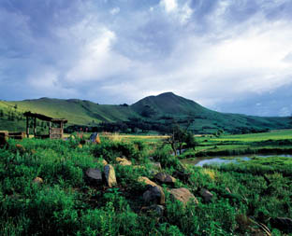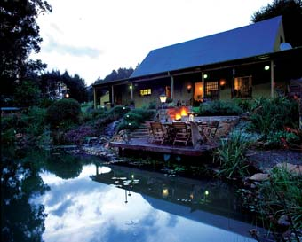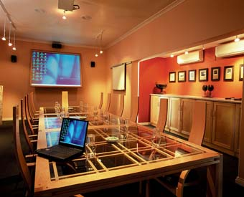

Stonecutters Lodge is situated in the Mpumalanga Highlands between Dullstroom and Lydenburg (Mashishing) and is only 3 hours from Gauteng and 1.5 hours from Nelspruit (Mbombela) Middleburg and Witbank (eMalahleni)

This scenic 4 Star Country Estate is an ideal setting for conferences or group functions, catering for up to 11 people (single) or 22 sharing, in en-suite double rooms.

- Owner managed with exceptional personal service
- Elegant reception rooms with fireplaces – lounge/dining and pub
- Exceptional meals – lunch buffets, 3-course plated dinners or casual braai evenings.
- Exclusive use of the entire lodge and all facilities
- Generator power in case of power-outage
- Fly-fishing and various team-building activities

The modern conference room is equipped as follows:
Equipment:
- Wi-Fi facilities
- 3 Electrical ports recessed in flooring beneath the boardroom table
- Fixed High Definition Projector for Data and DVD projection.
- Fixed big screen 2.0 metres x 1.5 metres
- 2 x flip charts
- UPS with 1 hour battery back-up for laptops
- A generator in case of an ESKOM power-failure
- Stereo sound system with surround sound
- Fully air-conditioned with reverse cycle heating
- Break away Room

Boardroom Dimensions:
Length: 9 metres, Width: 5 metres; Maximum Seating: Boardroom 16; U-shape 22

CONFERENCE RATES: (Including 15% Vat)
Every effort has been made to keep conference rates as low as possible and consequently the 24 hour Conference Package rate represents excellent value for money. Package rates vary per delegate depending on single or shared accommodation, midweek or weekend booking. Please discuss your requirements with Reservations and they will get back to you with a written quotation.

Day Conference Rate 2019

R 600 per person (snacks on arrival) or R 690 p.p. (Continental plus full English breakfast on arrival)
Rates are broken down as follows:
- Tea/coffee/ snacks on arrival R 75
Or Continental plus full English breakfast R 175
- Two tea/coffee breaks R 90
- Buffet Lunch R 220 p.p.
- Conference Room and all equipment (7 hours) R 250 p.p.
- Use of office services will be charged for. Prices include VAT

24-Hour Conference Rate 2019

CONFERENCE TARIFF 2018 | 1ST JAN - 31ST DEC 2019 | 24 HOUR PACKAGE
 | MID WEEK SHARING | WEEKEND SHARING
ACCOMMODATION | R 1 000 | R 1 250
BREAKFAST | R 175 | R 175
LUNCH | R 200 | R 200
DINNER | R 350 | R 350
MORNING & AFTERNOON TEA | R 100 | R 100
CONFERENCE FACILITY | R 230 (8 Hours) | R 230 (8 hours)
TOTAL PER PERSON SHARING | R 2 055 | R 2 305

.
 | MID WEEK SINGLE | WEEKEND SINGLE
ACCOMMODATION | R 1415 | R 2000
BREAKFAST | R 175 | R 175
LUNCH | R 200 | R 200
DINNER | R 350 | R 350
MORNING & AFTERNOON TEA | R 100 | R 100
CONFERENCE FACILITY | R 230 (8 Hours) | R 230 (8 Hours)
TOTAL PER PERSON SINGLE | R 2 460 | R 3 045
OFFICES SERVICES EXTRA | Prices include VAT | Prices include VAT

Terms & Conditions:
50% payable on confirmation of booking.
50% payable 15 days prior to event
Bar bill and sundries payable within 7 days of presentation of invoice.

Cancellation Fees:
50 % of total cost if cancelled 15 days prior to arrival.
100 % of total cost if cancelled 7 days prior to arrival.

Website: https://www.stonecutters.co.za
Reservations: 083 375 0132
Email: info@stonecutters.co.za

