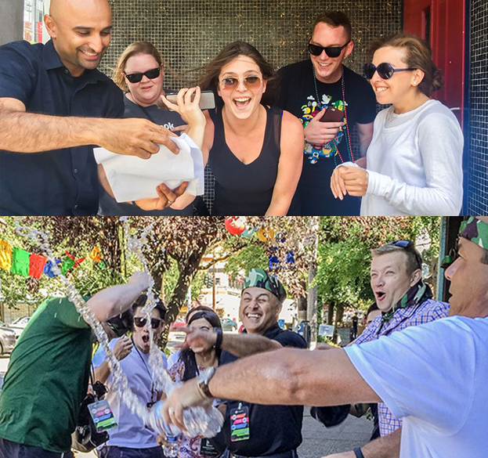  Why do corporate groups choose us?  We are North America’s leading team building event and group activity provider. When you partner with us, you’ll get:  - Fast Service – Get in touch, and our event solutions experts will get back to you before your deadline with a detailed activity proposal.  - Flexible Solutions – You can pick out the team building activity that best suits your needs, timeframe, and budget.  - Trusted Results – Our team regularly runs successful events rated 10/10 by large organizations, such as Apple, Google, Microsoft, and Coca-Cola, GE, and Amazon. | Who We Are  About Us  Outback Team Building & Training provides event planners and corporate groups with a variety of unique team building activities and development solutions, across North America.  Contact Us  Phone: 1-800-565-8735  Email: info@outbackteambuilding.com  Web: http://www.outbackteambuilding.com  MINUTE TO WIN IT TO WIN IT  Outback Team Building & Training | MINUTE TO WIN IT TO WIN IT  - Based on the popular TV game show, in Minute To Win It teams face off against the competition in simple 60-second challenges!
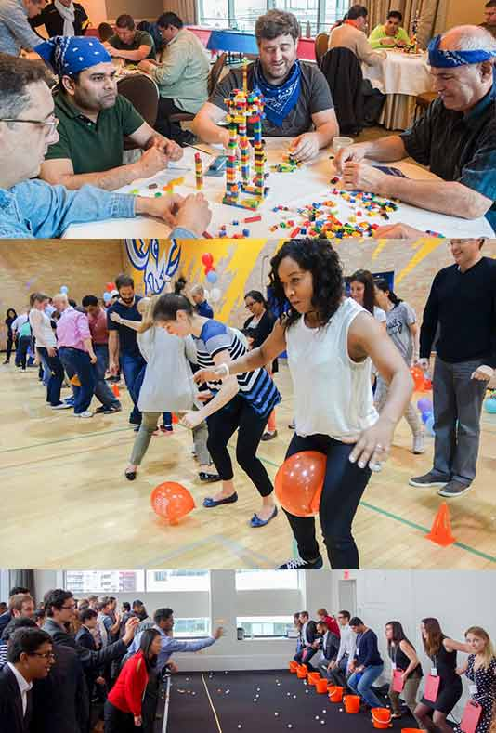  More info about Minute To Win It  Minute To Win It features teams of 6-8 participants per team using their brains and brawn in head-to-head competition of seemingly simple 60 second challenges.  Teams must work together to decide the best strategy and try to get the most points before time runs out. | SAMPLE CHALLENGE #1:  UP IN THE AIR  Working in pairs, teams must keep two feathers in the air using only their breath for 60 seconds. The team fails the challenge if any feather touches the body or the ground, or if the team members go out of the 60-Second circle.  “A BIG THANK YOU for such a great event. All your hard work, expertise, and energy made it an effortless experience.” – AT&T  SAMPLE CHALLENGE #2:  BITE ME  Teams will choose two members to participate in this challenge. Participants can only use their teeth to transport five paper bags of varying heights from the floor to the table using only their teeth. The task will be restarted if any other part of the body other than the feet touch the floor. | 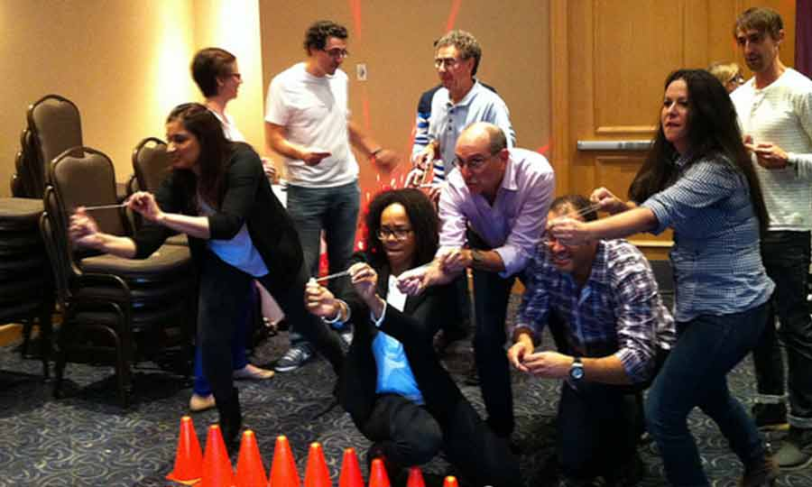  SAMPLE CHALLENGE #3:  HEADBANGER  All members of the team will compete in this challenge. Each person will be fitted with a pedometer, on their head. Each person will have to reach 100 steps in 60 seconds in order for the challenge to be considered complete.  BENEFITS OF MINUTE TO WIN IT  - Improves collaboration and teamwork  - Promotes communication  - Encourages problem solving  - Develops time management skills  - Boost decision making  - Improves strategic thinking skills

