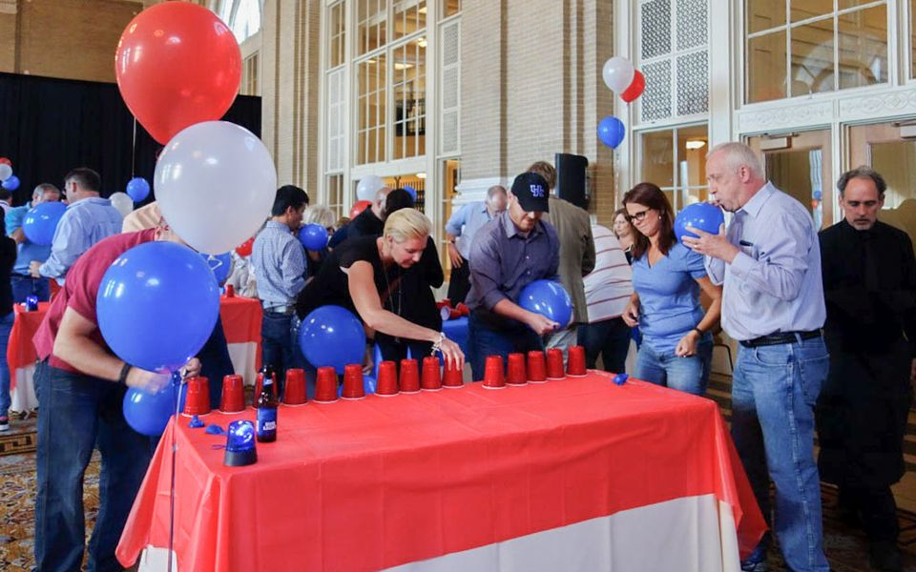  - MINUTE TO WIN IT  FRIDAY, May 5th  “And your time starts… NOW!”  Based on the popular TV game show, see if you have what it takes to beat the clock! Face off against the competition in a series of fast-paced challenges, and put your teamwork skills to the test.  From stacking cups, to shooting rubber bands, to flipping cookies… you’ll have to work together to become the ultimate Minute To Win It champions! |  | EVENT DETAILS:  LOCATION:  Address Line 1  Address Line 2  Address Line 3  Room #  DATE:  Friday, May 5th  LUNCH:  12:00 – 1:30 PM  ACTIVITY:  1:30 – 3:30 PM  PRESENTED BY:  OUTBACK TEAM BUILDING & TRAINING

Minute To Win It
“And your time starts... NOW!”
Friday, May 5th | Location, Place
- 20+ fast & fun team building challenges
- Based on the TV show
- Free food!
- Special prizes
“This is the best team buiding we’ve ever done! I never knew that shooting rubber bands and flipping cookies could be so challenging! ” |  | 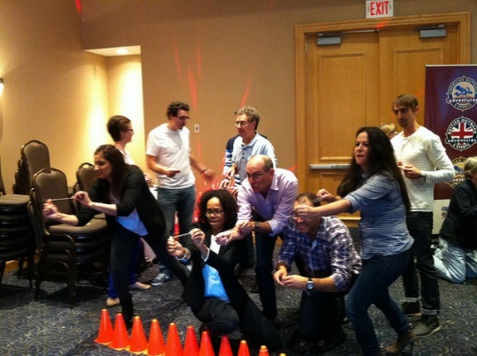
Schedule of Events
Monday  8:30 Breakfast  9:30 Minute To Win It  Noon Lunch  1:00 Seminar One  3:00 Seminar Two | Tuesday  8:30 Breakfast  9:30 Fun Event  Noon Lunch  2:00 Farewell | Point of contact  www.company.com
Company Name | 12448 Any Street, City, ST 12345 | P (123) 456-7890 | E info@company.com

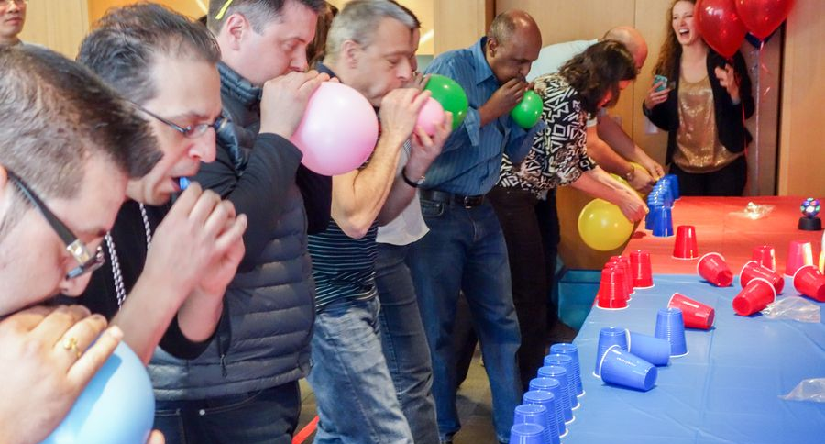

  - MINUTE TO WIN IT

FRIDAY, May 5th

“You’ve never done team building like this before.”
