TENSAGE INTENSIVE REPAIR & REJUVENATION

REPAIR MAINTAIN PROTECT

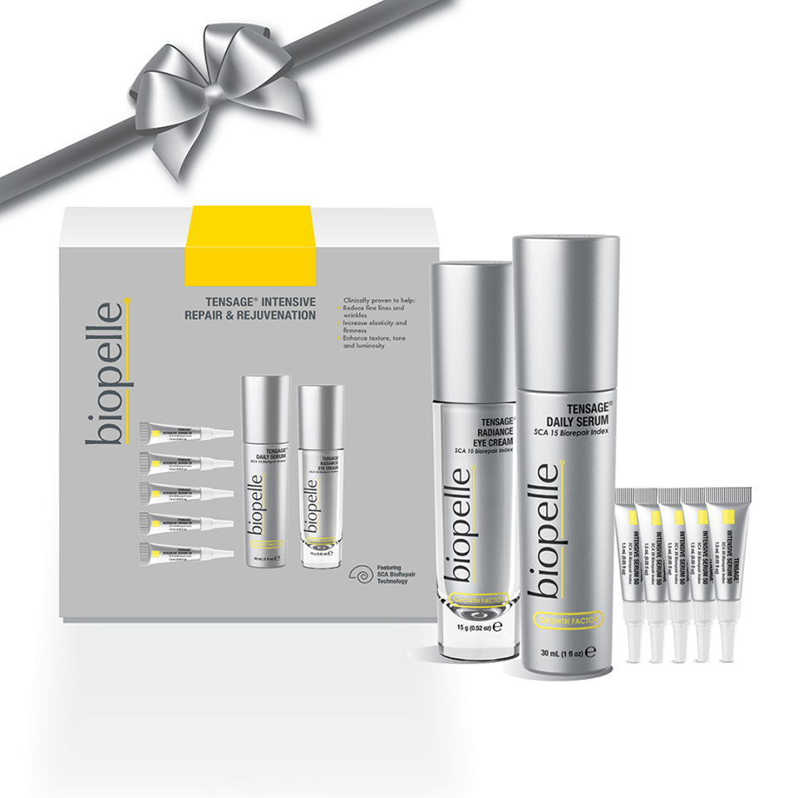

TENSAGE® Intensive Repair & Rejuvenation is a ten-day boosted treatment for dramatic improvement and daily regimen to maintain results. With recommended usage, the system will help to reduce the appearance
of fine lines and wrinkles, increase elasticity and firmness and enhance skin’s texture, tone and luminosity.

Containing...

1 Tensage Daily Serum SCA 15 - full size
1 Tensage SCA 10 Radiance Eye Cream - full size
5 Tensage Intensive Serum 50

TENSAGE Intensive Serum 50 For fast, dramatic improvement in the visible appearance of moderate-to-severe skin damage caused by UV light as well as environmental and smoke toxins.
TENSAGE Daily Serum Perfect for all skin types, this elegant, oil-free daily serum can help improve the visible signs of aging.

TENSAGE Radiance Eye Cream This lightly tinted cream helps even skin tone while firming and tightening the delicate eye area. Includes antioxidants for daily protection, peptides to help improve the appearance of fine lines, wrinkles and brightening agents to help illuminate tired eyes.

RRP
Normal - $448.00

Clinically proven to help:
• Improve the appearance of fine lines and wrinkles
• Improve elasticity, texture, tone and luminosity
• Reverse the visible signs of photo-damage

