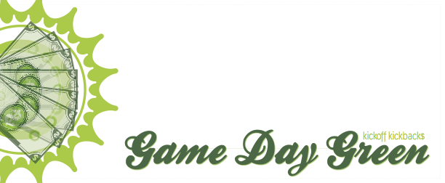
University Bookstore

October 15, 2011
10 am - 1 pm

Get 25% off your entire purchase!

