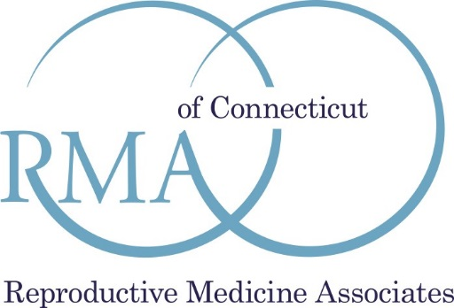

Patient Non-Discrimination Policy

Reproductive Medicine Associates of Connecticut, PC respects the dignity of each individual we treat. Every patient has the right to receive medical care that meets the highest standards in reproductive medicine regardless of gender, race, religion, national origin, disability or handicap, sexual orientation, gender identity or expression, age, military service, veteran status, or any other basis prohibited by federal, state, or local law.

