# The Jewellery Census | Media kit

**To the Jeweller…**

At the National Association of Jewellers, we’re leading the development of research which aims to understand and influence why the general public buy jewellery, and why they do not. This means we can then deliver a joined-up campaign with the sole objective to get more people buying more jewellery, more often.

For NAJ members, the research will give you a digital dashboard allowing you to cut data by demographics such as region, wealth, age, employment etc. This means you can use the intelligence the research gives you to better make decisions for marketing activities in a local, regional and even national capacity.

As a retailer and Chair of the Consumer Focus Steering Group, I must state that **we need your help** to make the Jewellery Census the largest research activity in the jewellery industry to date. Please can I ask you to share the questionnaire link with your customers, via whatever means possible. This could be in your e-newsletters, via your social media or even in store while people are waiting for services (there is a QR code below which you can print off - cameras on mobile phones will open the link).

To be here now, with the questionnaire ready to open out on THURSDAY 21st NOVEMBER, I am extremely thankful for the support of the Company of Master Jewellers and Goldsmiths’ Company who are co-funding the Census and the efforts of the NAJ’s Consumer Focus Steering Group who set this activity as a key milestone for the good of the jewellery sector.

Thank you in advance

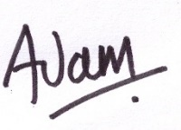

Adam Jacobs

Jacobs of the Jewellers of Reading

**In this media pack (**https://www.naj.co.uk/census-pack) (not currently live)

1. The Questionnaire: timescales and links
2. Copy for websites and newsletters
3. Social media phrases and imagery
4. QR code to print off
5. **The Survey**

Opens: 9.00am Thursday 21st November 2019

Closes: 6.00pm Sunday 8th December 2019

Link(s) to survey (please share only one link with your customer base, selecting the one most relevant to you).

NAJ Members Link:

<https://www.naj.co.uk/jewellery-census>

CMJ Members Link: <https://masterjewellers.co.uk/jewellery-census/>

Goldsmiths’ Company Link: [LINK]

1. **Copy for websites and newsletters** – we suggest one ‘open now’, one ‘reminder’ and one ‘last chance’
2. Example of news/ release;

[Headline] Who inspires you to buy jewellery? Meghan? David? Kim? Someone, or even something else?

**[intro] In between tasks? Tell ‘us’ about your love for jewellery by completing the jewellery ‘census’ for stores like ours to better understand valued customers like you.**

[YOUR COMPANY NAME] is taking part in the 2019 Jewellery ‘Census’ which aims to understand more about why people buy jewellery, and why they do not.

As part of the research, we want to know who and what influences jewellery purchases the most. So here at [YOUR COMPANY NAME] we’re wondering if Meghan, Duchess of Sussex, Kim Kardashian or Mr David Beckham has a bigger influence than our window display or private seating area. Maybe it’s all these things?

[NAME], Founder of [YOUR COMPANY NAME] said,

“I’m always fascinated by what people have seen, heard and felt to prompt a visit to our (or any other) jewellery store – is it something you’ve seen a friend or celebrity wear, a fashion trend or something else?”

The survey can be completed now and takes just 12 minutes to complete.

[Take Jewellery Census Survey](https://masterjewellers.co.uk/jewellery-census/)

1. Alternative headline suggestions (choose 1)

[COMPANY NAME] customers invited to take part in Jewellery ‘Census’

[COMPANY NAME] takes part in national research on jewellery trends

Who or what inspires you to buy jewellery? Meghan? Kanye? Our window? Something else?

If you had a £5,000 windfall what would you spend it on?

Are you more bespoke or brand, new or second-hand?

1. Alternative intro suggestions (choose 1).

**As a valued customer of <jewellers>, we’re delighted to be able to share this research with you.**

**Your opinion is vital to improve our business.**

**<Jewellers> is playing a key role in understanding more about UK jewellery choices, and so we are inviting our valued customers to respond.**

**In between tasks? Tell us about your love for jewellery by completing the jewellery census.**

**Make a real difference to the UK jewellery industry in just 12 minutes; tell us what jewellery means to you by completing this short questionnaire.**

**<insert 3 team member names>, part of the <jewellers> team welcome you to spare 10 minutes to complete the jewellery census – it’s not for everyone, you know!**

**We’re members of the National Association of Jewellers, and they’re conducting research into why people buy, and do not buy jewellery. Not that we’re competitive (much), but we love our customers and feel they’ve got a good perspective on things – please help us be recognised as a key contributor this important research.**

1. Body copy suggested

<jewellers> is taking part in the 2019 Jewellery Census which aims to understand more about why people buy jewellery, and why they do not.

As part of the research, the National Association of Jewellers want to know who and what influences jewellery purchases the most. So here at <jewellers> we’re wondering

if Meghan, Duchess of Sussex, Kanye West or Alesha Dixon has more of an influence than our window display or private seating area.

Maybe it’s all these things?

<name> Director of <Jewellers> said,

(choose one of the following)

“This is real big-picture research. We greatly value the opinion of our loyal customers so when the opportunity arose to invite opinion, it was an easy decision to ask for support”

“At <jewellers> we like to think we’re a bit different. This research will help us understand how unique we are in jewellery terms, and also make sure on each visit to us we have something ready and waiting which is just the right item for your needs at that time.”

“To us, your opinion counts. By taking 10 minutes or so to complete this research you aren’t just helping us, you’re also helping the thousands of other jewellers out there understand more about their customers’ needs.”

“I’m particularly interested in what people see, hear and feel to prompt a visit to our (or any other) store – is it something you’ve seen a friend or celebrity wear, or something else?”

The survey can be completed now and takes 12 minutes to complete.

Link to survey: (INSERT RELEVANT LINK HERE)

3.**Social media post examples**   
(use #jewellerycensus to post with)

(in addition to headlines suggested above)

The top ten influencers of Jewellery purchase(s) right now are? #jewellerycensus

Jewellery ‘census’ 2019 is open – your thoughts here please! #jewellerycensus

Bespoke or brand? Fine or preloved? What’s your preference? #jewellerycensus

Hey you, scrolling down your social feed looking for something interesting… #jewellerycensus

Is #Meghan the UK’s biggest jewellery influencer? Have your say – take our #jewellerycensus

Professional Jewellery Retailers want your views – take the #jewellerycensus here

Jewellery gifting is on the rise – but who’s buying for you, and who do you buy for? Take our #jewellerycensus here

Almost 700 years of consumer protection via #hallmarking means jewellery is a safe purchase #jewellerycensus

Who’s just helped a historic trade sector do something BIG and still has time to carry on scrolling afterwards… yep, it’s you. Help us by completing the #jewellerycensus

Now we’re biased here at <jewellers> but hypothetically, if you were to come into a £5000 windfall what would you spend your money on? Tell us by taking part in the #jewellerycensus now.

What #jewellery items do you want to see under the tree this Christmas? Tell us by taking part in the #jewellerycensus now.

**4.QR codes to print off in store**

**Did you know** if you take a mobile phone’s camera, and hold it over the code below, a button will pop up which will take you to a desired web page – saving you the trouble of typing it into your browser.

Alternatively, you could have a tablet or phone open on the survey for people to do, instead of using their own equipment?

1. NAJ Link: <https://www.naj.co.uk/jewellery-census>

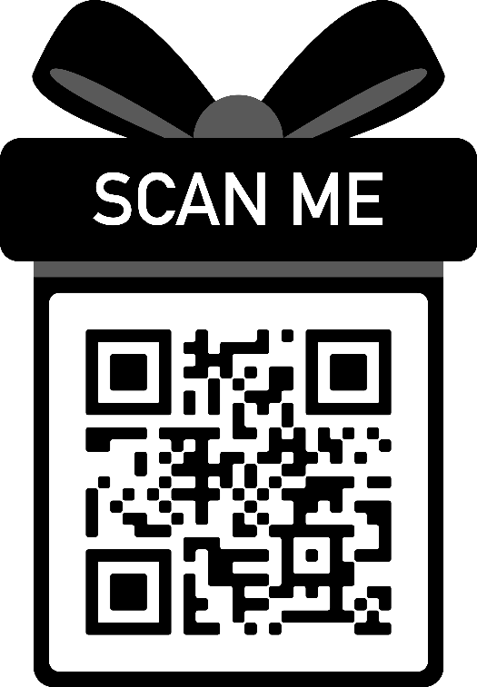 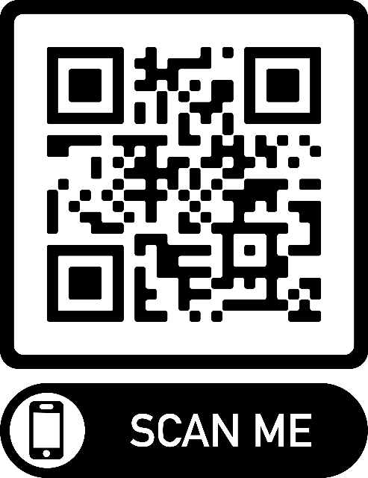

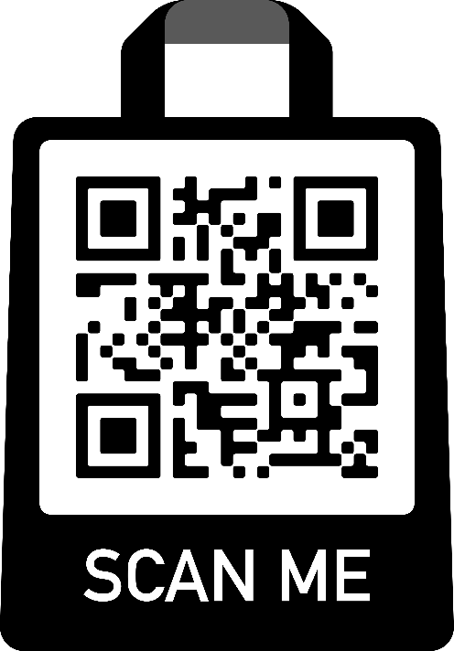 

1. CMJ Link:

<https://masterjewellers.co.uk/jewellery-census/>

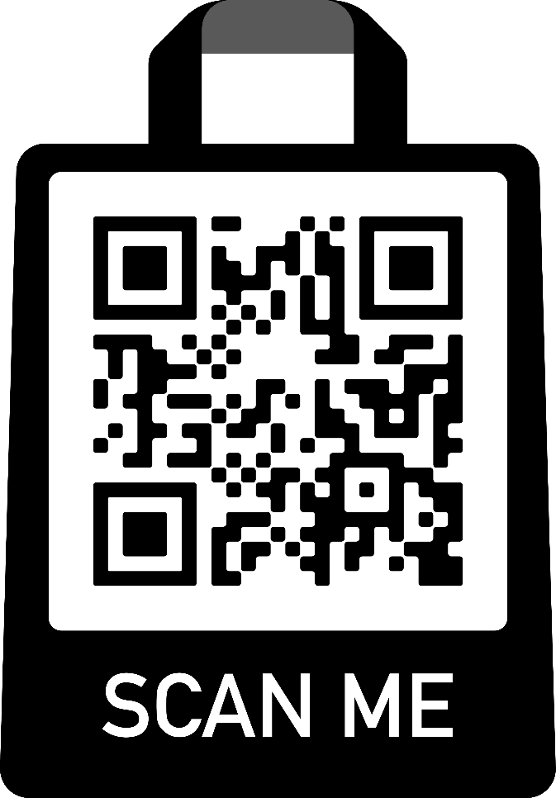 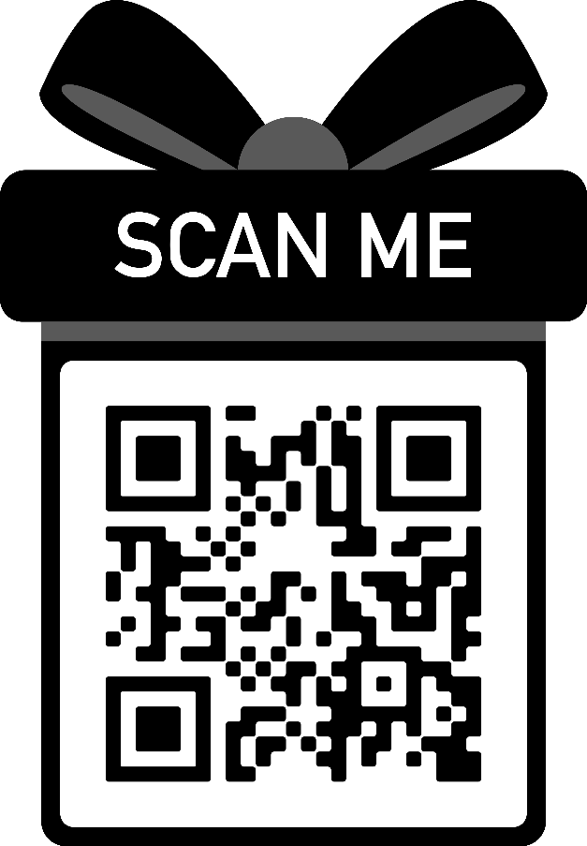

 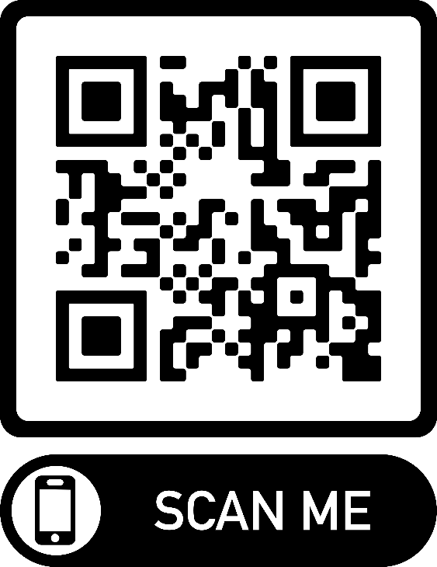

1. Goldsmiths’ Company Link: