Conflict Resolution

Task 1: Look at the following conflict resolution models and follow the instructions below.
- Explain and define each model
- Discuss their individual strengths and weaknesses
- Rank the models – which is the most / least useful?
- Decide which model is most appropriate for you. Explain your reasons, giving examples from work when possible.
- If you follow a different model of conflict resolution, describe and draw your model.

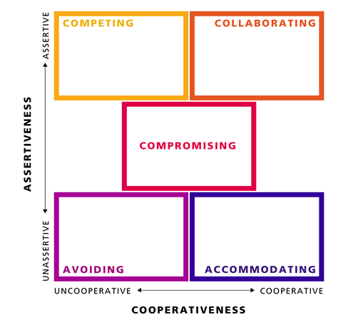
The Thomas-Kilmann Conflict Mode Instrument (TKI), taken from: http://xponents.com/managing-conflict-resolution/

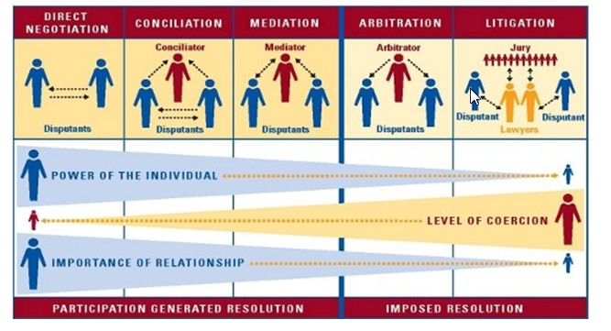

Taken from: http://www.partnersglobal.org/how/conflict-resolution

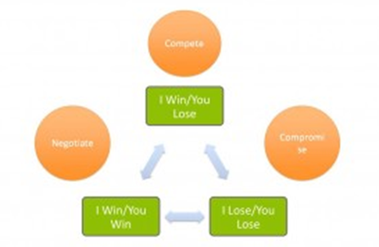

Taken from: http://blog.ncladvocacy.org/2009/10/strategic-partnering_mlt/

Task 2: Below are four common areas of conflict resolution. Complete the table by adding English words and phrases to match each step.
Step One: Set the Scene | Step Two: Gather Information
Present your perception of the problem: | Gather underlying needs, interests and concerns:
Active listening words and phrases: | Ask for other viewpoints:
Restating: | Show and confirm you respect opinions:
Paraphrasing / summarizing: | Express the need for cooperation to solve the problem:
Step Three: Brainstorm Possible Solutions | Step Four: Negotiate a Solution
Brainstorm solutions: | Bargain:
Show you are open to all ideas | Summarize solution:

Task 3: Read the following statements from employees talking in conflict resolution meetings. Decide the most appropriate response from your completed table above.
- “I just don’t know what to do now.”
- “I don’t think you understand what I’m saying.”
- “I can’t agree to that. That’s nonsense!”
- “I’m not doing that.”
- “The problem has just got really complicated.”
- “Can you agree that he’s the problem?”
- “Look, that’s not the real problem!”
- “I think you should move him to another department.”
- “I can’t work with him anymore.”
- “You weren’t there, you don’t understand.”

Task 4: In pairs, choose one of the following issues and role play Step One: Set the Scene. When you have finished, give each other feedback on language use and conflict management. You can decide who the boss is and who the employee is, and you can add more details to the situation.

- One of your team members is doing too much overtime. You need to speak to them to find out why and how this overtime can be reduced.
- One of your team leaders is putting too much pressure on their team. You need to speak to them to make sure they understand the effect it is having on their work.
- One of your team members had a loud argument with another team member in a status meeting. You need to speak to them to make sure it does not happen again.

Task 4: Now role play and complete the other three steps. Stop to give feedback after each step and continue to use the issues above. When you are finished, note language areas you need to focus on below:

Task 5: Read the following information about a conflict.
Background
Glomonix is an international company. It is in the process of developing a global R&D leadership programme within the Industry department. There are two main projects. The first is led by Mark, who is from the UK. Mark’s role is to manage R&D projects that have been initiated from the global R&D meetings and ensure everyone meets deadlines. Nori is in his team and is based in China.
Nadine is leading the other R&D project: to design and deliver a new agile development process for the Industry R&D department. Nori is a good friend of Nadine’s as they spent 6 months working together at Glomonix in Alpharetta, USA.
Situation
Nadine is worried that Nori has been under too much pressure whilst working with Mark. She is worried so she decides to email Mark about her concerns.
Email
Dear Mark,
I’m just back from China where I had the chance to meet and talk with Nori. I’m quite worried that he is under too much pressure in your project. He’s a fantastic worker but I know that he finds working with you on this project really demanding. I’m not sure you appreciate the pressure he is under. We talked through everything he was concerned about. He is more confident now after our talk and feels that he can meet the deadlines, but you should probably keep an eye on him. It would be a good idea for you to build a closer relationship and better rapport with him, to avoid this problem coming up again.
Best wishes,
Nadine
Reply to Nadine’s email
Nadine
Nori and I seem to be working just fine and deadlines are being met sufficiently. When I need your advice, I’ll ask for it. In my opinion, I think it’s better if you focus on your side of the project. I will look after mine. Your email was not very useful or helpful.

Task 6: You are either the boss of Mark, Nadine and Nori or Mark. If you are Mark, your Target Trainer will give you some information now. If you are the boss, read the following information.
You are about to meet with Mark to discuss these issues. Because of these emails, relationships are strained and there is now little communication between Mark and Nori which is causing problems with the project. Prepare for your meeting by answering the questions below:
- Which conflict management model will I use?
- Do I have a strategy?
- What is my goal from this meeting?
- Which language do I need for this meeting?
- What will I do if Mark gets angry / upset / defensive / aggressive?
Task 7: You are either the boss of Mark, Nadine and Nori or Nori. If you are Nori, your Target Trainer will give you some information now. If you are the boss, read the following information.
You are now about to meet with Nori (your meeting with Mark was yesterday). Prepare for your meeting by answering the questions below:
- Will I use the same conflict management model?
- Will I use the same strategy with Nori as I used with Mark?
- What is my goal from this meeting?
- Which language do I need for this meeting?
- What will I do if Nori gets angry / upset / defensive / aggressive?
- What do I need to remember from my meeting with Mark?
Task 8: Reflect on your performance in the role plays by getting feedback from others. When you are finished, note language areas you need to focus on below:

Role play cards

Mark

You are angry and frustrated. As far as you are concerned, this is a small problem, not something for the boss to be involved in. This was all unofficial and simply some colleagues getting drunk in a bar and having a gossip. You know you work hard and meet deadlines. You want this to go away quickly.
Prepare for your meeting by answering the questions below:

- Do I have a strategy when talking to my boss?
- What is my goal from this meeting?
- Which language do I need for this meeting?
- What will I do if my boss gets angry / aggressive / stubborn?

Nori

You are very nervous about the meeting. Before the emails, Mark was very rude to you in meetings. He never listens to you and he always rejects your proposals without discussion. You would like for Mark to respect you more – especially in front of the rest of the team.
Prepare for your meeting by answering the questions below:

- Do I have a strategy when talking to my boss?
- What is my goal from this meeting?
- Which language do I need for this meeting?
- What will I do if my boss does not believe me?

Conflict Resolution Language

Step 1: Set the Scene | Step 2: Gather Information
Present your perception of the problem:  - As I understand it, this is about…. | Gather underlying needs, interests and concerns:  - Tell me more about the problem / issue / situation.
Active listening words and phrases:  - Yes / uh-huh / mmm / ok / I hear you / please continue / I see / ahh / oh | Ask for other viewpoints:  - How do you feel about it?  - What is your opinion?
Restating:  - So, you feel the problem is…  - So, you’re saying…  - So, the problem is… | Show and confirm you respect opinions:  - I hear you. I see your point.  - I understand your concerns.
Paraphrasing / summarizing:  - To summarize / recap / sum up. | Express the need for cooperation to solve the problem:  - We need to fix / solve / resolve this together.
Step 3: Brainstorm Possible Solutions | Step 4: Negotiate a Solution
Brainstorm solutions:  - Let’s brainstorm solutions. | Bargain:  - If you do this, I will / can do that.
Show you are open to all ideas:  - I’m open to all / any of your ideas. | Summarize solution:  - Let’s summarize.

Trainer Notes

This set of materials is primarily to get participants thinking about the language and strategies they use when managing conflicts in English. This should be done with higher level participants who are experienced conflict managers in German.

Although the initial task is a warmer, it can take time. Feel free to remove some of the initial tasks.

If participants are having problems understanding the models, allow them to use the internet if necessary to research the models (in English).

A page of sample language has been provided at the end of the materials, but attempt to elicit (and possibly correct / modify) language they already use during conflicts to make the process easier and reduce the cognitive load on them.

If participants produce a stock phrase where substitutions can be made to vary phrases (verbs or nouns for example), ask them to add more. See below:

I | understand  hear  see | your | concerns.  problems.  worries.  fears.

