Inventions – Brilliant or Stupid?
This card game is to encourage critical thinking and fluency. The discussion questions can be put on the board before the session or you can print them out if you wish.

GAME INSTRUCTIONS FOR TRAINERS
- Cut up the invention cards and place them in a pile (face down) on the table between participants.
- Participants turn over cards one by one and decide of the invention is brilliant or stupid by discussing a set of questions (either on the board or printed and given to them as a handout – your choice). Feel free to add to the questions and let the participants ask their own.
- Once the participants have made a majority decision, place the card on top of the “Brilliant” or “Stupid” card (see final page).
- When finished, ask the participants to choose one of the brilliant ideas. The group then has to decide how best to bring it to market (for sales-focused participants) or how best to produce and manufacture the invention (for production / engineering participants). Or, you can choose to set up a Dragons’ Den roleplay where they have to pitch and then get investment for their chosen invention.

DISCUSSION QUESTIONS FOR PARTICIPANTS
Use the following discussion points to decide if each idea is either brilliant or stupid:
- Discuss the invention first:
- What is it?
- What is it made of?
- How is it made?
- Who is it for?
- How does it work?
- What is your personal opinion of the idea? Support your opinion with clear reasoning.
- What is your business / professional opinion of the idea? Support your opinion with clear reasoning.

Sources
http://www.boredpanda.com/funny-inventions/
http://mashable.com/2014/10/26/absurd-inventions/
https://uk.news.yahoo.com/airplane-seat-could-bring-awkwardness-205901278.html#PS3PThX
http://justsomething.co/23-craziest-japanese-inventions-you-never-knew-existed/
http://www.viralnova.com/strange-useless-inventions/

ZODIAC AIRPLANE ECONOMY SEAT PLAN
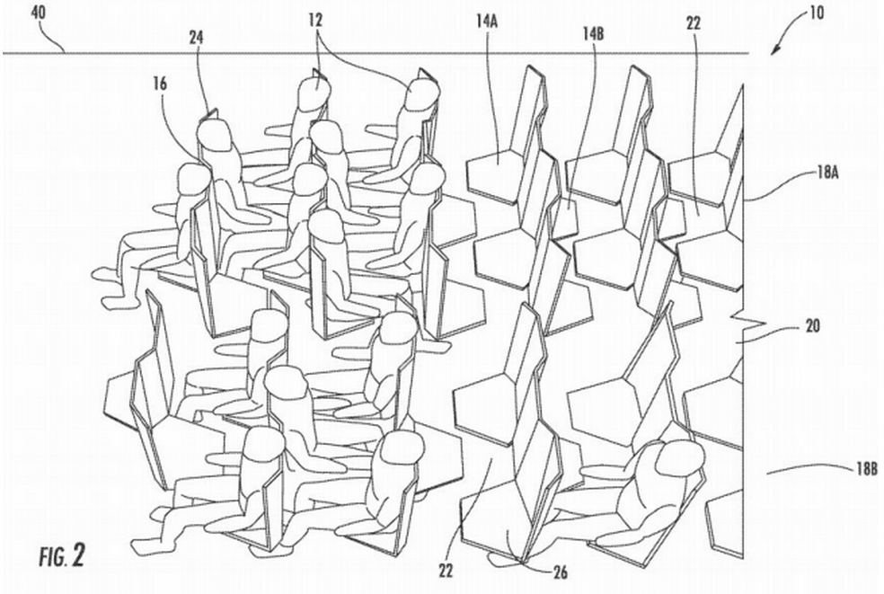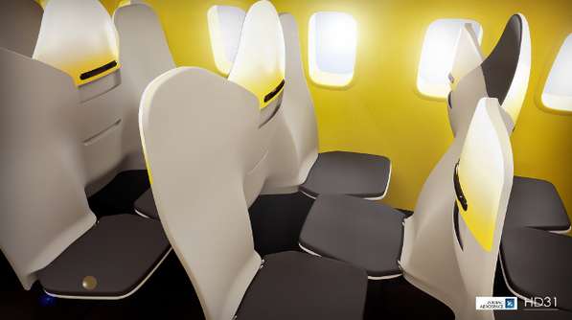
BABY MOP 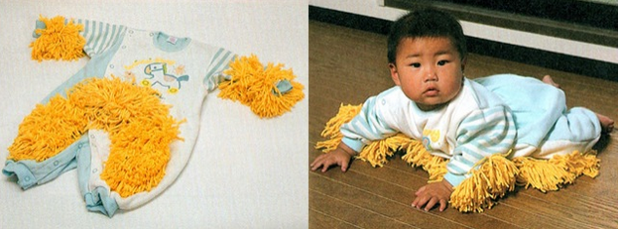

EXTENDABLE ARM FOR SELFIES 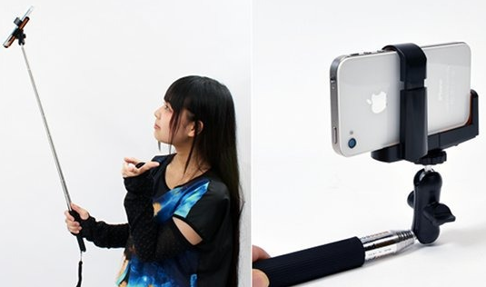
BANANA CONTAINER 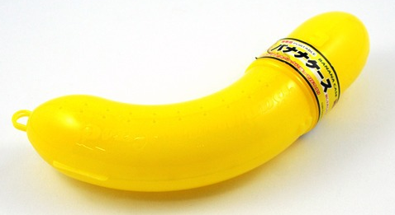
SQUARE WATERMELON AND EGG CUBER
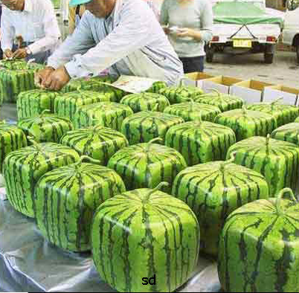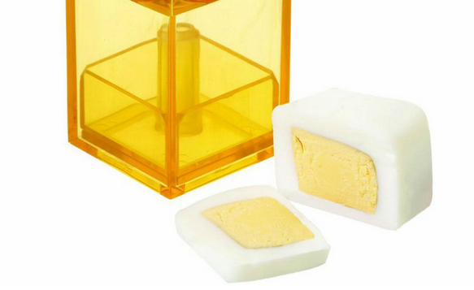

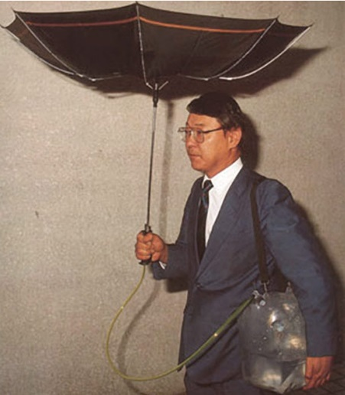
INVERTED UMBRELLA TO SAVE RAIN WATER

“DIN-INK” PEN CAP EATING UTENSILS

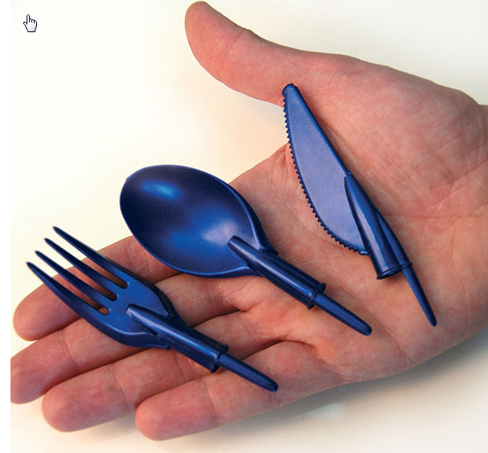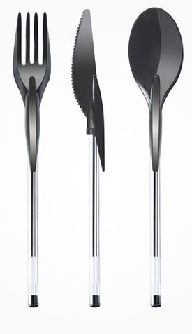

HAMSTER CAGE SHREDDER
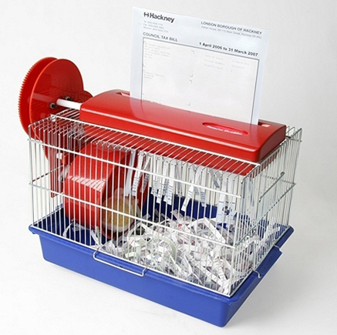
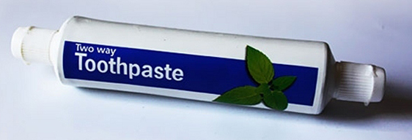
TWO-WAY TOOTHPASTE
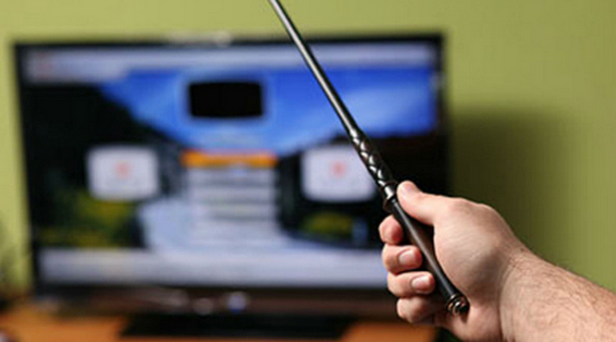
REMOTE CONTROL MAGIC WAND

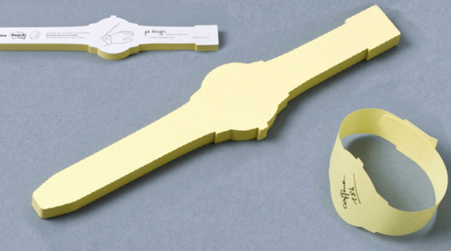
POST-IT WATCH

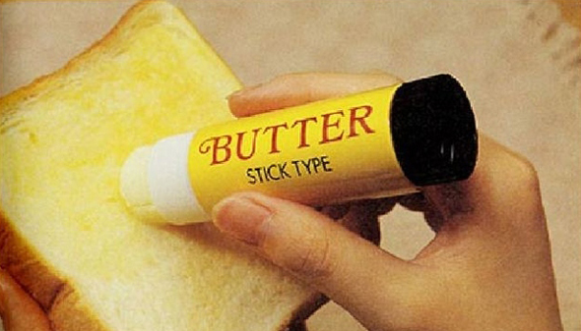
BUTTER STICK

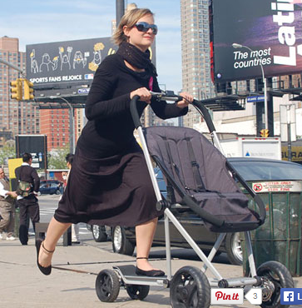
BABY STROLLER AND SCOOTER HYBRID

FLASK TIE
