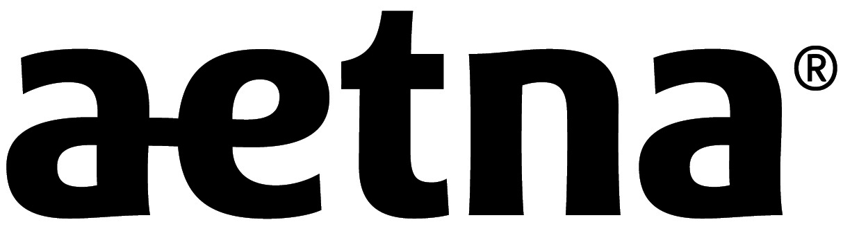 | Joinder Agreement for  Aetna International Expatriate Trust | Aetna International  Coverage underwritten by Aetna Life Insurance Company  Visit us at www.AetnaInternational.com

The undersigned Insert Name of Employer agrees to the establishment of an insurance trust fund (“Insurance Fund”) for the purpose of implementing a Trust Agreement (“Trust Agreement”) and to the designation of
U.S. Bank National Association, Willmington, Delaware as “Trustee” for said Insurance Fund and Trust Agreement.

The undersigned, as a Participating Employer : 1) agrees to be bound by the terms of the group policy (including all of its attached documentation) issued to the Trustee (including any amendments); 2) agrees that any insurance coverage shall become effective as of the requested date or the date a Subscriber (employee) and his/her Dependants are approved for participation in a plan issued through said group policy (subject to applicable underwriting requirements of the Insurer);.3) agrees that the covered benefits provided shall be in accordance and shall be subject to the terms of the policy or policies issued to the Trustee of the Insurance Fund; 4) agrees to make the required contributions to the Insurance Fund; and 5) also agrees that in the case of default, fraud or non payment, the Subscriber will be liable to the insurer for such fraud, or unpaid contributions for the coverage period, and such insurer may terminate coverage.

It is understood and agreed that no coverage shall become or remain effective as to any person if he or she fails to meet minimum underwriting requirements of the insurer.

I understand that, as an employer doing business and employing persons in foreign jurisdiction(s), I may be subject to foreign laws with respect to the provision of employee benefits and the insurance of those benefits. I understand that the Insurer may not be able to conduct business and/or pay claims in locations or with/to people or groups that are listed by the European Union, the United States of America and/or the United Nations or the United States Office of Foreign Asset Control (OFAC) as sanctioned countries and/or prohibited people or groups. I further acknowledge that both parties under this insurance arrangement shall be responsible for complying with any applicable anti-corruption and anti-money laundering laws, and certify that I have neither received nor been promised any improper benefit, payment, or advantage in connection with this insurance arrangement.

Agent(s) of Record: SSN/TIN:

Signed at (Location): Date:

Employer Name: Amount of Advance Payment* $
(*Please make check payable to Aetna Life Insurance Company)

By: Witness:
(Signature - Title) (Signature Required)
Print Name:

