15th Annual Children’s Grief Camp
Saturday, August 11, 2018-Sunday, August 12th, 2018
Camp Tekoa in Hendersonville, NC
8:00 am Saturday until 12:00 pm Sunday
Ages 5-15 years old

Contact Information: Please fill out one pre-application per child.

Name______________________________ Date of Birth_________________ Age ___________

Home Address: __________________________________________________________________

City:________________________________ State: ______________ Zip Code: ____________

Grade _________ (2018-2019 year) School________________________________________

Name of deceased __________________________Hospice Patient Y/N Date of Death_________

Relationship to deceased: ____Child ____Sibling ____Grandchild __________________Other

Cause of Death____________________________________________________________________

Family Contact_________________________________ Phone___________ Cell____________

Address__________________________________________________________________________

Email Address: ___________________________________________________________________

Additional Emergency Contact__________________________________ Phone______________

Parent/Guardian Signature______________________________________ Date_______________

Child’s T-Shirt Size_____________________________________________
(Please indicate adult/child size)
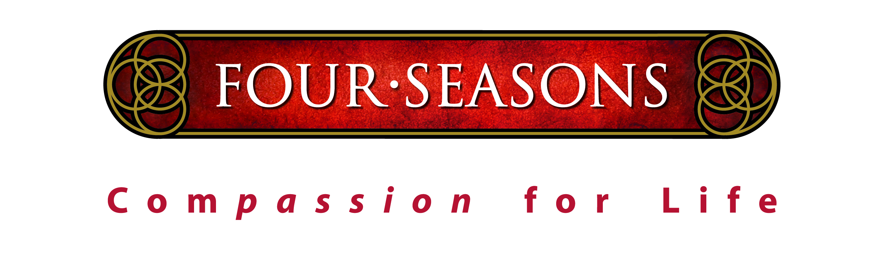
Mail to: Four Seasons
Blair Stockton, Heart Songs Coordinator
571 S Allen Road
Flat Rock NC 28731

Call for more information: 828-233-0334
THIS PRE-APPLICATION IS DUE BY June 15, 2018

