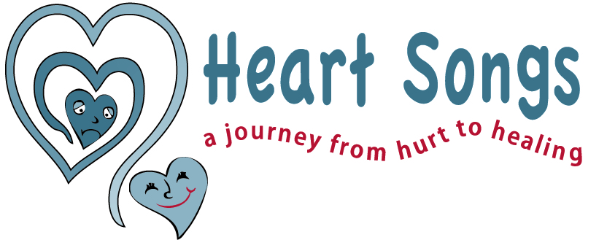

Understanding Grief Reactions of:
Children: Ages 5-9 years old

How they think:
- They understand death is final but they see it as happening to other people. They can become anxious about it and fear someone else in their family could die.
- They are learning about the biological processes of death and fear that death is contagious, so they may worry about “catching it”.
- They may be fearful that their words or actions may have caused the death.
- They are focused on spiritual explanations, “good vs. bad”, and are struggling to understand the how and why of death.

How they may feel: Sad – Anxious – Angry – Scared – Cranky

How they may behave:
- Withdrawn and suddenly aggressive due to loss of stability.
- Confused and angry about all the changes in their family.
- Resistant to talking about it because they are uncertain if their feelings are “good or bad.”
- Sleepless nightmares and fearful to sleep alone.
- Become unusually clingy and possibly noticeable regression in maturity, which may be only a temporary situation.
- Lack of concentration due to worrying about their family.

How you can help:
- Engage them in discussion about their feelings. Be open to listening and accepting their feelings as real.
- Reassure them that all their feelings are important to you, even if they seem irrational.
- Give clear and brief explanations of the facts. Be developmentally sensitive to the differences of each child.
- Re-explain facts surrounding death, and reassure them they did not cause it and they cannot catch the illness.
- Dispel any misunderstandings which may cause unnecessary worries.
- Use correct explanations about spiritual concepts and the meaning of death. Ask your child what they understand about dying. If an answer is unknown, explain that “we don’t always have all the answers, but we can talk about what it means to you”.

