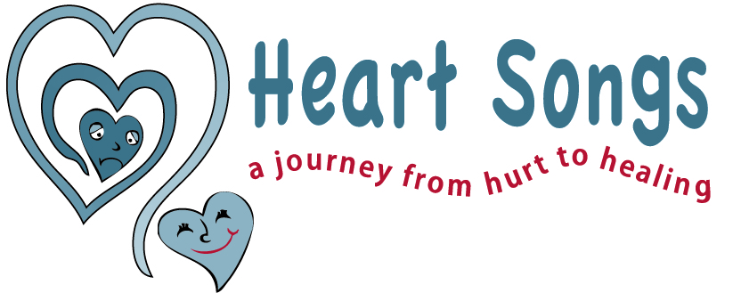

Understanding Grief Reactions of:
Tweens: 9-12 years old

How they think:
- They are learning how to cope with death because they understand the finality of death now
- They may not want to talk about it because they are UNSURE
- They are developing socially and becoming more aware of others and their sufferings and feel responsible
- They are developing empathy and are more aware of affect of death on others
- Their awareness means they have more concern & fear of death for others
- They fear isolation by being different from others

How they feel: Scared and lonely, helpless and vulnerable, fearful and worried, anxious about others’ feelings, afraid to talk about it

How they may behave:
- Reluctant to talk or show feelings
- Nightmares due to being worried and fearful
- Withdrawn or more aggressive due to vulnerability
- Decline in grades
- Lack of concentration
- Anxious about facts of death

How you can help:
1 – ACCEPT their feelings and validate their concerns
2 – REAFFIRM their values and thoughts and help them explore
3 – LISTEN and ask about their thoughts on death
4 – INVOLVE them in events surrounding dying process
5 – MODEL healthy coping and grieving styles
6 – PROVIDE open communication and stable relationships
6 – REASSURE them of their importance and security

