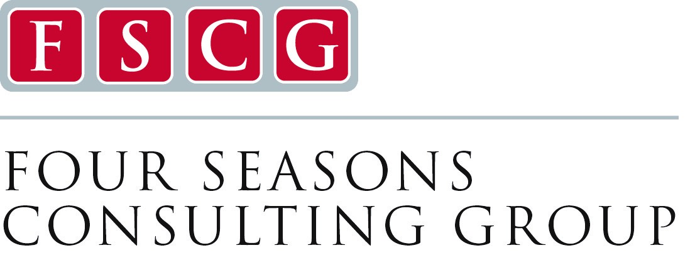
Palliative Care Program Development Workshop

Program Directors: John Morris, MD and Janet Bull, MD, MBA
Join our team in a dynamic educational experience aimed at
Building and Enhancing a Palliative Care Program.
September 30 – October 1, 2019
Asheville NC

- Are you interesting in developing a new community based palliative care program?
- Are you interested in expanding and growing your current palliative care program?
- Do you want to see improved clinical and financial outcomes from your palliative care program?
- Do you want to prepare your organization for serious illness care contracts with payers?
Who Should Attend: Those interested in developing, expanding, or improving Community Based Palliative Care, along with those who want to improve operations in service delivery. Bringing clinical and organizational team leaders is encouraged.
Description of Course: In this 2-day intensive, interactive course, participants will learn how to build and improve operations on running an effective and efficient community based palliative care program that focuses on a person centric approach to care and aligns with improved quality, leading to reduced hospitalizations and increased hospice transitions. Small groups with intensive faculty mentoring will help your team leave with a practical plan tailored for your program.
We will discuss and show programs how to determine gaps of care and opportunities to grow your program strategically in your community. We will discuss how to partner with hospitals, nursing homes, hospice, cancer centers, assisted living facilities, ACO’s and payers to provide value and get reimbursed for services. We will demonstrate how to align care with patient’s needs and develop an efficient system for patient care. We will discuss working with payors and designing a program that aligns with reimbursement.
Tools will be shared which may include: recruitment and eligibility, marketing, billing and coding, productivity, patient visit templates and metrics to collect.
The curriculum covers:

- Making the Case for Community Based Care
- Models of Community Based Palliative Care
- Leadership of Palliative Care
- Organizational Logistics for a community palliative care program
- Legal and Compliance
- Developing a Business Plan and Financing Palliative Care
- Staffing and Productivity Guidelines
- Quality
- Important Data and Metrics
- Marketing and Growing Palliative Care

For More Information Contact
Lisa Massie
828-233-0359; lmassie@fourseasonscfl.org
www.fourseasonsconsultinggroup.com

