YouScience In-Depth Results Walk-Through Guide

What You Will Need for the Walk-Through
- Projector or Oversized Monitor
- Computer (for projector)
- Stable Wi-Fi connection
- Log into the YouScience Demo Account to show results (or use your own)
  - Demo account info:
    - Go to www.youscience.com/login
    - In the Email section please type – example@youscience.com
    - Password – DiscoverYou1
- Computers for students to view their results
- Understanding of your own results. Explaining aptitudes is easy when you know your own and can personalize them during walk-through with students.
- Recommended: Copies of YouScience Profile Workbook for students to complete as they review results.

Top Areas to Cover
NOTE: The YouScience Profile contains a wealth of information. You will only walk through some of it today. Encourage students to spend time digging in and learning about themselves. They have access to their Profile for ten years, so they can come back to it as they apply to college, internships, or jobs.

Aptitudes: Emphasize that aptitude levels aren’t high or low- students should be focusing on their greatest strengths- the largest portions of the aptitude “pie.” There are pros and cons to all, and the most important aspect is FIT with a career.

Interests: Interests, unlike aptitudes, will change as a student is exposed to new experiences.

Bookmarking: Encourage students to bookmark any points they feel truly resonate with them, that they find interesting, or want to remember for the future by clicking on the “heart” icon next to each descriptor.

Careers: Encourage students to begin exploring careers and saving those that interest them or have never considered before.

Describing You: Emphasize the power of the Describing You section for use with resume writing, college essays, and internship applications.

Step 1: Aptitudes – Choose 3-4 to Discuss from Core Drivers and Read Over How Each Student Contributes to a Team

Tips for Administrator
Aptitude “Pie”- Have students focus first on the largest portions of the pie (these are their strongest aptitudes). To explore the aptitude more in depth, the student can click on Explore to read more about it.

Point out the following for the Aptitudes you review (to access this information, have students click on “Explore” for each of their aptitudes)
- Definition: About the aptitude in general
- Your Results Show: Your characteristics
- Daily Impact: Tips for work, school, and social life
- Easy & Difficult: Encourage students to come back and review these as they are browsing careers
- Tips for Success: Encourage them to come back and review these as they are browsing careers
- Recognizing in Others: Summaries of each level of the aptitude – how others are different from them

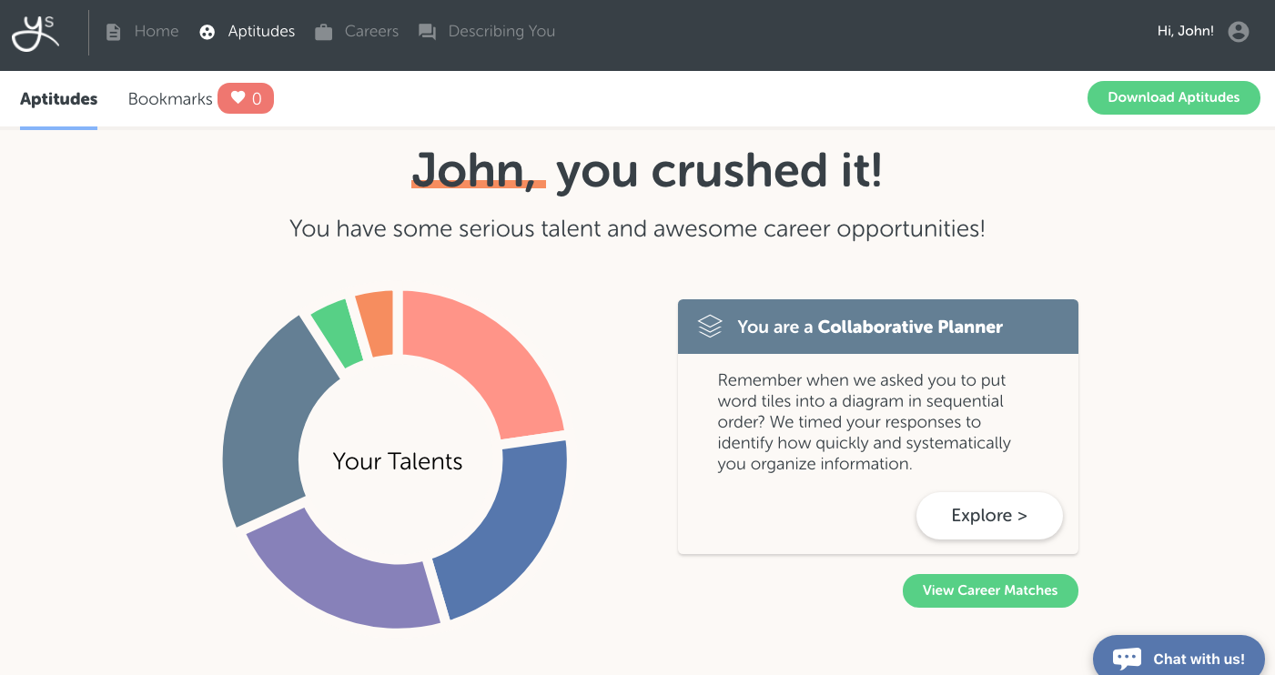

Step 2: Teamwork

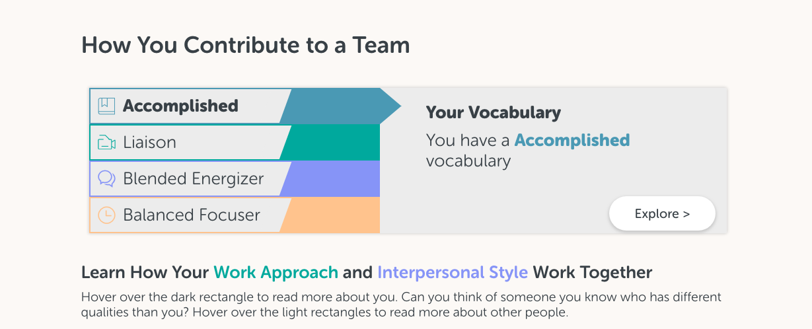
How You Contribute to a Team- Personal Approach
- Vocabulary Levels: Solid, Accomplished, Masterful. Emphasize that this is an aptitude that can really be built upon as students continue to read and write more inside and outside of school.
- Work Approach: Specialist, Liaison, Generalist. Does the student prefer focusing on one passion and digging deep to master that one thing? Or does the student prefer to be involved in multiple areas of work? Encourage students to think of work approach examples from school or teams they are a part of.
- Interpersonal Style: Introvert, Blended Energizer, Extrovert. This personality trait is actually not included in our career matches because every personality type can really be successful in most careers, as long as they have the aptitude(s) for that career. Encourage students to explore the traits of others as well, to fuel discussion about how to collaborate together in a group with many different personalities.
- Timeframe Orientation: Future Focuser, Balanced Focuser, Present Focuser. This aptitude describes how the student sets goals- are they more inclined to set a goal for the future and pursue it long term? Or are they fueled by quick, short term goals?

Interpersonal Style and Work Approach
- Ask students to explore this graph, focusing on the darkest square in the graph (the square that describes them) to learn more about how they interact with others and their work. This is another great opportunity to discuss why each of these combinations are needed in the workplace, and the different traits each of them bring to the table.

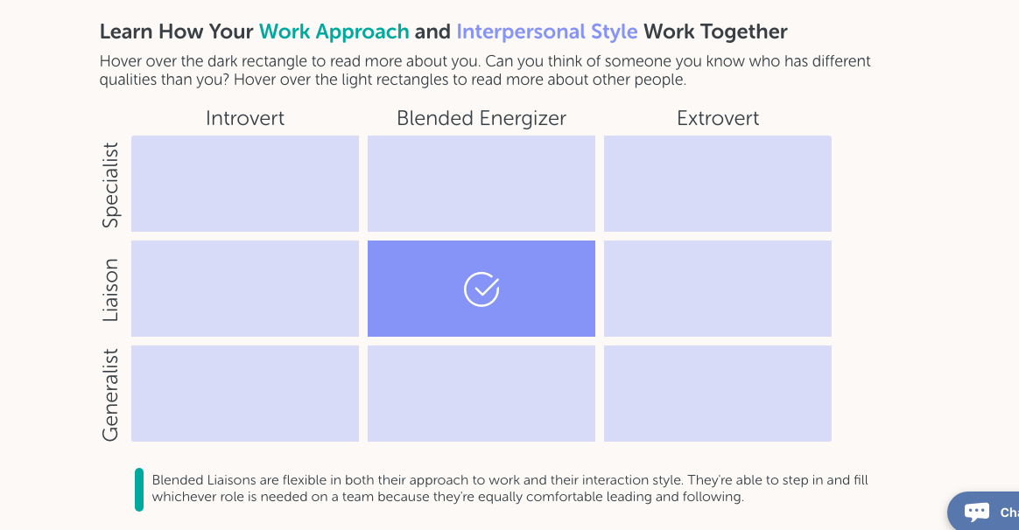

Conversation Starters During Aptitude Review
- Use the following ideas for engaging with students depending on which 3-4 aptitudes you choose to highlight.

Conversation Starters Guide
Personal Approach Aptitudes
Aptitude | Questions | Explanation
Interpersonal Style | When you get home from a party or hanging out with friends, how do you feel? Are you pumped up or are you drained? | - Extroverts gain energy from being around others, whereas introverts lose energy and need time to themselves to recharge.  - Blended energizers might be energized one day and drained the next. Have students think of specific times when this happened to them, and think about how they felt afterwards, so they can connect and identify with their Interpersonal Style.
Time Frame Orientation | Have you thought about your plan over the four-year timeframe of high school? | - Future-focused students will get restless and bored with the “details” of scheduling classes semester by semester as they are solely focused on finishing high school and moving on to bigger and better things.  - Present Focusers need to be reminded to make sure they are doing what they need to be on track for their future goals.
Work Approach | How would you feel if your future boss asked you to sit in a room alone and do a specific project on your own for a week? Would you love it or would you hate it? | - Generalists want to know what’s going on with everything and always be connected to what’s happening. They would hate this situation. They love being connected and knowing what everyone is doing. Generalists are great at using their skills to coordinate people and projects.  - Specialists relish this scenario. They love digging in and becoming an expert on a topic or completing a specialized project. This type of work project is right in their wheelhouse.
Core Driver Aptitudes
Visual Comparison Speed |  | For Double Checkers:  - Do you edit yourself?  - I bet you’re really good at hands-on activities.  - I bet you’re great at staying organized.  For Visual Scanners:  - Does a mistake in a detail get your sidetracked/derailed for the overall objective?  - Be sure to read the instructions thoroughly before you take an exam, don’t rush.
Spatial Visualization |  | For Abstract Thinkers:  - I bet you are great at dealing with abstract concepts.  - Are you usually able to express your feelings easily?  - I bet you have an eye for details.  For 3D Visualizers:  - Do you imagine seeing the world in 3D, angles, depth of field?  - Did you enjoy playing with Legos or K’nex when you were younger?  - Do you find yourself drawing to help organizing your notes?
Idea Generation |  | For Brainstormers:  - Do you edit yourself in group activities?  - Do you frustrate people when working together because you are talking too much, are others hesitant to share because you over share?  - I bet you enjoy debating topics with your friends.  - Do you enjoy creative writing? (stories, songs, poems, etc)?  For Concentrated Focusers:  - Do you find it easier to implement an idea rather than come up with one yourself?  - Are you usually able to express your feelings easily?  - I bet you have an eye for detail.
Inductive Reasoning | In which career is it important to be able to gather facts quickly and make a decision versus taking a slower more methodical approach? Describe the difference between and ER Doctor versus Family Doctor. | For Fact Checkers:  - I bet you are great at gathering all the facts in a situation.  - Have you thought about a career in research?  For Diagnostic Problem Solvers:  - I bet you like detective, suspense, and mystery shows.  - Would you prefer a fast-paced career over a more slow-paced one?

Step 3: Interests
Realistic Investigative Artistic Social Enterprising Conventional
- Since students should pay close attention to their top 3 interest areas, we have highlighted them at the bottom of their aptitude landing page.
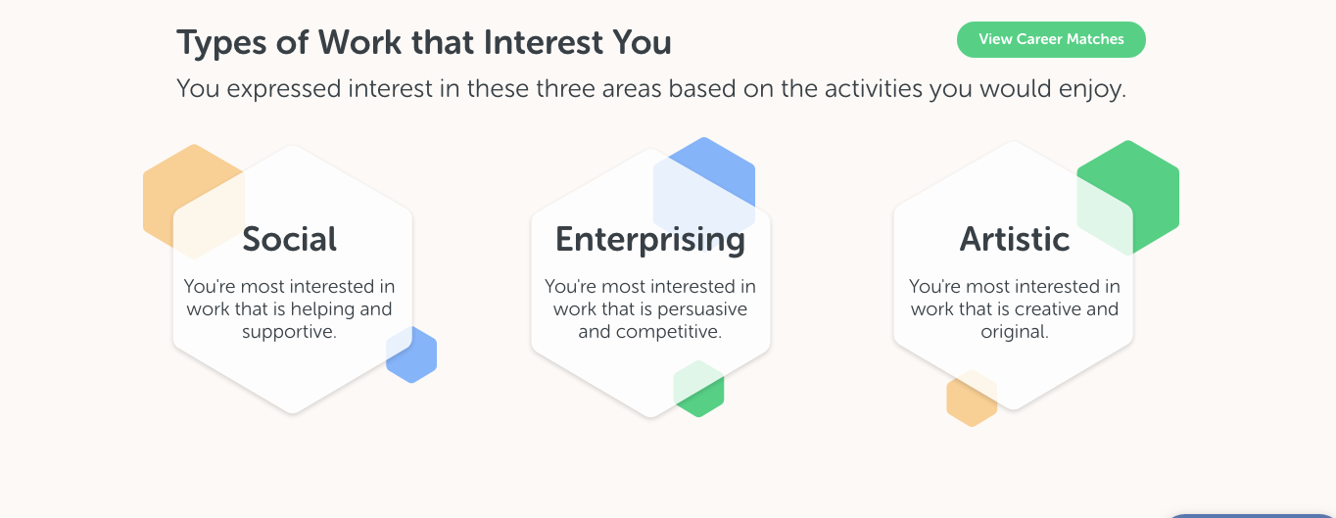

- ASK: How do students demonstrate their interests today? What ideas do they give them for their future?
- It is very important to stress that their interests will change as they are exposed to new things as they go through life, so ask students to keep this in mind as they explore careers.
- Ask students to filter their careers by “Aptitude Fit” to make sure they understand the impact of their interest results on their Overall Fit careers.

Step 4: Download a PDF version of the Aptitude Results
- Encourage students to download their Aptitude Results in the top right corner to Save, Print, or Share with Others.

Step 5: Encourage Students to take the Amplifier Exercises to Fine-Tune their Results
The amplifiers are located at the bottom of the Aptitudes page.

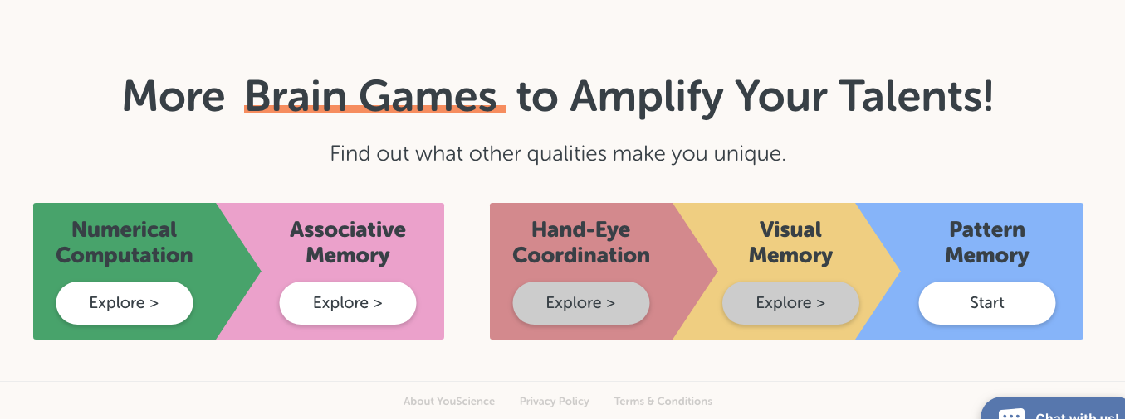

CAREERS

Step 6: Careers
Demonstrate how to sort careers
- Sort by Interest first: These careers fit their interests today. Interests may change with time and experience. Affirm positive qualities about the student. e.g. “Your desire to help people and be altruistic really comes through in your careers here.”
- Sort by Aptitude only: These careers align with their natural strengths. Success will be easiest for them here, but they may lack exposure to these fields. Encourage them to explore each career further.
- Sort by Overall Fit: Aptitudes & Interests combined. Best of both worlds.

Save Careers
- As you go through career matches, encourage students to SAVE any careers that peak their interest, any that surprised them, or that they may have never heard of before and want to learn more.

Pick a Career to Explore
- From Aptitudes & Interests combined (Overall Fit) and click on the Career Card.

Highlight the Following in the Selected Career:

A Day in the Life
Career Description; Core Tasks: VERY valuable, gives them a sense of what being in this career is really like. Encourage thorough exploration of this area.

Aptitude Fit Analysis Graph
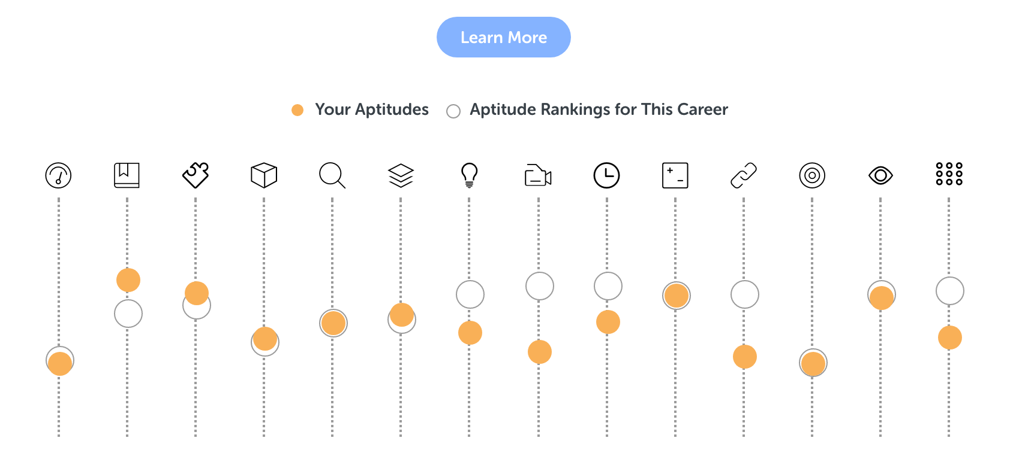
- Alignment between their aptitude levels (orange circles) and career aptitude levels (white circles)

- Use terms match and mismatch to describe Aptitude alignment. If a student’s aptitude is below career-level: They could get frustrated and find it more challenging than others. If their aptitude is far above career-level: They may get bored or restless since they aren’t getting to use and express this area. Discuss hobbies your student could participate in to fulfill this area.

Education
Scroll through Educational Requirements, Commonly Held Degrees, Best Majors or Career Programs.
- Click the Major within a career to learn more about each one. Look at Related Careers (other careers you can pursue with this major).

Salary & Jobs
Click on a specific State to see Salary Range and Growth Rate / Job Openings. Also point out the different Industries people in this career work in (broadens their sense of what this job is).

Step 7: Saved Careers

Top 4 Careers
- Have students drag & drop their Top 4 favorite careers into the dotted box to rank and prioritize their favorites.

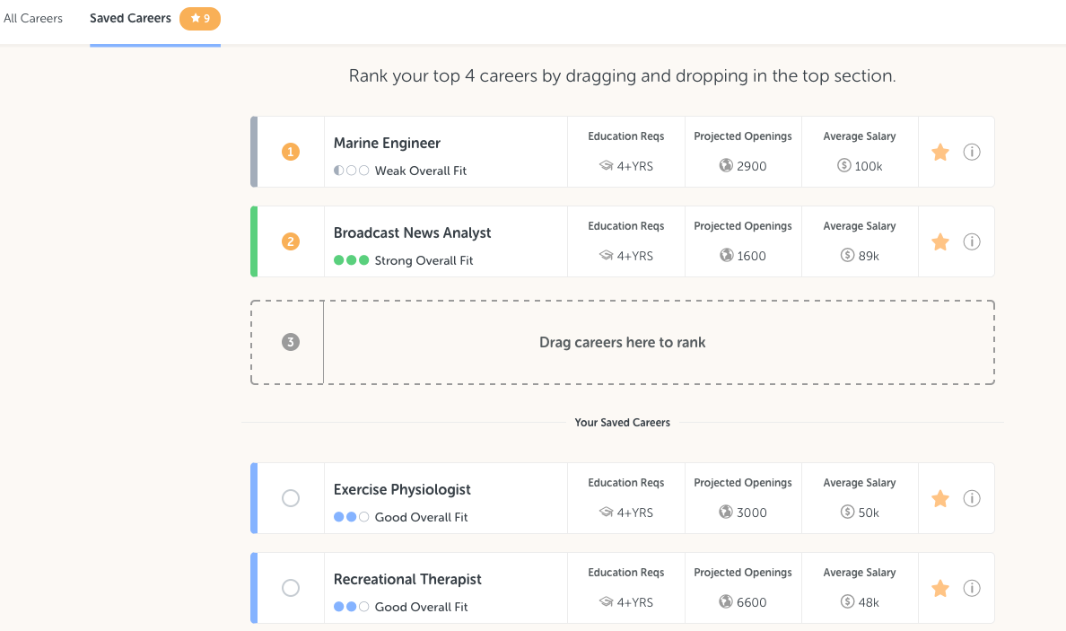

Step 8: Describing You

Terms that Describe You

- These are terms and keywords that can be used to describe yourself to others. These terms are pulled from all of your aptitudes. Use them in bullet points or on applications or resumes. Remove anything you don't agree with by clicking the blue circles to the left of the term.
- The initial state is that every keyword is selected, but this allows students to curate their results, so that it is maximally meaningful to them.

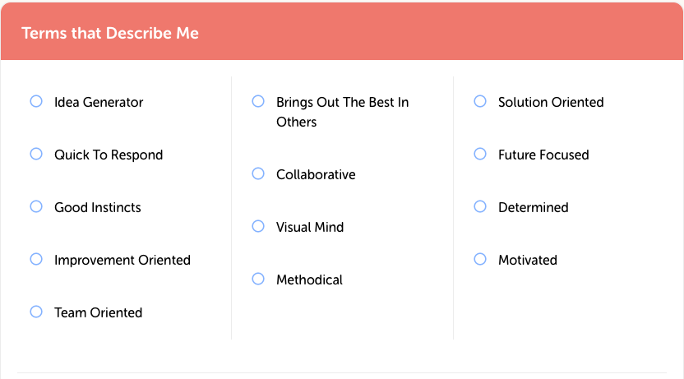

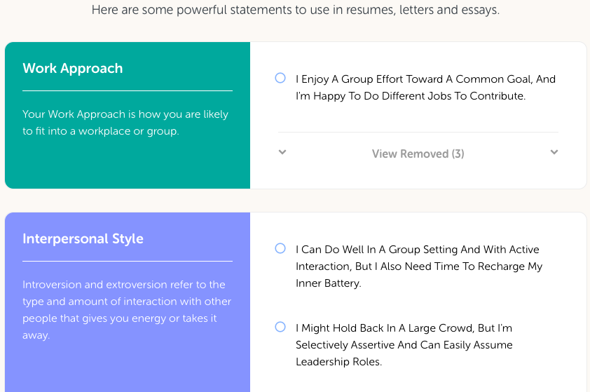
Aptitude Statements

- These can help describe how you work and think. These statements are grouped by aptitude. They can give you some great talking points for interviews and great statements for college essays or cover letters. Click to remove anything you don’t feel applies to you, to further personalize your Discussion Guide. Discuss ways they can use the Discussion Guide – college essay writing, cover letters, resume building, interviewing, letters of recommendation, etc. Encourage them to download their Discussion Guide in the top right corner to save, print, or share with others.

You’re done!

Encourage your students to keep exploring and digging deeper within their results. Remind them that they can review their Bookmarked information under the My Aptitudes and Careers page. Also, be sure to point out the Downloadable Results Report and Discussion Guide within the Aptitude and Describing You sections as supplementary tools to share with parents and advisors.

