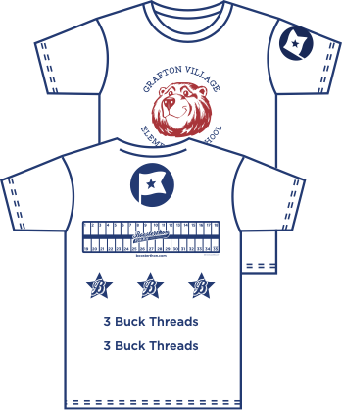

[SCHOOL NAME] is so excited to host a Fun Run (powered by Boosterthon) to help our school! Boosterthon is a fun, nine-day program that combines world-class character content with a highly-profitable fundraiser.

To increase the excitement and school spirit of this event, we’re hoping to provide each student with a FREE custom t-shirt to wear the day of the Fun Run event, at no cost to our school.

In order to make this happen, we need your help! We’re hoping to partner with local businesses to help sponsor our shirts. If your business would like to sponsor our t-shirts, please see the information below for pricing and details. Your logo or name will be displayed on the back of a shirt worn by [ENROLLMENT #] students year-round, providing continuous exposure for your business! Thank you so much for your consideration!

OPTIONAL: INSERT SPONSORSHIP BUNDLES HERE

Premium Ad ($750)

OPTIONAL: INSERT SPONSORSHIP BUNDLES HERE

Name Ad ($250)

OPTIONAL: INSERT SPONSORSHIP BUNDLES HERE

Sleeve Ad ($1000)

OPTIONAL: INSERT SPONSORSHIP BUNDLES HERE

Regular Ad ($1000)

| Contact Info | |
| --- | --- |
| School |  |
| Name |  |
| Email |  |
| Phone |  |

All donations are tax deductible. Please send your name, phone number, and business logo (or name) to email address below by [DATE] to secure your spot. Please make checks payable to [SCHOOL/PTA/PTO] and mail to [SCHOOL ADDRESS] by [DATE]. Our contact info is below if you have any questions. Thanks so much for sponsoring our shirts!