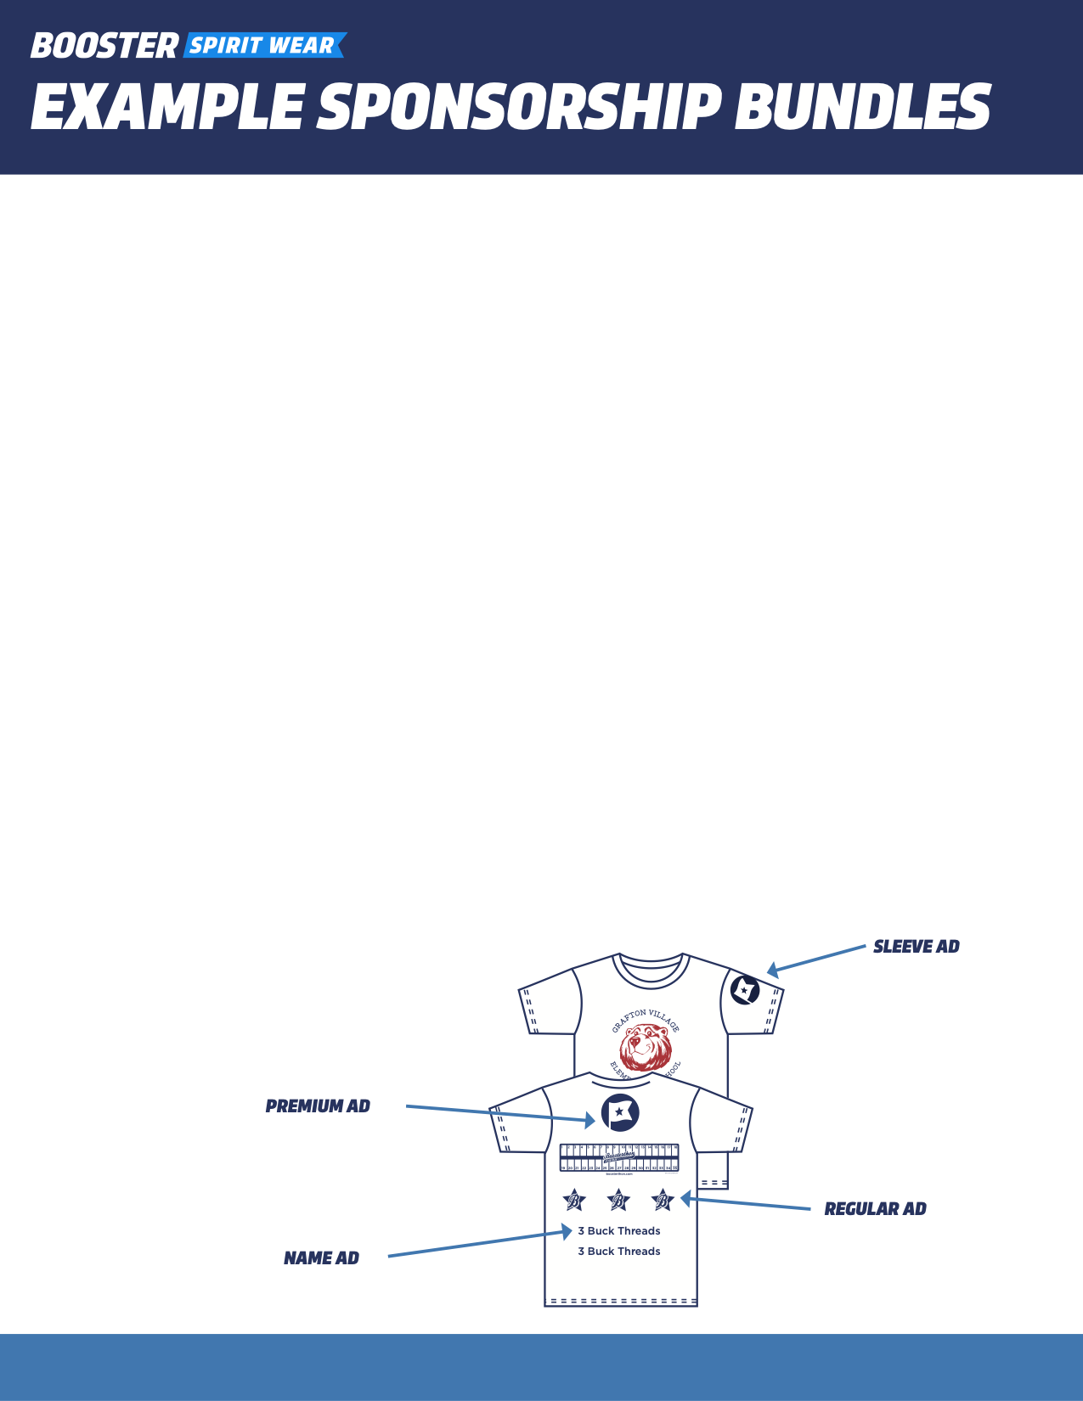

Below are a few examples of sponsorship bundles. Feel free to edit them for what best fits your school and community!

Sleeve Ad ($1000)

* Ad on the sleeve of Boosterthon T-shirt
* Information table at the Fun Run (no selling/no food)
* Company signage (provided by company) to display at the Fun Run
* Name announced at Fun Run and listed on other marketing material
* Sponsor logo placed on School/PTA/PTO website or Facebook page
* One t-shirt

Premium Ad ($750)

* Large ad on the back of Boosterthon T-shirt (above or below the track)
* Company signage (provided by company) to display at the Fun Run
* Name announced at Fun Run and listed on other marketing material
* Sponsor logo placed on School/PTA/PTO website or Facebook page
* One t-shirt

Regular Ad ($500)

* Medium ad on the back of Boosterthon T-shirt
* Name announced at event and listed on other marketing material
* Sponsor logo placed on School/PTA/PTO website or Facebook page
* One t-shirt

Name Ad ($250)

* Name on back of Boosterthon T-shirt
* One t-shirt