NOTICE OF CANCELLATION

PUBLIC HOSPITAL DISTRICT NO. 1-A
OF WHITMAN COUNTY
d/b/a
PULLMAN REGIONAL HOSPITAL

The Regular Meeting of the Board of Commissioners

scheduled for Wednesday, September 4, 2019

is cancelled.

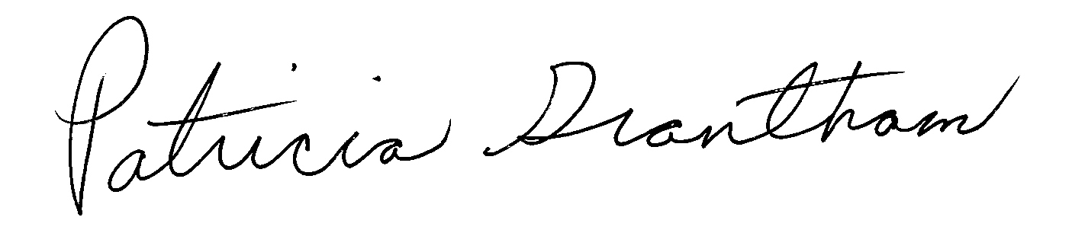
Patricia Grantham, President
Board of Commissioners
August 26, 2019

