**Crisis Now: Change is Underway**

**Business Case**

We have arrived at a time of great opportunity. A perfect storm in which psychiatric boarding challenges, escalating healthcare costs, public safety concerns around mental health and higher rates of incarceration for individuals experiencing mental health issues have solidified a desire to change how we address acute mental health needs within our communities. We have an opportunity to truly deliver on the commitment to better health outcomes, improved experience for those with acute mental health needs and dramatically lower healthcare costs through the implementation of a recently established set of crisis care service delivery standards.

The National Action Alliance for Suicide Prevention’s *Crisis Now*: *Transforming Services is Within Our Reach* report and the corresponding business case resources offer a quantifiable, cost-reducing roadmap to replicate systems that are being implemented, in varying degrees, across the United States. The approaches and the levels of care advanced within the *Crisis Now* model already exist in a vast majority of our communities as physical health and first responder system counterparts; so significant aspects of this design are in many ways familiar to healthcare leaders and community stakeholders.

Additionally, tools are now available to calculate the very real impact of developing a comprehensive mental health crisis response system. This data-driven approach that corresponds with the Crisis Now Business Case can be applied to any population through the use of tools on the National Association of State Mental Health Program Directors’ (NASMHPD’s) website [www.crisisnow.com](http://www.crisisnow.com/); supporting independent analysis of cost impact that follows design implementation.

**The Crisis Now Difference**

Crisis Now bypasses the hospital ED and targets 100% access for individuals in need. It paves the way to reducing incarceration of individuals with a mental illness and ending psychiatric boarding in emergency departments. By utilizing advanced innovative practices and tools to assess community need for those experiencing a mental health crisis, this model reduces the cost of care for individuals experiencing a mental health crisis by 50% while dramatically improving the healthcare experience and aligns service to the individual need.

Crisis Now is a replicable and sustainable model that not only advances exceptional practice standards, but also offers corresponding data and tools to (1) predict the number of mental health crisis episodes a community will experience, (2) estimate the number of beds and other crisis resources a community will require to optimally address the need, (3) project the cost of implementing services and (4) evaluate the impact on justice system demands.

Adoption of this model will improve the quality of the crisis system and care for those in crisis in areas that utilize it. The innovation is in the operationalization of practice and standards. The tools created support easy modeling of capacity and service requirements that actually decrease costs by providing the right care at the right time.

Business Case video: <https://youtu.be/GWZKW8PLIgQ>

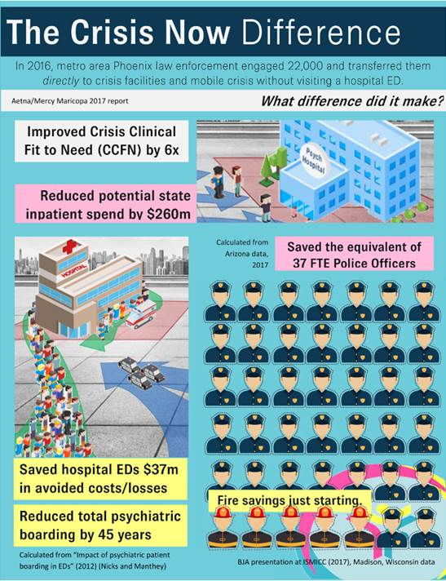

**Core Elements to an Effective Crisis System**

* **Regional or Statewide Crisis Call Centers**. This represents the incorporation of a readily accessible crisis call center that is equipped to efficiently connect individuals in a mental health crisis to needed care. These programs use technology for real-time coordination across a system of care and leverage big data for performance improvement and accountability across systems every minute of every day. At the same time, they provide high-touch support to individuals and families in crisis that adheres to National Suicide Prevention Lifeline (NSPL) standards.
* **Centrally Deployed Mobile Crisis on a 24/7 Basis**. Mobile crisis services are typically comprised of a two-person (licensed clinician and peer partnerships are common) crisis response team that offers outreach and support to people experiencing a crisis in the community (not a healthcare facility). Recently, programs have shown greater success by using GPS-enabled technology dispatched from the crisis call center to efficiently connect individuals in crisis with the nearest available mobile team. Programs should include contractually required response times and medical backup.
* **Residential Crisis Stabilization Programs**. These facility-based programs offer short-term mental health crisis care for individuals who need support and observation. The design of these facility-based programs may vary, but ideally will include a medically staffed flexible observation/stabilization area (often limited to 24 hours of care) that implements a no referral refused process in which walk-ins, law enforcement and other first responder referrals are immediately accepted without requiring any form of screening prior to acceptance. These observation/stabilization programs are often paired with some form of subacute short-term (2-5 day) facility-based crisis program (could be inpatient, respite or residential) to offer more than 24 hours of care without escalating to more costly acute inpatient options that would result in longer lengths of stay and higher per diem costs than programs with specific mental health crisis resolution expertise.
* **Essential Crisis Care Principles and Practices**.
  + - Embracing recovery
    - Significant role for peers
    - Trauma-informed care
    - Suicide safer care
    - Safety/security for staff and consumers
    - Crisis response partnerships with law enforcement



The Retreat Model video: <https://youtu.be/QtnJrVZxTkU>

**Assessing Crisis Services Intensity Need**

Due to the lack of a crisis system, individuals in crisis often interface with the justice system, first responders, hospital emergency departments (EDs) and correctional facilities. These resources are essential to supporting a healthy community, but are not designed to meet the unique needs of individuals experiencing a mental health crisis. The diagram below represents potential paths of flow for individuals experiencing a mental health crisis. We estimate that for every 100,000 members of a representative population, 200 of those population members will experience a crisis that requires something more than a typical outpatient or phone intervention. Research has offered data that can be used to stratify the service level needs of those individuals and that data can be applied to most efficiently design a cost-effective service delivery system.

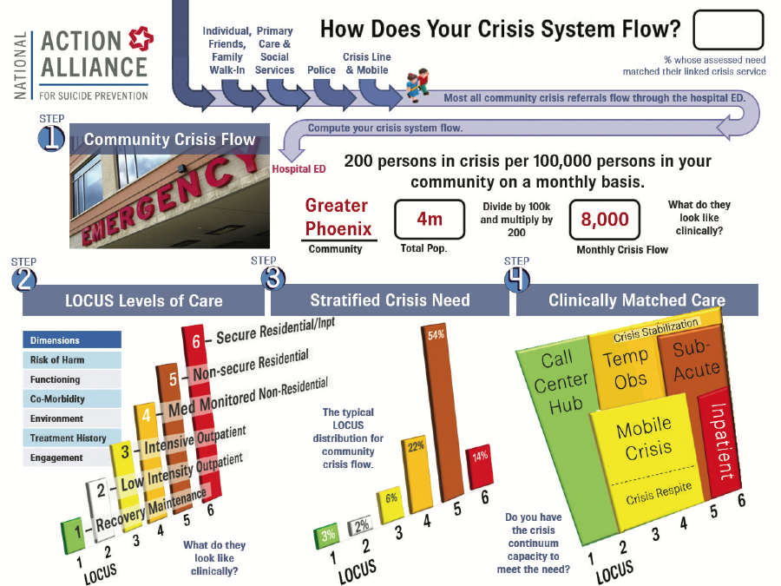

**Crisis Now Outcomes**

*Crisis Now Transforming Crisis Services: Business* *Case* suggests that a comprehensive crisis system is affordable and within our reach. The cost of crisis services is covered by the decreased spend on the more expensive traditional hospital based services. The savings can fund a comprehensive crisis system and radically transform behavioral health delivery.

The *Crisis Now* *Business Case* profiles Maricopa County, Arizona, which includes the greater Phoenix area. There, the associated savings of a crisis system containing all three core aspects of a crisis system have included:

* + 37 full-time equivalent (FTE) police officers engaged in public safety instead of mental health transportation/security;
  + Reduction in psychiatric boarding of 45 years annually; *and*
  + Decrease in inpatient spend by $260 million.

Arizona in Operations video: <https://youtu.be/ORq1MkODzQU>

Recent NASMHPD Paper Describing the Calculator and Business Case: <https://www.nasmhpd.org/sites/default/files/TACPaper5_ComprehensiveCrisisSystem_508C.pdf>

**Needs Calculator developed by RI International**

*\*Example of a table produced by the* *Crisis Resource Need Calculator*

***References***

NASMHPD’s *Crisis Now website*, [www.crisisnow.com](http://www.crisisnow.com/).

*A Comprehensive Crisis System: Moving Toward Zero Unnecessary Emergency Room Admissions and Zero Unnecessary Jail Bookings.* NASMHPD’s Technical Assistance Coalition Contract/Task Order: Alexandria, V, Broadway D. E, and Covington D. National Association of State Mental Health Program Directors. (2018).

*Business Case, the Crisis Now Model.* This business case builds on the foundational model: Covington, D, Hogan, M, et al. *Crisis now: Transforming services is within our reach.* National Action Alliance for Suicide Prevention: Crisis Services Task Force. (2016).

National Action Alliance for Suicide Prevention: Crisis Services Task Force. (2016). *Crisis now: Transforming services is within our reach*. Washington, DC: Education Development Center, Inc.

National Action Alliance for Suicide Prevention: Crisis Services Task Force. (2016). *Crisis now: Transforming services is within our reach*. Washington, DC: Education Development Center, Inc.

Interdepartmental Serious Mental Illness Coordinating Committee (ISMICC). The Way Forward: Federal Action for a System That Works for All People Living with SMI and SED and Their Families and Caregivers. (2017). 79