**BTOES19 Award Submission**

**Best Achievement in Operational Excellence to deliver Business Transformation**

**Synopsis**

Aprimo, a global provider of marketing technology solutions for content, operations, and performance, was [divested](http://resources.aprimo.com/press/teradata-s-marketing-operations-division-is-reborn-as-aprimo) from data warehousing giant Teradata in July 2016. New owner, private equity firm Marlin Equity Partners, had faith in the company, which suffered during the Teradata tenure.

Founded in 1998 in Indianapolis, Aprimo--once considered one of the city’s brightest tech startups with $69 million in revenue in 2007--devalued from $525 million in 2011 to $90 million in the sale.

Though the company pioneered the marketing operations space, it was in a place of complex transition after the divestiture, as it was left with no operational infrastructure out of Teradata, and was facing increased competition amidst a changing market. Aprimo leadership sought a business transformation to help the organization stabilize, evolve, and regain its renowned status.

After extensive customer and market discovery, the company created a broad scope of strategic, operational transformation initiatives designed to generate value in the market and benefit customers, including standing up a new best-in-industry operational model, a series of acquisitions, multiple product enhancements, and a complete rebranding/relaunch. Aprimo’s successful business transformation has enabled it to:

* Offer an expanded, integrated, cloud-based platform
* Increase its customer base by 18% and new-name pipeline by 302%
* Earn leadership category recognition from research firm for 3 different products within the same year

**Strategic Objectives and Scope for Operational Excellence deployment**

CEO John Stammen---one of several executives brought back to Aprimo to lead the business transformation--had a clear objective and scope for the company’s future.

“Our vision is to be the platform that connects the marketing ecosystem,” he said in a  [media report](https://www.ibj.com/articles/59549-aprimo-getting-new-life-under-new-ownership-old-name) about the divestiture. Aprimo also sought to be the #1 global Marketing Operations and Digital Asset Management (DAM) technology company by 2020.

The company’s **short-term, 1-2 year business transformation strategy** included a full restructuring of the entire company, new operating principles, a new alliance program, an expansion of the product portfolio with acquisitions, and a cloud migration.

Aprimo’s **long-term, 3-5 year strategy** focuses on product enhancements, external integrations, and various and various outreach and education initiatives to help once again make the company top of mind for brands and industry influencers.

**The Operational Excellence implementation and timeline**

As soon as the divestiture ink was dry, Aprimo began implementing its short-term business transformation strategies.

* In July 2016, it [purchased](http://resources.aprimo.com/press/marlin-completes-acquisition-of-revenew-and-announces-the-relaunch-of-aprimo-brand) Revenew, Inc., a provider of through-channel marketing automation, which enables enterprise brands to market to, through and for their channels. The move was designed to support the company’s desire to connect the marketing ecosystem.
* In March 2017, it [purchased](https://www.cmswire.com/digital-marketing/aprimo-acquires-adam-software-to-enhance-its-dam-strength/) ADAM Software, a leading global provider of enterprise-class Digital Asset Management (DAM) software, a strategy that would launch Aprimo into a new market to better align it with where the industry was going.

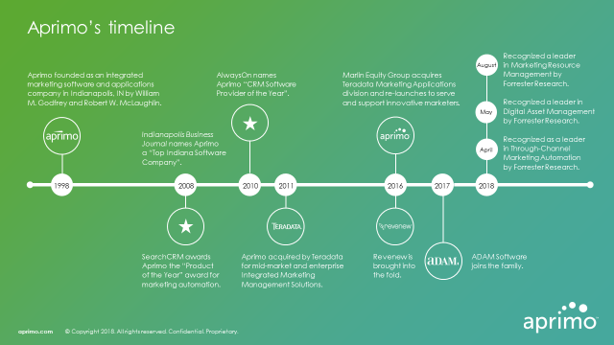

In November 2016, Aprimo began migrating its solutions to a SaaS-based model via the [Microsoft Azure cloud platform](http://resources.aprimo.com/press/aprimo-launches-marketing-operations-platform-on-microsoft-azure-2). The initiative was driven by the desire to create a strategic partnership alliance program, respond to a market demand for cloud services, and provide quicker activations and enhancements for its solutions.

As these short-term business transformation strategies took shape, Aprimo also focused on more long-term strategies. The company developed multiple external solution integrations and developed various outreach to not only gather insights on how the market needed its products to evolve, but also to reassure everyone that [Aprimo is back](http://resources.aprimo.com/youtube-all-videos/we-are-back).

Such initiatives included:

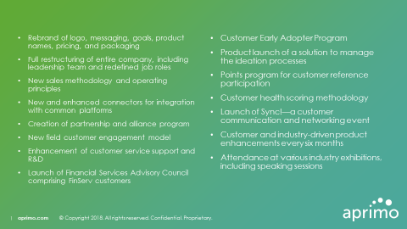

**The Size of the Deployment Challenge**

Aprimo’s business transformation deployment encompassed **all divisions** within the company, including its new headquarters in Chicago, and other offices in Indianapolis, Raleigh, London, Ghent, Amsterdam, Beijing, Manila, Melbourne, Paris, and Frankfort. **All 400 employees**—spanning leadership, sales, marketing, product, and other groups—were involved in the business transformation.

Aprimo not only has been able to connect the marketing ecosystem as it originally intended, but also transform itself into an Experience Command Center that manages all the behind-the-scenes activities involved in creating great customer experiences.

**The Impact of the Operational Excellence Deployment**

As [Aprimo’s business transformation was enterprise-wide](http://resources.aprimo.com/aprimo-in-the-news/why-this-chicago-company-decided-to-rebuild-its-culture-from-scratch-built-in-chicago) and continually evolving, the company developed a new HR training/on boarding program, a company-wide process to establish enterprise core values, and trained **100% of employees** to be ambassadors of the new brand.

In addition to the **4 short-term and 15 long-term operational excellence projects** listed above, Aprimo also initiated an industry influencer program and several research initiatives to help it keep pulse on the market, as well as provide customer outreach. While **100% of the short-term projects are complete**, **100% of the long-term projects have been kicked off** and are enjoying success as they continue to evolve.

**The Organizational Results of Operational Excellence Deployment**

Aprimo already achieved some of the general sales and customer retention goals of its business transformation initiative. For example, it has **increased its customer base by 18%,**

from 173 to 204, resulting in **104% ARR**. The company also **moved 20% of its customers to the SaaS-based environment** and now receives **55% of ARR from SaaS solutions**.

Further, Aprimo gained a greater presence in the industry for its platform, receiving a leadership category recognition for three different solutions from an [independent research firm](https://www.aprimo.com/forrester-wave-marketing-resource-management/). Other further growth and industry recognition results include:

* **302% increase** in new name pipeline
* **44% increase** in active users for its Marketing Operations solution
* **53% increase** of new website visitors
* **44% YOY increase** in published media articles
* **518% YOY increase** in media impressions

**Conclusion**

Aprimo has come a long way with its business transformation spurred by its divestiture and need to regain a leadership position in the market as well as with customers. “The New Aprimo,” as it has been called during the transformation, is delighted to once again be an independent organization, CEO Stammen said. “We’re humble and we’re hungry,” declared John Stammen, Aprimo’s CEO. “We are grateful for our customers and we are eager to continue to the journey towards smarter marketing with them.”