TRANSFORMING CULTURE FOR MEANINGFUL CHANGE AT WEATHERFORD
SYNOPSIS
As one of the largest global oilfield service companies, Weatherford operates in more than 90 countries; employs approximately 28,450 people; and leads the oil and gas industry in disciplines such as managed pressure drilling, tubular running, and artificial lift. Growth through acquisitions coupled with a lack of integration resulted in a disjointed company without a common identity.
Following the introduction of Mark A. McCollum as President and CEO of Weatherford, the company set out to transform its culture in April of 2017 with these objectives:
- Transform the business into one defined company
- Create a collaborative, inclusive, and effective workplace
- Empower employees to drive improvements
At the same time that Weatherford embarked on a cultural transformation, it began a financial one to uncover $1 billion in improved recurring earnings by year-end 2019. In short, it began an aggressive endeavor – two simultaneous transformations executed across one multinational organization.
The cultural transformation, which is the focus here, helps to realize sustainable improvements to business performance in parallel. As Mr. McCollum states, “I firmly believe that a strong culture is a key ingredient to unlocking our full potential.”
In one short year and a half period, the organization has seen a dramatic difference in its culture, and all levels of the organization have embraced the changes. To date, it has created a level of communication and collaboration that is driving company results. In point of fact, the company has implemented transformation initiatives worth an estimated $600 million, or 60% of the $1 billion goal.

CHALLENGES
Over the course of approximately 35 years, Weatherford grew by acquiring more than 250 companies. Each of these companies brought their own employees, processes, and cultures; however, they were never fully integrated into the parent organization. Longstanding operation as a portfolio company with various product lines also made it difficult to define the culture. This company’s culture was particularly incohesive and muddled by divisions in product lines and geographic regions.
The company’s varied philosophies and systemic inefficiencies, from the sales organization all the way to the payroll department, negatively impacted its ability to achieve its full potential. Thus, at the time of the former CEO’s departure, the company carried a significant burden of debt and a fractured culture.

IMPLEMENTATION
MOTIVATING THROUGH A MISSION STATEMENT AND CORE VALUES
With the new CEO Mr. McCollum at the helm, the company embarked on a cultural transformation to set the stage for its future. In his first month, the communications and marketing team introduced a mission statement and core values for the organization.
The mission statement expresses the company’s purpose to deliver innovative technologies and services that meet the world’s current and future energy needs in a safe, ethical, and sustainable manner. It also emphasizes its commitment to serving customers as a trusted business partner.
Similar to the mission statement, the core values help to elucidate long unspoken ideals of the organization. The following six values not only guide the everyday actions of the global workforce, but also establish the foundation of a strong culture:
- Ethics and integrity – An unwavering commitment to act respectfully and responsibly in all work
- Discipline and accountability – A commitment to work toward goals and deliver on them
- Flawless execution – A relentless pursuit to deliver maximum value and achieve high safety and service quality
- Collaboration and partnership – A dedication to building strong, transparent relationships with customers, partners, and colleagues to further the shared mission
- Innovation and technology leadership – Inspiration and drive to create value-added technologies
- Commitment to sustainability – A focus on the diversity of our enterprise and an awareness of the impact of our actions
With the introduction of a new mission statement and core values, the company reinvigorated a “One Weatherford” spirit to unify the organization. Articulating these things also helped to shape the company’s identity as one entity while making fundamental changes to the business.
Another initial step the company took to bolster the foundation of the company was to conduct a thorough and comprehensive evaluation of the way it operates. After a hard look at the entire organization, it was evident that there was a lot of room for improvement in efficiency and consistency.
The company addressed these areas for improvement head-on with an organizational realignment. The new structure clarifies responsibility, prioritizes process discipline, and solidifies a strong connection between operational leadership and field-level decision makers. By breaking down silos and creating alignment to a common set of goals and objectives, the company built accountability into its fabric.

CONNECTING THROUGH CULTURE-SHAPING SESSIONS
Weatherford engaged Senn Delaney, a leading culture-shaping firm, to help on its journey. Further, the company is now taking the principles introduced and making them its own. Mr. McCollum had used the firm several times when working at Halliburton and Tenneco and seen its effectiveness. In fact, Larry Senn, the founder and widely recognized father of corporate culture, was a personal mentor for him.
The culture-shaping sessions help employees to unpack their current mindsets, or unfreeze, and ultimately find ways to be more productive, less stressed, and live in the present moment both at work and at home. First, the top 700 people in the organization went through a two-day leadership program. Now, the next 4,000 people, down to the front-line managers, are participating in unfreezing sessions to create a commonality of culture that drives the company forward. Every participant is asked to cascade the message further down through the organization.
The unfreezing sessions use multiple exercises that benefit the participants and organization as a whole. As one example, the sessions teach the concept of “Be Here Now,” which encourages them to focus on the task, or person, at hand with full attention. This focus can enhance work/life balance, create more fulfilling relationships, reduce stress, improve creativity, and increase productivity.
The sessions also teach the concept of the accountability ladder so that participants can transform themselves from whiners into winners. By working problems up the rungs of the accountability ladder, they can reflect on their decisions and consider proactive actions to improve outcomes—challenging themselves to ask “What more can I do to get the desired results?”
Another key concept is blue-chip priorities. The session challenges participants to think about their “blue chips,” or their most important professional and personal priorities, and to put more focus and energy towards those items moving forward.
All of the concepts in these culture-shaping sessions arm employees with a common language for work and home life. They also give them a safe way to talk about their feelings and understand others’ motives.
Employees who have undergone these training sessions remark on its impact on their overall happiness and perspective. According to Mr. McCollum, one employee remarked, “I don't know how to describe the impact of the two days that I went through except that I had been reborn in terms of how [I see myself] as a leader, as a husband, a father, and the way [I am] as a person.”

EMPOWERING EMPLOYEES TO DRIVE CHANGE
Although the culture-shaping firm led the initial sessions, Weatherford has trained its own employees to present them going forward. Additionally, the company has aligned its values with the teachings in the unfreezing sessions to continue to embed them in the organization. Building off of the “Be Here Now” concept, the company created a “Be the Change” campaign to empower employees to take action when they see fit. The campaign encourages them to be empowered, supportive, driven, open, inspired, and engaged. Given that the company operates in countries across the world, all of these materials are being translated into multiple languages.
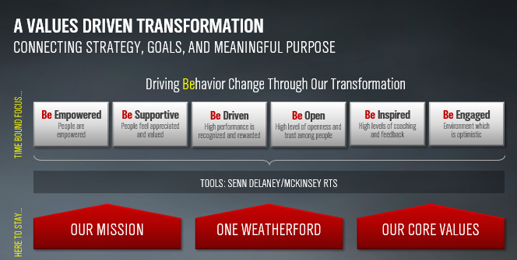
The company has also created a transformation portal for employees to view the progress of the initiatives. They can see updates from the company’s transformation office, read relevant announcements, and submit ideas – no matter how big or small – that could make a difference.
In addition, the company introduced a competition in 2018 to collect ideas for transformation initiatives across the organization. This campaign was called Weatherford’s Got Talent and garnered more than 1,500 ideas from across the globe. The finalists were voted on by employees across Weatherford, and the top three winners were announced during the second annual One Weatherford Day, a global town hall webcast led my Mr. McCollum.
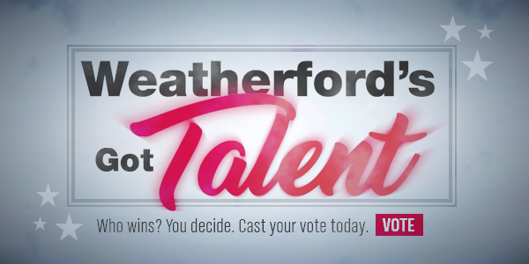
The first annual One Weatherford Day was held in August 2017. This was the first time the company had called all employees together to share in the strategic vision of the organization. Since then, the company has held a number of global town hall webcasts to provide transparency, unite the organization, and give employees a forum in which to ask their senior leaders questions.
Furthermore, the company has focused on diversity and inclusion (D&I) as part of its cultural transformation. With newly created D&I groups, it intends for employees to build relationships and drive change.
DEVELOPING DIVERSITY AND INCLUSION
On March 8, 2017, United Nations International Women’s Day, the company launched its diversity and inclusion (D&I) program. The program aims to provide employees with an environment where they feel comfortable, respected and can thrive. The program includes the following four networks:
- Young Professionals Network – Provides professional and personal development opportunities and increases community engagement
- LGBTQ Network – Creates a supportive, strong culture of inclusiveness so everyone feels fully included regardless of self-identity
- Veterans Network – Improves the lives of veterans, within Weatherford and our communities, through outreach, networking, recruitment, mentorship, and career development
- Women of Weatherford Network – Engages, supports, empowers, and inspires women to foster professional growth, advancement, and leadership
By providing an environment that celebrates diversity across all facets of life – including gender identity, race, age, national or ethnic origin, sexual orientation, veteran status, and more – the company aims to bring the best out of its employees, advance the cultural transformation, and further its own goals.
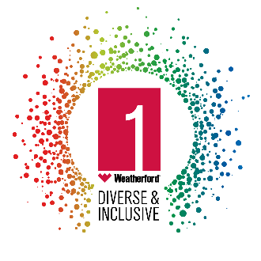 | 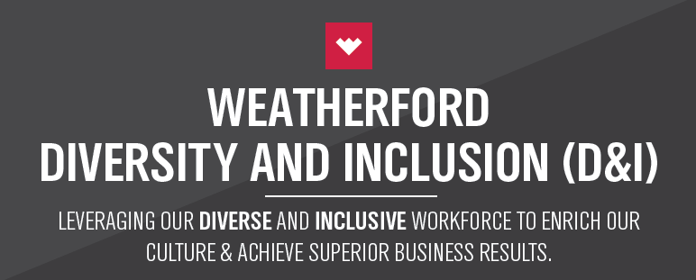

RESULTS
Since the end of 2017, Weatherford has successfully implemented an aggressive transformation to make substantial improvements to the bottom line. The cultural transformation has made meaningful contributions to the overall company performance. Defining the company mission and values, conducting culture-shaping sessions, and establishing D&I networks have all fostered internal collaboration to unite toward the common goal.
EBITDA results clearly indicate the positive impacts of the transformation program, of which the cultural program is a large part, so far. Through the third quarter of 2018, the company has increased EBITDA by 60%, or $195 million, compared to the year-to-date levels last year. This increase well outpaces the company’s largest peers. Approximately $150 million, or about 75% of the $195 million, is a direct result of the transformation efforts.
To add to that, every quarter, the company is executing transformation initiatives worth approximately $200 million. This execution rate gives a clear line of sight to reach the target of $1 billion by year-end 2019, which is on schedule with original plans. As well, it represents the increased productivity, inspired motivation, and firm commitment of Weatherford employees to deliver on the ultimate financial goal.

