BUSINESS TRANSFORMATION & OPERATIONAL EXCELLENCE AWARDS

Best Achievement in Operational Excellence to deliver an outstanding Customer Experience Excellence

Implementation of Bank of America Voices

**Synopsis**

Bank of America is one of the world’s leading financial institutions serving 67 million consumer and small business clients with 4,400 retail financial centers, 16,100 ATMs, and award-winning digital banking with 36 million active users, including 26 million mobile users.

Our purpose is to help make financial lives better through the power of every connection.

In order to improve our client-centric culture of operational excellence, a key opportunity was identified to improve the quantity, quality, and timeliness of feedback from our clients.

The charter for a transformational initiative was created, with the primary goal of providing a centralized client experience survey platform for the Consumer Bank, enabling timely, actionable client feedback to be rapidly communicated and integrated throughout the business to improve client experience.

This initiative had several components such as survey redesign, migration from multiple vendors to a single platform, installation of a rules-based decision engine to optimize sampling, and the implementation of customized dashboards providing real-time feedback to employees at every level in the Bank.

The outcome was an immediate improvement in client experience driven by employee behavior. The real-time feedback enhanced our culture of coaching and recognition, enabling client-facing employees to see scores and comments from clients and understand how each employee can drive satisfaction through their own actions. Additionally, we have transparency to process improvement opportunities through the implementation of a ‘closed loop’ process, whereby dissatisfied clients are identified and contacted by management to resolve any open issues.

**Strategic Objectives and Scope**

This project aligns to Bank of America’s responsible growth strategy, which includes our customer-focused strategy to deliver exceptional client care through every connection at every touch point. This project was initiated to transform our Consumer and Small Business organizations to be better connected to our clients through their direct feedback, improving accountability at every level and enabling client-driven process improvement.

The scope of this project was defined as all surveys for our Consumer Bank and Small Business clients:

* 14 surveys at 5 vendors (this includes surveys for interactions that occur at/with Financial Centers, Contact Centers, ATMs, Mobile Banking, Online Banking, IVR, Merrill Edge, Small Business, Home Loans Origination, and Collections)
* 67MM clients
* 60K employees within Consumer and Small Business that have direct and indirect impact to client experience

The objectives of this project were to:

* Survey simplification and redesign which aligned the questions in the survey to employee behaviors for insights, accountability, and measurement. This includes shortening the length of the surveys to improve client response rates.
* Migrate surveys from 5 separate vendors to one platform at Medallia, enabling a ~~more~~ holistic view of our clients as they interact with us across multiple channels.
* Build and install a rule-based decision engine that enables us to manage the survey sample to accurately reflect our client population across businesses and interaction methods.
* Deliver customized dashboards to all employees to share real-time feedback from clients.
* Implement a ‘closed loop’ process whereby dissatisfied clients are identified for direct outreach by management and problem resolution.

**Project Implementation Methodology & Timeline**

This project initiated with a Request for Proposal effort to find the right vendor partner who could best accomplish the transformational objectives set forth in the project charter. Once a vendor was selected, the team utilized Bank of America’s waterfall methodology to structure the overall project deliverables timeline (e.g. planning, requirements, communication and learning plans, etc.).

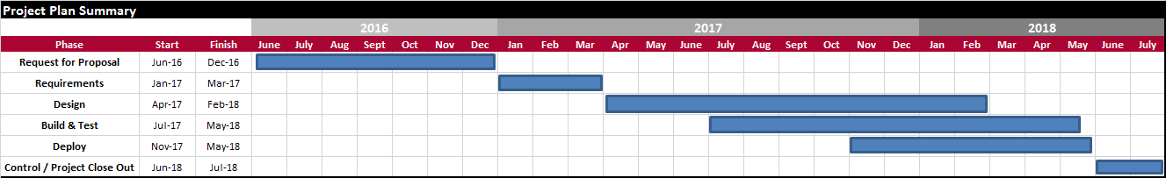

After the requirements were finalized, the team realized the scope magnitude and complexity was larger than originally plan. For this reason, the team began to leverage a more iterative and agile approach to design, build, test and deploy each of the fourteen survey programs. The following outlines the different deployment events that were completed for the Voices project:

* November 2017 – Client Services, Online Banking, Mobile Banking, ATM
* December 2017 – Financial Center, Small Business Banker, Merrill Edge Field
* January 2017 – Merrill Edge Home Office
* February 2017 – Merrill Edge Premium Elite
* March 2018 – Home Loans Servicing
* April 2018 – Home Loans Originations (First Mortgage and Home Equity)
* May 2018 – Collections and Recovery

**Challenges**

**Data**

* Standardizing the data dictionary across each of the surveys for each business and interaction type created challenges as the metadata and labeling was specific to each survey and/or vendor.
* Information Security policies and guidelines are always a critical consideration.
* Concurrent development of data lake (Hadoop) for feedback storage in conjunction with the data standardization had obvious timing and dependency implications.

**Scale**

* The number of employees who will view feedback dashboards and require access is ~60K users
* Fourteen different surveys, connecting to >60MM customers were deployed, replacing existing surveys and their respective datasets

**Schedule & Methodologies**

* The vendor (Medallia) uses their agile project delivery methodology
* The overall initiative to deploy used DMAIC
* Most technology teams used agile methodologies with their own timelines which all needed to be coordinated to the master initiative Work Breakdown Structure (WBS).

**Impacts, Benefits, and Value Generation**

Consolidation to a single vendor increased control throughout the feedback process, creating value by not re-surveying clients too frequently (which drives opt-outs). It is also enabled cross-channel analysis to understand client satisfaction throughout their journeys and across different interaction methods (such as contact centers, ATMs, etc.).

Increased quantity of responses due to shortening and simplifying the surveys enables employees to have more actionable information available for them to react to.

Improved timeliness of feedback is expected to improve employee rate of behavioral change and accountability. With real-time feedback, employees are more likely to recall the interaction and understand what they did well and where they had opportunities for improvement.

This initiative is already driving product~~s~~ and service~~s~~ improvementsand will help Bank of America ~~to~~ grow revenues through improved relationship retention and relationship deepening. A primary component of this value generation is the implementation of a ‘Closed Loop’ process whereby dissatisfied clients are identified through analysis of their feedback (scores, and text comments) and then contacted by a manager to resolve any outstanding issues and concerns. This benefits clients who provide feedback, as they will be contacted for issue resolution. This also enables Bank of America to identify process improvement opportunities by identifying the root cause of client dissatisfaction, sharing findings across the Organization and integrating those learnings into product and process improvements.

**Business Results and Outcomes**

**Client Satisfaction improved 3.1% across all Consumer and Small Business Clients since the launch of Voices.**

Client Satisfaction is a key business driver to revenue growth through relationship deepening and referrals. Since the launch of Bank of America Voices we have seen an improvement of 3.1% across the entire Consumer organization with even greater improvement in several client segments.

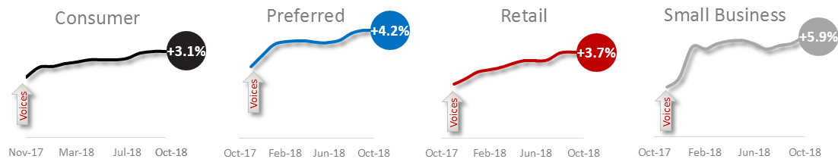

**135% increase in our Financial Centers exceeding Client expectations!**

We have seen some of the most significant client satisfaction results in our financial centers. In the 12 months since launch, Voices has helped drive our greatest single-year increase in client satisfaction. Current scores are at an all-time high and the trajectory remains strong.

* YTD, more than **95%** of our financial centers are consistently exceeding client expectations and receiving scores of 9 or 10 from their customers more than 80% of the time. This is a vast improvement over two years ago when only 40% of our financial centers were exceeding 80% satisfaction levels. The introduction of Voices has helped reduce variability and enabled real-time feedback and coaching so our frontline associates can consistently exceed client expectations.
* Through our ‘closed loop’ process, we have followed up with more than **130,000** clients YTD (who expressed dissatisfaction in survey responses) to ensure their concerns were addressed to their satisfaction.

**90% of Small Business client now rate their Small Business Banker a 9 or 10!**

Since the launch of Voices, we have also seen tremendous improvements in satisfaction across our small business clients. Analysis of their feedback has helped identify key pain points and refocused our efforts on exceeding expectations through advocacy.

* Voices has provided teams with actionable feedback which helped reduce variability and propelled **100%** of small business markets to exceed 80% satisfaction levels.

**Since the launch of Bank of America Voices we have seen a drastic improvement in Client Experience Tracker (CET) scores**

At Bank of America, we also measure Client Satisfaction with our CET metric. This is a weekly performance metric obtained by surveying clients about their channel usage in the last three months (not just the most recent interaction) and their degree of satisfaction. We are consistently yielding **all-time highs** week over week.

