Best Achievement in Technology Enabled Process Automation (Robotic Process Automation, Machine Learning, Cognitive Learning, Blockchain etc )-
This case study is about how a large North American Retail giant, Loblaw Achieved 40 percent automation through a digital transformation. They were looking to increase their IT efficiency by applying automation throughout their processes. Within a short time, Loblaw Transformation path with ignio's AI Solutions accomplished:

Complete end to end solutions for SAP, Delta and ITOperations

ignio office is empowering the SI partners with ignio' s AI Solutions

Diversified implementation owners: ITOps by Cognizant, SAP by Accenture and Delta by TCS

Express resolution SLA commitments

ignio as enterprise wide AI platform for all business needs

Benefits post automation

 Ugo Orsi, Vice President, IT Operations, Loblaw Companies Limited, said: “Loblaw was looking for an AI tool to disrupt its IT Operations. We chose ignio™ for its ready-to-use features and pre-built knowledge of IT and SAP operations. This enabled quick adoption of AI within Loblaw, and laid the foundation for self-healing, machine-managed IT operations. ignio™ is the linchpin of our IT operations transformation program.”
Digital automation benefits: Firstly, a 96% success rate which touches about11,000 servers has resulted in savings in excess of 252,000 Canadian dollars in ignio’s proactive ticket automation resolution in SAP ops alone. For the SAP landscape involved 13 production system across the SAP landscape such as ECC, Solmen, SRM, Xi, BI, CHP, REP which impacted 60 FTEs, 5000 Tickets/month. Secondly, the Infrastructure Services automation touched 20,000+ servers landscape across the company involving 80+ FTEs and automation of 70,000 Tickets/month. Finally, the scope of automation Covered 1200+ pharmacy stores Infrastructure servers impacting 60 FTEs, 10,500 Tickets/month
- 2K tickets/ month
- 10 Use cases Live
- <5 Mins Execution SLA
- 17K tickets/ month
- 35 Use cases Live
- 10 technologies
- 1.5K tickets/ month
- 32 Use cases Live
- <5 Mins Execution SLA

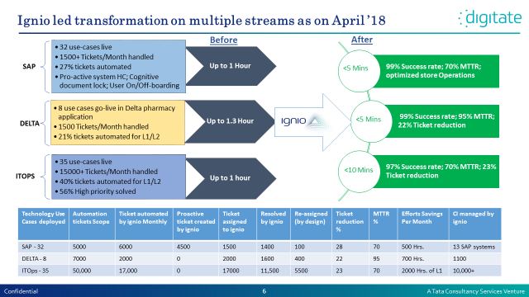

About ignio
ignio is the world’s first cognitive automation solution for enterprises. ignio helps transform the operations of an enterprise and accelerate their journey to become a “digital enterprise”. It eases all aspects of a day-in-the-life of an IT executive, whether it is to keep enterprise IT running and make users happy, plan for business of tomorrow, or eliminate surprises and emergencies.
ignio makes enterprise technology and operations smarter, more responsive and much easier to manage. It replaces industry-standard run-book automation with “cognitive automation”and is a layer of intelligence for the IT enterprise. By self-learning the enterprise’s context continuously and applying this learning to predict future needs and prevent impending failures, it enables a virtual prototyping of enterprises.
ignio delivers optimized, proactive and predictive operations by combining “capabilities” with “connected intelligence”. Capabilities are reusable and adaptable “service automation” modules pre built into ignio for a wide range of technologies. Through it’s innate capabilities, ignio introduces “Services” as software in an enterprise. A notable aspect is its ability to build the context of an enterprise, its underlying inventory by technology, the behavior patterns of each of the nodes and the way the inventory connects to a business applications and business services. The context of an enterprise or otherwise called “Connected Intelligence” is built by seamlessly integrating data from a wide range of sources to create an intelligent and comprehensive view of the organization. The connected intelligence platform enables the customer to:
- Create a 360⁰ view of enterprises’ technology and operations context.
- Make decisions on a course of action in response to events.
- Perform actions using capabilities

About Loblaws: https://www.loblaws.ca/
The first transformation story is about Canada's food and pharmacy leader, with a network of corporate and independently- operated stores in communities across the country, and employing close to 200,000 Canadians.
Loblaw's purpose – Live Life Well – supports the needs and well-being of Canadians who make one billion visits each year to the company’s stores. Loblaw is positioned to meet and exceed those needs in many ways: convenient locations that span the value spectrum from discount to specialty; full-service retail and pharmacies; no-fee banking; affordable fashion and family apparel; and, three of Canada's top consumer brands in President's Choice®, Life Brand®, and no name®. An innovative and transformational company and its brands always deliver new products, they created one of the best loyalty program in the world. One of the four corporate values that drive the group is Excellence. Constantly striving for innovation and superior performance and within the IT Enterprise, the ecosystem was no different in their quest to continuously seek latest and best solutions to drive efficiency and productivity.
We are well aware that we are operating in a digital era. This video can give you a better context on how Loblaw IT Operation is getting ready for the digital era: https://events.gartner.com/#/en/navigator/SYM28/agenda/1427163/sessiondetail/speakers-tab?profilematch=false
The IT Landscape
To give a context to the width and depth of the operations, the automation scope would have impacted 150,000 employees that were serving customers across 2,000+ stores and supported by 26 distribution centers. The IT infrastructure is spread across 16 offices and two data centers and more than 25,000 were hooked up to the grid.
The Enterprise landscape was dotted with more than 200 applications both custom built and package solutions and the technology stack was diverse ranging from SAP, JDA, SAS, Workday, Eagle eye, Ariba, ServiceNow, Salesforce etc… A few large vendors were enlisted on the panel such as Accenture, Cognizant, NTT, Adastra as well as TCS.

The Optimization journey
The teams at Loblaw IT have been working for 7 years to continuously reduce cost and drive efficiency with strong experience on IPsoft automation, infrastructure virtualizations, and application cost reductions. (SAP, JDA just for example)

3 years ago, they realized that a transformational break through was needed to win in the digital era. The top IT operation KPI’s were outlined to be achieved in 3 years.
- To reduce recover time from any failure within 15 minutes from the existing duration of 120 mins. (The 15 minutes MTTR is for customer facing applications only)
- To deploy changes in production in 1 day
- To achieve where ever is possible 99.999 availability
- To fund transformation by reducing OpEx

In order to achieve these goals Loblaw launched multiple programs to modernize our IT landscape and focused on how to better automate our operations.
We started analyzing multiple products and we landed on IGNIO for it ready to use cases.
What was achieved so far
Ignio Assets Deployed: Benefits Delivered in Ten Months
- AI.SAPOps solutions: Cycle count posting; Purchase Order Retrigger  - AI.SAPOps integrations (on Prem & Cloud): Sol Man; CRM; SRM; Promo(HANA); gateway System; Fiori  - AIOps integrations: Teradata; Sharepoint  - Product Extension: New reports on Ticket resolution & effectiveness  - Ignio office framework which has been since become a best practice acknowledge and appreciated by the marketplace. | - Ignio for SAP. 90% MTTR reduction, 1500+ INC/month automated.  - Automation in Infrastructure Services. Ignio improves IT SLAs to business by enabling IT staff to focus on critical issue resolutions instead. 80% MTTR reduction, 17000+ INC/month automated.  - Pharmacy Delta Application. Faster restoration of services for better patient customer service across 600+ stores. 95% MTTR.
Examples of Ignio optimization
- On initiation of User Termination process, the user needs to be terminated within 36 hrs from all 12 SAP Production system to comply with data privacy and security audit regulations. | - All termination tickets were processed successfully by ignio with an average resolution time of 4 minutes. | - Manual effort would have been 375+ hrs. Which would have led to an SLA breach. | - Risk of data security and privacy completely avoided due to ignio’s Swift and flawless resolutions.
Strategy and impact in Loblaw’s own words:
“Ignio has proven in some specific cases, such as SAP Purchase Order, to provide an MTTR below 15 minutes.
Ignio was one of the key reasons why we were able to convince our top 3 partners Accenture, Cognizant and TCS to commit an 80% cost reduction in 3 years. They all signed contract were they committed to reduce their operational cost in 3 years.”

Case study 2
Impact at a large North American Retailer – A 5 billion dollar group luxury fashion brand with 90 stores manned by 16,000 employees struggled to sustain superior customer experience at store and maintain 100 percent availability of mission critical applications.
ignio impact: By performing health checks, ignio demonstrated through its dashboard the brand’s health peak season readiness. A comprehensive blueprint makes ignio context aware of the 24 peak season critical applications. Not only “zero downtime” was achieved but 600 ticket were autoresolved by ignio. The biggest benefit was 30 minute reduction of MTTR for critical incidents.
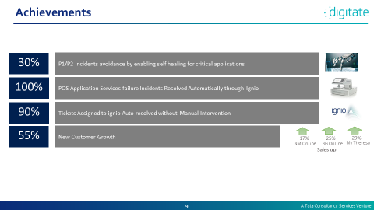
ignio has played a very crucial role in our Peak Season and reduced P3 and improved operations, some of very critical Applications have reduced P3 incidents. Thanks for putting the right people to implement and configure- Fritz Debrine , VP Infrastructure & Operations
Thank You ignio team for setting up auto resolution to our Application services, it really helped and saved our time a lot in terms of incidents. Great job
– David Houghton , Operations Manager POS

