

2019 BUSINESS TRANSFORMATION & EXCELLENCE PROJECT AWARDS

**CATEGORY: Best Achievement Technology Enabled Process Automation**

**Title: You’re Hired: How Labor Finders Utilized BPM to Digitally Transform its Electronic Employment Application Process and Enable Process Automation**

SYNOPSIS:

Labor Finders International, Inc. is the oldest and largest privately-held light industrial labor staffing Franchise Company in the U.S. and a leader in the blue-collar staffing industry. For over 40 years, Labor Finders has worked with thousands of employers around the country, processes upwards of 120,000 applications per year, and puts more than 20,000 Americans to work every day.

With more than **three million** temporary and contract employees work for America’s staffing companies **during an average week**, America’s staffing companies hire more than **15 million workers (1).** Due to the competitive nature of the business, delivering value to its customers and achieving competitive differentiation is critical to attract and retain franchisees, employees and workers. At the same time, legal compliance and adhering to business rules and standardized procedures was important. What exacerbated the need for technology-enabled process automation was that the company was experiencing higher volumes of data as a result of company growth, and did not have a scalable system in place.

In 2016, Labor Finders started its yearlong planning phase where it evaluated the efficacy and ROI of integrating a BPM software platform with its proprietary software that would provide over 200 office locations nationwide with a new **Electronic Application Hiring Process**. This **Technology-Enabled Process Automation** initiative, implemented from Q1 2017 to present, has shown significant results, both financially ($1,380,000 projected cost savings first year) and operationally—contributing to record financial performance and growth, and enabling the company to retain its edge in a competitive industry.

**Strategic Objectives and Scope**

This process improvement initiative project fit in with the organization’s strategic objectives of 1) ensure that every branch office across the country was using most up to date, legally approved employment application (there were offices that were using older versions that were not legally up to date) – so with this process there would be more control across the board, and 2) standardization of the employment applications hiring process.

Having over 200 locations on the “same page” was important for both legal concerns and overall operational efficiency and improved productivity. Goals of the project included:

* Implement a consistent nationwide employment application process;
* Branch users will no longer need to manually enter applicants into system;
* Ensure that every office was using the most up to date employment app forms;
* Automate and enforcement of business rules (did not want some decisions to come from branch offices);
* Implement process with a consistent order in the document handling process;
* Eliminate human error;
* Applicants will spend less time filling out applications with automated propagation of information;

1 “Staffing Industry Statistics,” August 2018, <https://americanstaffing.net/staffing-research-data/fact-sheets-analysis-staffing-industry-trends/staffing-industry-statistics/>

* Applications processed more quickly will result in faster hires and processing more applicants in any given time period; and,
* Seamless integration with third party systems, i.e., electronic I-9, work opportunity tax credits, and behavioral assessments.

**Project Implementation Process and Timeline**

Labor Finders leadership team was highly involved in the entire process automation initiative, giving it top priority. A liaison was given responsibility to manage the process between senior management and the attorney team focused on legal considerations and ramifications of a new system. Management dedicated a significant amount of time on due diligence and imagining all possibilities rather than implementing right away – and planning process took close to a year.

This management involvement and approach to business excellence led to a quality implementation process, which began in the design phase with translating and evaluating usefulness of all application forms, and included the following issues:

* Re-design forms and content in forms
* Designed user-interface to coincide with how users were used to working
* Technical decisions – how to make it work and integrate with internal systems
* Ensure legal team evaluated forms and system as a whole to ensure legal compliance
* New workflow, in chronological order, was established in the new platform

After a 10-month implementation and nationwide roll-out, Labor Finders is now reaping the rewards of a well-planned and executed process automation project.

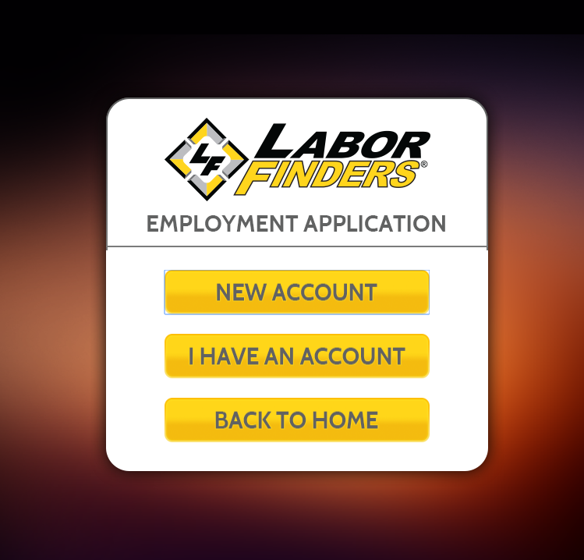

*Start up Screen*

**Size of Project Challenge**

Labor Finders developed its own application on top of BP Logix Process Director, the BPM platform in use. This innovative project deployment resulted in a seamless integration via the company’s proprietary software solution with Process Director with extensive use of BP Logix web services API. This resulted in a key success factor, which didn’t require staff to learn a new system.

In order to manage the roll-out process to a large number of offices, Labor Finders created individual project plans to implement and roll-out the new Electronic Application System to each Franchise Group, which included individual on-site training and support. The company conducted training in 25 different cities across the U.S. where staff from nearby offices attended training, covering 200+ locations with onsite training followed by online support.

Individual franchise project plans were implemented and executed to manage a formal approval process that was required for individual franchisees to implement their own policies and procedures as part of the standard core Employment Application. Labor Finders was able to incorporate this process while managing quality assurance of newly implemented processes enabled by BPM technology.

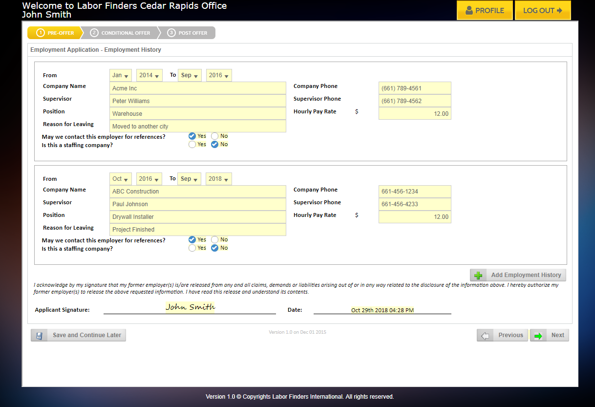

*Electronic Application, Employment History Page*

**Organizational Impact**

This technology enabled process improvement initiative was designed to empower franchisees and branch office employees across the nation to utilize and apply the same business rules in day-to-day business and enhance the way they could effect change from an individual office stand point, identifying other areas for enhancement and positive change.

This industry is subject to employment law litigation, so since rolling out the Electronic Application process, Labor Finders is ensuring legal hiring practices, and audit trails to support its business practices. Now that everything is electronically tracked, Labor Finders can ensure all offices are operating in accordance to the law. When you don’t have a well-established process, you are subject to large fines. For example, Labor Finders recently had an inspection and audit by U.S. Immigrations and Customs Enforcement, an agency under Department of Homeland Security. This audit was performed without a glitch – because everything is electronically tracked it’s easy to establish accordance with legal practices, and ensure all 200+ offices are operating in compliance with the law.

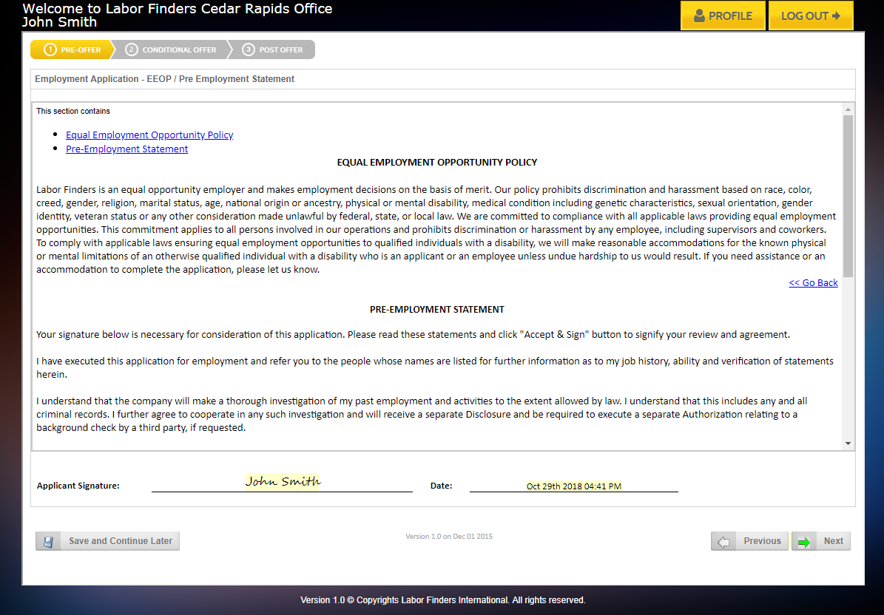

*EEO Policy Screen*

Impact of project results on customers (franchisees, branch staff and applicants) and value generated from the digital business excellence project contributed significantly to the organization in the following ways:

* Saving significant money by eliminating the need of printing hundreds of thousands of paper employment applications a year;
* Saving significant money by eliminating more than 90% the time dedicated by branch staff to process each individual employment application: some of the most time consuming tasks eliminated were manually reviewing each individual paper form, manually setting up applicants in proprietary software, scanning and uploading paper application into proprietary software;
* Reducing the need for branch staff involvement and time spent on each application. Improved accuracy and output (time savings, standardization issue, and compliance issue);
* Peace of mind knowing business rules are enforced now across all offices, so less is subject to individual branch staff decision-making;
* Ability to now focus on customer service and revenue generating activities; and,
* Faster and better end-user experience for applicant.

Organizational Learning:

It’s important to note how the organization developed as a result of the business excellence project. The digital transformation that Labor Finders experienced facilitated its current formalized and streamlined hiring process. This Electronic Application Hiring system changed dramatically for the better, as an example, new kiosks were implemented in offices where people could apply via kiosks and set up appointments rather than walk away with a printed application. This improved approach expedited the overall process where the applicant also benefits by streamlined, organized process with quick response times and subsequent job placement. Also, previous to this project implementation, staff didn’t enter every applicant into the system. They entered applicants only if they had an immediate job for them. With the new Electronic Application system, everyone is entered into the system, and if not eligible for hire, applicant is flagged and is seen by other offices. This saves a lot of time, if someone was declined, other offices would track individuals easily.

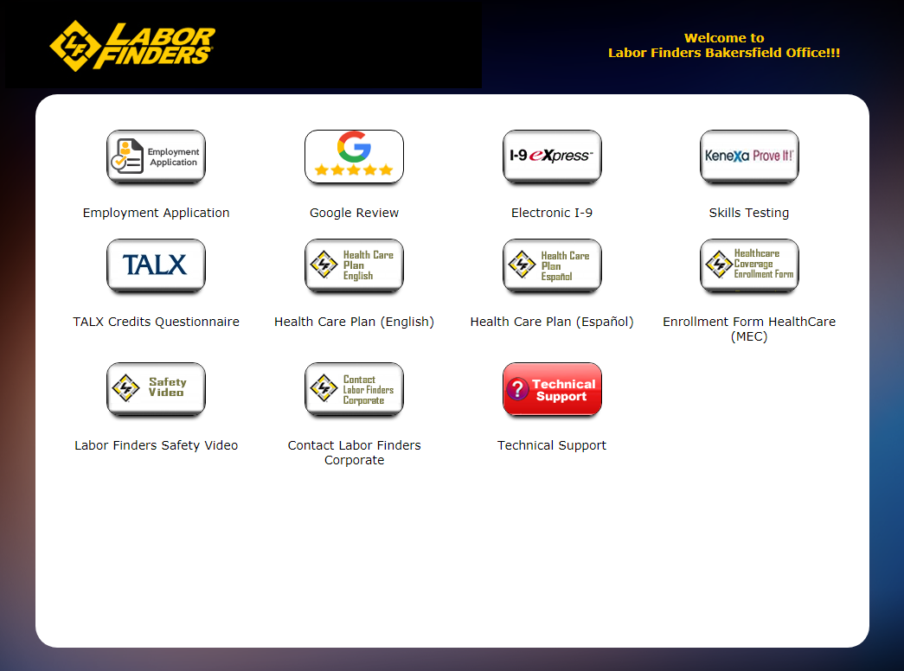

*Branch Office Kiosk Screen*

With the enforcement of business rules, Labor Finders was able to control and manage offices in an efficient and effective way. The added “insight” attributable to the Process Director, the BPM platform in place, is contributing to Labor Finders’ successes, as the organization now has the statistics in place so it can determine how many they hired, as a percentage, of those whom applied in a given time period. The resulting improved business process also allows the company to examine those who are qualified to work, but weren’t hired. These improvements in hiring practices has led to a leaner organization equipped with tools to make hiring even more effective for all stakeholders.

**Business Results**

* **Savings of $1,380,000 yearly,** over previous paper-based process
* Improved user-experience for branch staff. **4,500 hours of manual support activity has been automated over the last year**.
* **90% reduction in time needed to process applications** freeing up resources to dedicate that time to revenue generating activities.
* **Applicants take 20% less time in filling up the application**, making the process more user-friendly and allowing offices to process more applicants per day.
* **Implementing a digital process has enabled Labor Finders to process approximately 20% of the applications remotely** where applicants can apply from home without having to come in person to the office. The ability to apply remotely has allowed offices to extend the reach of applicants who, in the past, would not apply if offices were located too far.

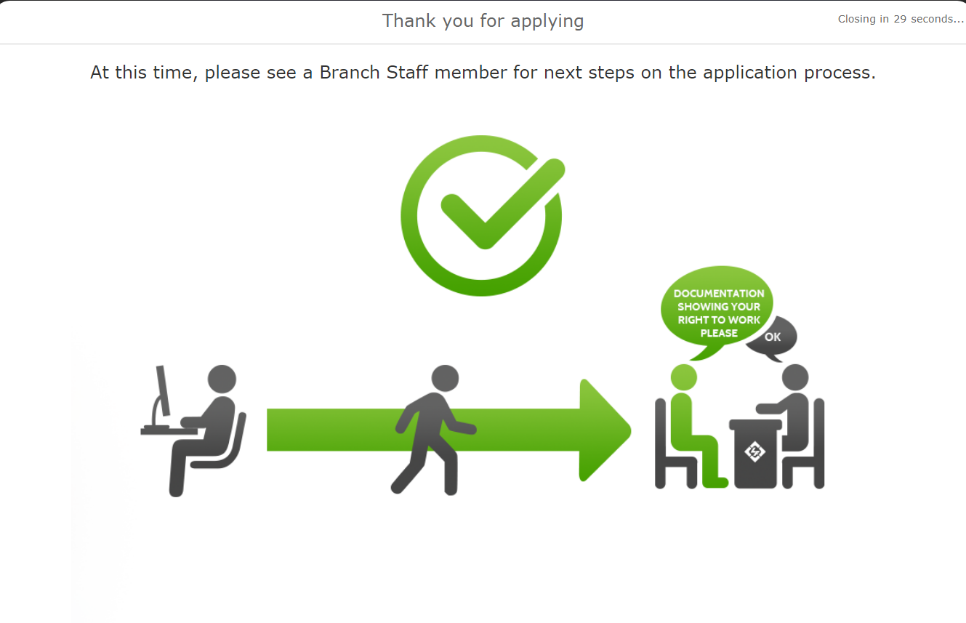

*Electronic Application – Final Thank You Screen*