**BCBSM – Best Operational Excellence Project Under 90 Days – Medicare Advantage Attribution**

**Synopsis**Blue Cross Blue Shield of Michigan (BCBSM) is a nonprofit, mutual insurance company and independent licensee of the Blue Cross and Blue Shield Association. Founded in 1939, BCBSM is the largest and most trusted provider of health insurance in Michigan, and serves company and government-sponsored group plans, individual plans, Medicare and Medicaid through traditional preferred provider arrangements, health maintenance organizations and health savings account plans.

|  |  |  |  |  |
| --- | --- | --- | --- | --- |
| Members | 5.4 Million |  | Employees | 8,100 |
| Hospitals | 152 |  | Revenues | $26.9 Billion |
| Physicians | 33,000 |  | Claims Paid | $23.1 Billion |

Under contract to the Centers for Medicare and Medicaid Services (CMS), BCBSM markets and manages Medicare Advantage (MA) products to individuals age 65 and older and is the 6th largest Medicare Advantage plan in the country. Like all health insurance products, MA plans are based on **trusted relationships** – between patients, physicians and health plans. These relationships establish a fundamental association among the parties for the maintenance of health and the delivery of care in the event of illness. The data supporting and defining these relationships is a particularly critical underpinning to MA health plans, as the relationship between a member and their primary care physician (PCP) is the basis for defining accountability to: (1) a member’s health and (2) performance-based measurement and reimbursement to physicians.

A **care relationship** is defined as the one-to-one association of a member to a PCP, who is most responsible for providing healthcare service to the respective member of a health plan. This alignment of a member to a PCP in an MA Plan is known as **MA Attribution**.

**Medicare Advantage Attribution: Why it matters**Accurate MA Attribution enables the highest quality of care and the most accurate reimbursement of physicians for the services provided. It also enables health plans to actively measure and manage the quality of care provided, so that performance payments by the government can be maximized.

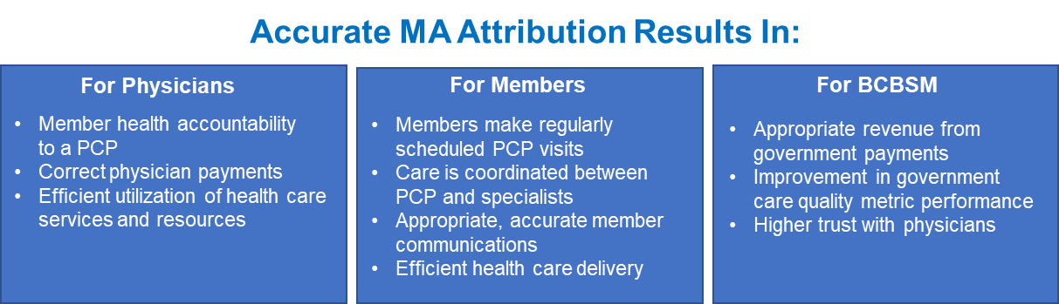



**Strategic Objectives and Scope**In response to critical feedback from some physicians, in early 2018, BCBSM leadership recognized the organization’s MA Attribution process and underlying data needed to improve. Incorrect MA Attribution was hindering BCBSM’s ability to determine physician performance against quality, timeliness and cost of care metrics. Payments to physicians were being delayed, resulting in physician frustration. What’s more, members were receiving erroneous communications. For BCBSM, gaps in care remained unresolved, lowering plan quality scores and resulting incentive payments.

An initial evaluation of the process revealed a widespread lack of understanding of the required steps and proper sequencing of the Attribution process across the organization. To that end, a cross-functional team of business leaders, subject matter experts, and process improvement professionals was assembled to examine the process and prepare recommendations for creating an improved, repeatable process that could consistently deliver improved outcomes and improved data quality across the Attribution process. To achieve quick results, the leadership team determined a **Kaizen event** would mostquickly and efficiently optimize the process by providing a structured problem-solving methodology that engages all stakeholders across the end-to-end process. The Kaizen event enabled the team to identify a portfolio of improvement opportunities within two days rather than traditional improvement projects which could extend well beyond four to six weeks.

**Implementation Process and Timeline**

**Pre-event Planning**Member and physician dissatisfaction created an urgency to improve the quality of the Attribution process. Executing a successful Kaizen event required thorough upfront planning, including: formalizing the scope of the event, identifying and securing the required resources, establishing objectives for the event, scheduling leadership briefings and the facilitated workshops. This saved valuable time during the event and enabled the Kaizen participants to start fast and sustain the momentum through the event.

The event included **13 business areas across 11 executive leaders, 3 BCBSM corporate entities**, and an external vendor partner as important contributors in defining current and future state business processes. In preparation for the Kaizen event, the facilitation team met with all **17 participants** to ensure expectations were clear regarding mindsets, behaviors, expectations and the event logistics. The team prepared and syndicated project charter documents with executive leadership to ensure alignment and prioritization of the planned approach and targeted outcomes.

**Kaizen Event**The Kaizen event offered an effective way for cross-functional teams to apply improvement tools, establish relevant metric programs, and to sustain their improvements. Participants learned to work with one another to solve problems rapidly and in a highly effective way. The Kaizen event provided the focus, structure and skilled facilitation for making larger scale rapid improvements in a structured setting with a sequestered, multi-disciplinary team.

As part of the event, **all** **executive leaders** engaged with the participants at the close of each day, to clear the path of any constraints, and observe the team’s progress.

* 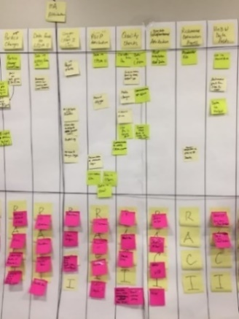**Day 1: Understanding, documenting, and diagnosing current state processes —** to identify pain points, process gaps and waste in the end-to-end process, and build an understanding of the requirements and outputs of upstream and downstream contributors. This was the first time many of the contributors understood the MA Attribution process on an end-to-end basis and could recognize the role they played – *or should play*.  
    
  *A skilled facilitator coached the team to think lean, identify waste, apply specific tools and problem-solve. Using outputs from Day 1, the facilitator created a Process Accountability Tool as a foundation for guiding participants to defining future state elements, roles and responsibilities on Day 2 of the event.*

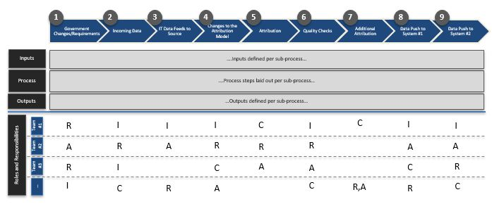

**Illustrative**

* **Day 2: Designing the future state and identified roles and responsibilities —** in creating the future state process, the team focused on three outcomes: (1) reducing cycle time, (2) improving the overall quality of the data, and (3) eliminating bottlenecks and gaps to improve the reliability of the end-to-end process and the outputs. By the close of day two, the team had aligned on **9 future-state sub-processes**, each with unique set of roles and responsibilities, and **8 distinct actions** necessary to enable that future state.

The event wrap-up was built around a comprehensive review of the recommendations with the executive leaders, who endorsed the recommendations, and committed the resources necessary to implement the 8 actions.

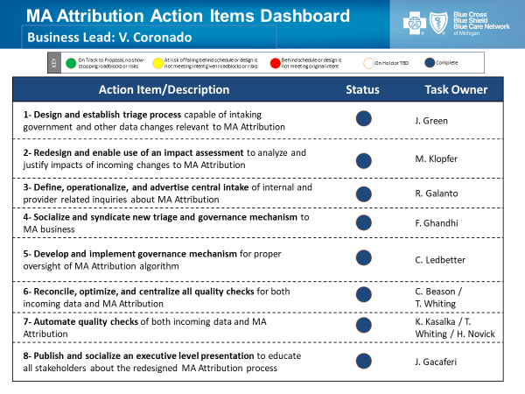

**Implementation**Following the Kaizen event, and with the endorsement of the executives, the team transitioned quickly to implement the identified actions. The facilitation team utilized an action plan tracker (shown at right) in meeting regularly with the initiative teams to monitor progress and enforce accountability throughout implementation. A cadence of touchpoints with executives ensured momentum was sustained and all obstacles were cleared promptly.

All 8 action items were **completed within 8 weeks**, and the future state was fully operational upon completion.

**Impact and Results**

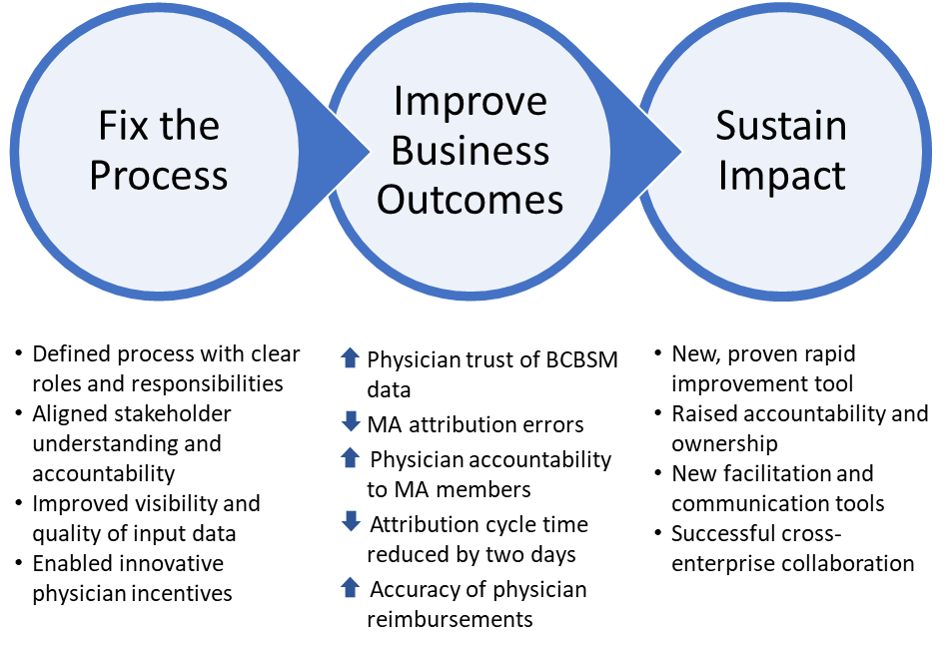

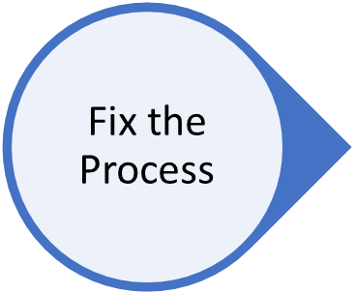The source of the MA Attribution inaccuracies was the **process**. It was not clearly defined or understood. It required contributions from many departments; and these departments didn’t understand their roles, nor did they fully understand the impact that their contributions have on the final process outputs. As a result, it was of primary importance to address these process problems so that the MA Attribution process would consistently deliver its intended outcomes and enable improved outcomes in the business.

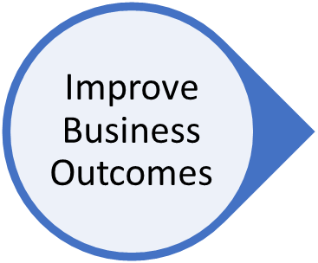With the redesigned and stabilized business process, the **improved business outcomes** are already apparent. MA Attribution errors have been vastly reduced, removing barriers to the proper functioning of physician-member relationships, increasing the accuracy of physician reimbursements and raising the physicians’ trust in BCBSM.

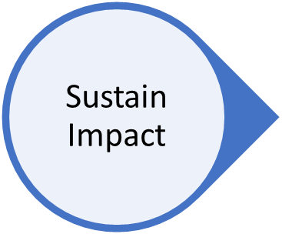Through this work, BCBSM has realized improvement in its **Continuous Improvement** capabilities through the successful deployment of Kaizen as a rapid improvement technique, and with the new toolset to facilitate process accountability. In addition, successfully delivering on this complicated, cross-enterprise process redesign has instilled confidence in the business to tackle similar problems.

**Conclusion – Improved Accuracy, Happy Physicians, Better Care**Ultimately, the improved process resulted in more precise MA Attribution for the **14%** of BCBSM's total MA membership where inaccuracies were discovered. This improvement has increased the quality and accuracy of every program and/or payment that is consuming MA Attribution data.

To illustrate the scope of this improvement, through this project the team identified **six different payment programs**, totaling more than **$60 million** in payments that consume MA Attribution data**. Increased** **MA Attribution** accuracy has improved the overall correctness of payments across these respective programs.

In addition to better understanding the downstream impacts of MA Attribution, the alignment and deployment of the agreed-to future state has clearly defined accountability and ownership of the process as well as increased BCBSM’s ability to manage its relationships with physicians.

But positive business results must equate to positive member results. This project delivered on that count as well. Improving MA Attribution accuracy enhances that sometimes complicated relationship between members, physicians and BCBSM by ensuring the right care is delivered by the right physician, at the right time – and at the right cost.

With accurate MA Attribution, **MA members get timely, efficient health care**, delivered cost-effectively that improves their overall quality of care, *and* their quality of life.