**Operational Excellence to Deliver an Outstanding Value Creation   
or Innovation Execution Project**

**Synopsis**Blue Cross Blue Shield of Michigan (BCBSM) is a nonprofit, mutual insurance company and independent licensee of the Blue Cross and Blue Shield Association. Founded in 1939, BCBSM is the largest and most trusted provider of health insurance in Michigan, and serves company and government-sponsored group plans, individual plans, Medicare and Medicaid through traditional preferred provider arrangements, health maintenance organizations and health savings account plans.

|  |  |  |  |  |
| --- | --- | --- | --- | --- |
| Members | 5.4 Million |  | Employees | 8,100 |
| Hospitals | 152 |  | Revenues | $26.9 Billion |
| Physicians | 33,000 |  | Claims Paid | $23.1 Billion |

**The Challenge**

Early in the current decade, BCBSM faced increasing competition in a challenging landscape — the Affordable Care Act significantly changed the regulatory and market environments, competition from for-profit insurers was increasing, and the rising cost of care was a growing burden for individuals and employers. These developments created threats to BCBSM’s market position, but also presented opportunities to strengthen its competitive position and the company’s performance.

In late 2015, a new 3-year program, Strategic Business Transformation (SBT) program was launched. This program set out to advance two specific dimensions of the company’s strategic plan: Deliver the business at a meaningful lower cost and identify and invest in the necessary business capabilities to win in the market. The program set aspirational goals to achieve financial outcomes across the company – over $300M in value and targeted improvements.

**A Structured Approach**

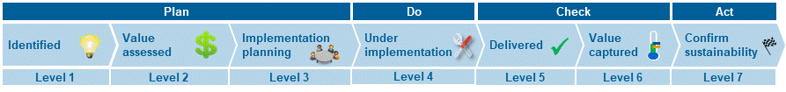Enterprise transformation programs, such as SBT, are challenging; research shows that 70% of transformation programs fail to meet their stated objectives. To beat the odds, the BCBSM team began a systematic journey to manage their transformation program to a successful end, and quantifiably measure results. The program was divided into 8 workstreams, each workstream had an identified executive owner and contained initiatives to address process pain points, capability gaps, and inefficiencies. Each of the 150 initiatives had an initiative leader who was responsible for delivery of that improvement. BCBSM created an implementation framework to assess the status of the program initiatives. This standardized initiative lifecycle helped assess the execution readiness of each initiative and track progress.

**The Path Forward**

Through delivery of the SBT program, BCBSM was committed to realizing measurable business outcomes and value. The SBT Program Office (PO) needed to answer the question, “**How will we know** we’ve met our stated objective to achieve $300M in value?” Along with the initiative leaders, the PO assessed what was at stake for each of the 150 distinct initiatives in the SBT program and confirmed that the outcomes of each proposed initiative were worthy of the enterprise resources. Initiatives in the program took all forms $-$ process improvement, renegotiation of vendor agreements, automation of manual work, and retirement of legacy systems, among others.

The team partnered with the initiative leaders to identify the value source or “driver” and articulate expected benefits from the implementation of each initiative. The expected outcomes were classified into value types for each initiative, categorizing the value either as **Financial**, resulting in direct value with a measurable, verifiable P&L impact; or **Strategic**, resulting in indirect or supporting value that, while perhaps difficult to convert to dollars, is measurable and defines why an initiative should be undertaken.

Beyond describing the initiative benefits as a value type, BCBSM needed to discretely quantify each initiative’s impact in economic terms. The PO partnered with initiative leads to understand the operational metrics impacted (call volumes, enrollment time, testing cycles, defects, cost of HW/SW and data storage, etc.). Each initiative had identified metrics that represented current performance, an established baseline, and an addressable spend. Further, each initiative had an expected change in the metrics and spend as a result of implementing the initiative, and a target timeframe they expected to realize the value. Planned metric changes were tied to expected savings or future costs avoided, and the formula that would be used to calculate the resulting economic change was document and syndicated with all stakeholders.

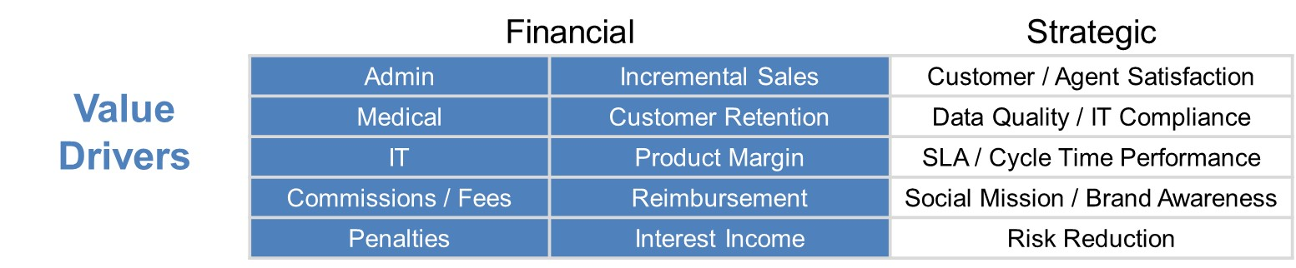

**Staying the Course**

Once an initiative reached implementation, the PO conducted regular value checkpoints with the initiative leads to ensure the initiative was on track to meet its stated objectives, which confirmed critical information:

* Is the *initiative* on time? On budget?
* Are the *initiative milestones* on track? Any issues?
* Are there any risks to reaching the *value* as estimated and in the planned timeframe?
* Overall, is the forecasted *change in metrics* and associated *economic value* still on track?

Frequent progress reviews with initiative owners reinforced accountability and validated incremental progress. These routine reviews, in combination with clear expectations, facilitated expected outcomes while providing transparency for necessary adjustments. If an initiative slipped off course, or the initial economic value was compromised, the team was able to quickly make go-forward or abandon decisions based on the expected value to be achieved.

**Collecting the Evidence**

When the business area reported the initiative completed, they partnered with the PO to measure and document the stated outcomes. Supporting documentation was collected to demonstrate the measurable and/or economic impact. Documentation gathered demonstrated such changes as base budget reductions, year-over-year reductions in the general ledger, reductions identified on invoices, reductions in customer service calls, etc.

Verifying realized value was not without challenges, in particular:

* ***Isolating the impact of an initiative***, so that a clear cause-and-effect relationship can be demonstrated
* Evaluating ***cost increases*** ***avoided*** or ***prevented***
* Assessing value impacts on ***upstream or downstream business areas***

To address these challenges, the PO worked with the business areas to:

* Identify all metric influencers for relevant value drivers and documented cause-effect assumptions for each driver early in the process
* Evaluate the impact of the initiative on cost trends *-had we not acted*- to substantiate cost avoidance metrics
* Syndicate initiative value estimates with all impacted areas to ensure early alignment with all expected outcomes.

**Partnering with Finance: Show me the Money**!

The partnership between the PO and Finance throughout the program proved to be a key factor in claiming the savings. The PO provided Finance line-of-sight to forecasted savings *by cost center*, enabling Finance to plan for annual budget reductions, update forecasts, and explain budget-actual improvements. As initiatives were completed, and the resulting value calculated and evidenced, the PO and the initiative owners developed the SBT Savings Packages – one for each initiative. This document told the initiative story: it described the improvement opportunity, explained what the initiative set out to do, and the resulting impact on the business, including the economic value.

With ceremony, the PO reviewed each Savings Package with their finance partners; value was not claimed as achieved until the BCBSM Financial Controller provided his approving signature. It ensured traceability from the initiative to the outcome and to the bottom line. Working with the SBT PO, Finance was able to identify the discrete reductions in the cost centers, enabling them to close the loop and ensure the value earned was sustained.

**Results: What gets measured, gets done**

The SBT program illustrates the effectiveness of the rigorous **Value Management** process at BCBSM. Business owners of workstreams identified initial opportunities, expected outcomes and value targets. The program began with an overall target of delivering $300M in value. To date, the program has exceeded the target, delivering an evidenced value of over **$375M**.

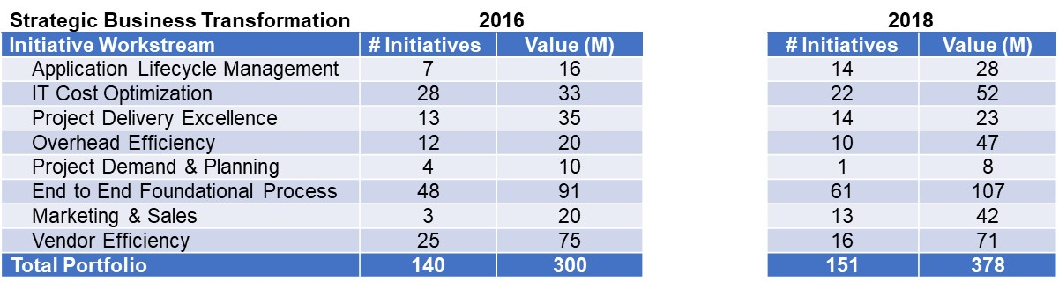

**A Cultural Shift**

The BCBSM Value Management process is threaded through the entire initiative lifecycle — from identifying an improvement opportunity through implementation, verification of business outcomes, and sustaining the improved performance. BCBSM has indoctrinated Value Management into all continuous improvement efforts.

The discipline which guided the value realization in the SBT Program established the foundation for the development of the Value Management Playbook. The Playbook guides initiative owners and teams, providing background on value concepts such as defining capabilities, identifying value drivers and value types, developing value formulas, engaging key stakeholders for alignment, and syndicating value expectations. The playbook also includes templates and models to support the process.

Below is an overview of the BCBSM Value Management Playbook.   
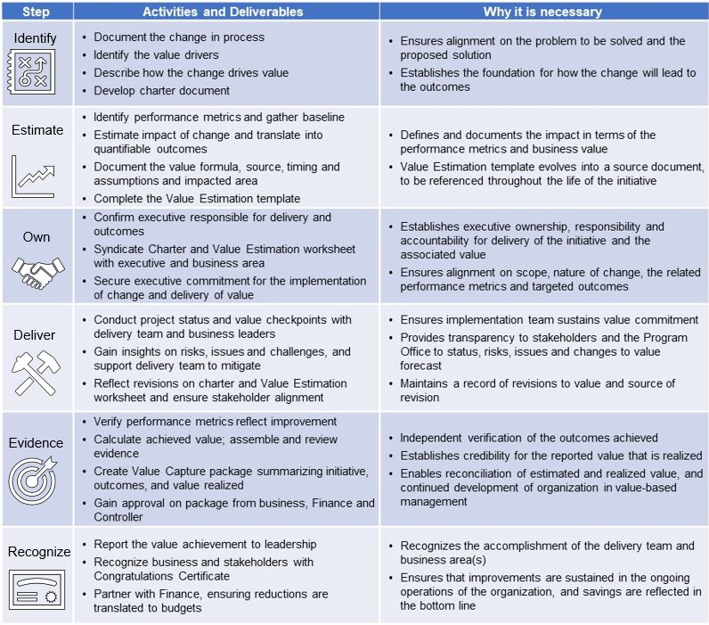

A successful example of the BCBSM Value Management process can be found in the supplemental pages. These pages share artifacts from one of the transformation initiatives: ***Expand the use of Agile Project Methodology***. [See 2 supplementary pages for details.]

**A Strategy for Sustaining a Continuous Improvement Culture**

Every transformation program is launched to create value. To ensure the appropriate return on strategic investments, it’s important to be confident that the anticipated results will be realized before the commitment of time, resources and budget. And it’s equally important to know that, at its conclusion, an accurate review of the initiative can take place to collect lessons learned, to support future efforts and to ensure that improvements are sustainable.

There remains a certain art to business transformation, but the value-based approach that BCBSM established assures that the ultimate evaluation of change initiatives moves from subjectivity to objectivity. Through a rigorous, straightforward process, value estimation is accurately established up-front with a thorough consideration of expected impact, capabilities – existing and to be acquired, and value drivers. Once implementation begins, ongoing reviews with business owners reinforce accountability and validate incremental progress toward the anticipated results – allowing for in-process adjustments as necessary.

Post-implementation, a rigorous process verifies that reported value is truly realized by the enterprise and can be evidenced, and substantiated. Additionally, post-implementation lessons learned are collected. What worked is documented so that it can be repeated. What didn’t work is documented to drive process improvement. And equally important, what worked – *but wasn’t anticipated* – is documented to make the Value Management discipline even more robust.

The SBT program was a successful transformation program that delivered meaningful outcomes to the enterprise. Beyond achieving the program’s stated goals, building emerging capabilities, positioning for the future and surpassing the savings and value targets, the value management discipline inherent in the program has had a positive impact on the BCBSM corporate culture.

For business groups, successfully completing an initiative via this rigorous process has become a tangible symbol of the credibility and integrity that is the foundation of the overall BCBSM culture of operational excellence. For this reason, departments and business owners look to the Value Management system to validate the integrity and effectiveness of their *own* internal processes. This cornerstone of the organization’s transformation validates the efficiency of its business operations and itself – through effective Value Management – adds strategic value. And as BCBSM continues its journey of continuous improvement, it has become the way they confidently head into the future, positioned for success, to compete in the marketplace and win.