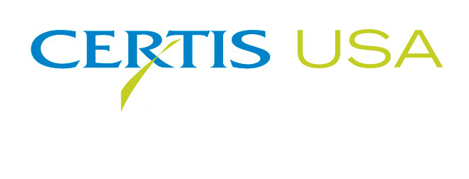
Certis USA Introduces Homeplate® Non-Selective Herbicide

COLUMBIA, Maryland, February 6, 2018 — Certis USA, the biopesticide company, introduces Homeplate®, an OMRI listed, non-selective, broad-spectrum, fatty acid, burndown herbicide that works as a foliar contact spray to control a wide variety of weeds. Homeplate is a non-systemic Total Vegetation Killer labeled for use in all crops, including outdoor and protected crops. Homeplate has proven efficacy against a growing list of broadleaf weeds and grasses that includes, but is not limited to black nightshade, Canada thistle, catchweed bedstraw, chickweed, common lamb’s quarter, foxtail, shepherd’s purse and wild Chamomile. It is rainfast within three hours and achieves total kill within 12 hours to 72 hours depending upon environmental conditions. In addition to burndown, Homeplate is flexible with labeled uses in direct and shielded sprays, pre-plant applications, post-harvest sprays, as a harvest aid and desiccant, for sucker control and as a pruning and trimming aid.

Homeplate contains a blend of 44 percent caprylic acid and 36 percent capric acid as its active ingredients. It is fast-acting and features a unique mode of action that kills the green parts of plants and shuts down photosynthesis, causing the plants to essentially starve to death. Homeplate’s high solubility and formulation stability allow for better spreading and burndown to control weeds. It comes conveniently packaged in two, 2.5-gallon jugs per case, as well as 250-gallon totes. Homeplate has a reentry interval (REI) of 12 hours and has a zero-day pre-harvest interval (PHI). Homeplate is currently registered in 45 states, with plans to register throughout the U.S. in the coming months, including California. It is NOP (USDA National Organics Program) labeled, OMRI® listed, has a CAUTION signal word and is exempt from the requirement of a tolerance when used in or on all food commodities (MRL exempt).
-more-
Certis USA Introduces Homeplate® Non-Selective Herbicide
Page 2

“Homeplate delivers consistent and unparalleled performance against target weeds on both conventional and organic farms,” Mike Allan, Certis USA Vice President, North America, said. “This powerful herbicide contains fatty acids derived from palm and coconut oils and is a strong complement to the Certis product portfolio and reinforces our commitment to provide quality bio-based solutions to support grower needs.”

Headquartered in Columbia, Maryland, Certis USA is a leading manufacturer and distributor of a broad line of biopesticide products for specialty agricultural and horticultural markets and the home and garden market. Certis USA products provide valuable solutions by meeting the challenges faced by today’s growers who are seeking sustainable alternatives, resistant pest management and harvest solutions, and low pesticide residues for market flexibility and export accessibility. Homeplate is a registered trademark of W. Neudorff GmbH KG. For more information about Certis USA and its products, please visit www.certisusa.com.

# # #
Media Contact:
Rick Purnell, Mona Howell & Associates Marketing Communications
760-799-5578, rpurnell@monahowell-associates.com

