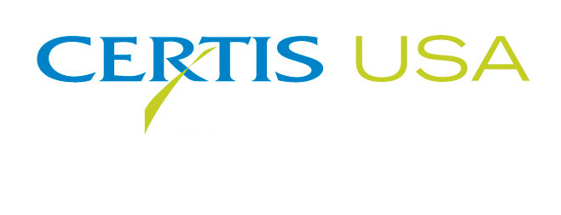
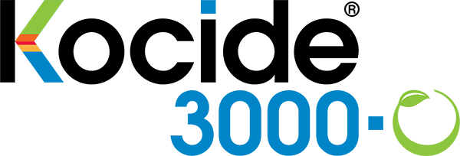

Kocide® 3000-O Copper Fungicide/Bactericide
Approved for Use in Organic Agriculture

COLUMBIA, Maryland, FEBRUARY 7, 2018 — Kocide® 3000-O copper fungicide/bactericide receives approval by the U.S. EPA for use in the organic production of vegetables, small fruits, tree crops and vines. Available from Certis USA, Kocide 3000-O is NOP Approved and OMRI® Listed.
Jim Black, Certis USA Director of Business Development, said, “Our growers need the flexibility of producing their crops organically. We’re pleased to provide organic producers access to the copper fungicide they’ve relied upon for their commercially grown crops. Kocide 3000-O is an excellent addition to the Certis USA product line of more than 25 organically approved biopesticides.”
Kocide 3000-O is a technologically advanced copper fungicide that is formulated to deliver a maximum concentration of biologically active copper ions while providing outstanding plant safety. The advanced formulation allows for lower use rates than competitive copper fungicides and provides effective control of a broad range of bacterial and fungicidal diseases, including walnut blight, bacterial spec and spot, citrus canker, mildew, fireblight and bacterial blast.
Michael Harowitz, Kocide Business Manager at Certis USA, said, “Kocide copper fungicides have provided growers with reliable, proven performance for more than 50 years. We are excited to be offering Kocide 3000-O for organic as well as conventional production. Kocide 3000-O has the same label as Kocide 3000 and offers the same excellent disease control. Kocide 3000-O will be available in the market place in mid-February 2018.”
Headquartered in Columbia, Maryland, Certis USA is a leading manufacturer and distributor of a broad line of biopesticide products for specialty agricultural and horticultural markets and the home and garden market. Certis USA products provide valuable solutions by meeting the challenges faced by today’s growers who are seeking sustainable alternatives, resistant pest management and harvest solutions, and low pesticide residues for market flexibility and export accessibility. For more information about Certis USA or its products, please visit www.certisusa.com.
#
Media Contact:
Felicia Gillham, Gillham & Associates Marketing Communications
619-482-8820; Cell: 619-341-3054; fgillham@gillham-associates.com

