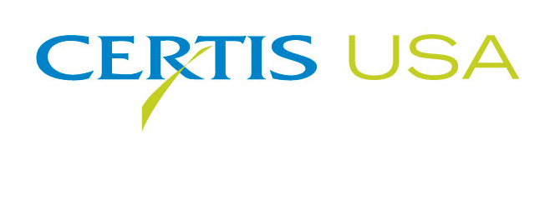
Certis USA Names UAP Canada
As Marketing Partner for Double Nickel Biofungicide in Canada

COLUMBIA, Md.—March 10, 2016—Certis USA chooses UAP Canada as an exclusive provider of its Double Nickel biofungicide to Canadian growers of fruiting and leafy vegetables, potatoes, grapes, strawberries, tree fruit and other crops. Double Nickel represents a new generation of fungicides and bactericides that have biologically based active ingredients, are of low risk to the environment and are sustainable crop protection solutions. UAP is the largest distributor of agricultural inputs in Canada. Its products are made available to Canadian growers through national and regional dealers and an extensive field sales force.

Double Nickel is a naturally occurring strain (D747) of the beneficial rhizobacterium Bacillus amyloliquefaciens, which rapidly colonizes roots, leaves and other plant surfaces to prevent establishment of disease-causing fungi and bacteria. It uses multiple modes of action to control powdery mildew, Botrytis, bacterial disorders, damping off, and root and crown diseases, such as Pythium, Rhizoctonia, Fusarium and Sclerotinia. Double Nickel is a valuable tool for management of resistance to chemical fungicides and use in Integrated Pest Management (IPM) programs. It has a four-hour re-entry and can be applied up to and including the day of harvest. The biofungicide is available as Double Nickel 55 WDG and in a liquid concentrate (LC) formulation.

Tim Damico, Certis USA Executive VP, NAFTA, said, “We look forward to working with UAP Canada. We know we’ll receive excellent representation of our products with them. The marketing personnel and sales force at UAP Canada have the respect of the growers they service. They have demonstrated expertise and extensive knowledge of specialty ag production. The success of the Double Nickel franchise in the U.S. will serve as a springboard for additional adoption in the Canadian market. Double Nickel will be in good hands with UAP.”

Headquartered in Columbia, Maryland, Certis USA is a leading manufacturer and distributor of a broad line of biopesticide products for specialty agricultural and horticultural markets and the home and garden market. Certis USA products provide valuable solutions by meeting the challenges faced by today’s growers who are seeking sustainable alternatives, resistant pest management and harvest solutions, and low pesticide residues for market flexibility and export accessibility. For more information about Certis USA or its products visit www.CertisUSA.com.

-30-
Media Contact:
Felicia Gillham
Gillham & Associates Marketing Communications
619-482-8820; Cell: 619-341-3054

